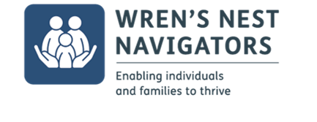
WREN’S NEST VOLUNTEER ROLE DESCRIPTION

Role: Activity Assistant

Summary
We are looking for volunteers who have pride in their neighbourhood and are eager to make a positive difference in the lives of families and/or individuals within the Wren’s Nest community.

The Activities Assistant will attend project activity sessions with the aim of providing support to the Session Lead. This could include encouraging participation and positive behaviour choices with participants, taking the register at the beginning of a session, assisting with setting up and packing away activity materials.

There will be a need for the Activity Assistant to communicate effectively with young people and parents during all sessions and as such safeguarding and child protection policies must be understood and followed.

Full training will be given and a full DBS check will be required (no cost involved).

Role Description
An Activities Assistant will be expected to attend activity sessions that are taking place as part of the project, ideally at least one session per fortnight, with sessions lasting between 2-3 hours. You will play a valuable role in helping a member of your local community to build on their strengths and to take steps toward improving their health and wellbeing as well as motivating them to reach their full potential.

Skills/Experience
We require no formal qualifications – the only thing on paper that we need is a full DBS check. If you are a parent, carer or sibling you will immediately bring direct experience of relationship, of different responses to authority and of a wide range of attitudes and behaviours.

You will be able to reflect on life experiences where you, personally, have faced difficulties and challenges in life, with which you gained essential learning and understanding about many of the experiences that an individual may face.

If you are interested in volunteering as a mentor or would like more information and an informal chat please contact:

dudleywrensnest@ymcabc.org.uk

