**Special Educational Needs and Disabilities**

**Needs Assessment**

**2020**

Needs Analysis of children and young people with Special Educational Needs and Disabilities

Prepared by the Integrated Commissioning, Performance and Partnership Team

# Executive summary

The purpose of this SEND Needs Assessment is to facilitate the understanding and identification of this subset of population and for local strategic partners to use them to develop robust local commissioning plans. This SEND Needs Assessment was commissioned by Integrated Commissioning and will drive the narrowing of health inequalities within the population of Dudley.

This needs assessment explores the characteristics of the children and young people with special needs and disabilities resident or schooling in Dudley, combined with information from partner organisations such as health together with nationally published information. It discusses the factors which can lead to a child having special educational needs and/or disability and will be used to determine actions that all partners will take to meet the health and social care needs of the community and to address the wider determinants of inequalities in health and wellbeing. In essence it is anticipated that the report will inform our:

* Understanding of the health and wellbeing needs of children with SEND and/or disability;
* Understanding of the current demand for services and project future need where possible;
* Provide an evidence base to inform service planning, commissioning processes and be a source of information for the SEND team;
* Make recommendations to improve provision

**There are 8,330** children and young people special educational needs and or disability attending Dudley schools; this includes **1,747 with EHCPs** and **6633** are eligible for SEN Support. 17% of the school population have SEND (January school census 2020).

**2,340** children resident in Dudley have an Education, Health and Care Plan (EHCP). Of this, **1,664** (71%) are aged 5 to 15, and **584** are aged 16 to 25. Less than 100 children are under the age of 5 (January 2020).

#### Vulnerable Children

One in four children looked after or in care (CIC) have an Education, Health and Care Plan (EHCP) this is slightly less than the national average. Children in Need (CIN) within Dudley are less likely to have an EHCP; however, the proportion with special educational needs without EHCP (25.3%) is slightly more than England (24.4%) and West Midlands (23.5%). (March 2019 statutory data returns).

#### Disability

In 2011 there were 4,318 children and young people aged 0-24 years in Dudley recorded with long-term health problem or disability which limits daily activity. The prevalence is marginally higher than the national average. The high population prevalence of risk factors associated with disability, such as low infant birth weight and economic disadvantage, may be contributory factors to levels of SEND in the area. Over 7,000 individual children and young people were identified by CCG data (September 2020) to have at least a form of disability indicating a rate of 7.6% of the 0-25 population.

#### Early Years

The number of children accessing early years educational support services has been increasing over the past 5 years. In the academic year 2019/20, a total of 1,066 (72%) children aged 2 and 7,228 (94%) children aged 3 and 4 years old benefitted from funded early education in Dudley. **Communication and language** needs are the most predominant concern for children age 0-5.

#### Primary Schools

The proportion of pupils with EHCPs attending primary schools in Dudley is in line with England average but above average for the West Midlands. The proportion of pupils receiving SEN support is however higher than the national and West Midlands averages. The most common category of SEND need is speech, language and communication needs (SLCN) at 35% followed by those with moderate learning difficulties, 25%. Almost four in ten children are identified as having **communication and interaction** needs and this is in line with England average.

#### Secondary Schools

As with Dudley primary schools, the proportion of pupils attending Dudley secondary schools provision is similar. Percentage of pupils with EHCPs (1.5%) is slightly below England average (1.8%) whilst the proportion with SEN support (13.0%) is higher than the England and West Midland averages.

The most common category of SEND need is moderate learning difficulty (MLD) at 35%, followed by those with specific learning difficulties (20%). One in two pupils with SEND in Dudley secondary schools have **cognition and learning** needs and this slightly more than England average. There are concerns that this picture doesn’t match with local knowledge of professionals where it is believed that SEMH and not MLD is the most common category of need.

As with primary pupils, a greater number of secondary pupils are categorised under the moderate learning difficulty than nationally leading to concern, that children’s needs are not being accurately identified.

#### Special Schools

Almost 900 children were on roll in Dudley state maintained special schools (January 2020) indicating an increase of 131 children compared with 2016 figures. The proportion of pupils attending special schools in Dudley (1.8%) is higher than England average (1.4%) but in line with West Midland average. The vast majority of pupils with EHCP attend Dudley special schools (99.6%) this is higher than the England average of 97.9%.

One in four pupils (26%) have autism spectrum disorder (ASD) followed by those with speech, language and communication needs (23%). Dudley special schools appear to be outliers for the high proportion of pupils with MLD (22%) compared with England (12%) and West Midlands (14%). One in two pupils have **communication and interaction** as their main needs and this is above rates for England and West Midlands.

A total of 2,340 children and young people have their EHCPs maintained by Dudley in January 2020 having increased significantly over the last 5 years with annual average growth of 16% and resulting in demand for high quality provision and specialist places. Over 200 additional children now have EHCPs per year with more children being placed in independent settings including out of area placements. At the time that this report was written, 2,645 children were currently open within the Case Management System (CMS - Synergy) indicating additional **300 children and young people in six months**

The fastest growing need in Children and young people are in Speech, Language and Communication needs (SLCN), Autistic Spectrum Disorder (ASD) and Social, Emotional and Mental Health (SEMH). Increasing numbers of those with SEMH are placed high cost out of area settings due to lack of capacity locally.

# Key Points: Local context

* Dudley is home to more than 321,597 people (ONS population estimate 2019)
* 0-25 population is 97,356 children and young people, representing 30% of the population of Dudley (ONS - mid-19).
* Birth rate in Dudley is 60.5 per 1000 female population aged 15 to 44 9. (ONS - 2019)
* Infant mortality rate in Dudley is 4.1 per 1,000 live births (2017-19) and is not significantly different from the England average (3.9) (ONS - 2019).
* 10% of the population have long term illness (Census 2011)
* 4.4% of children aged 0-24 have their daily activities limited due to disability (Census 2011).
* 1,710 young adults were in receipt of Disability Living Allowance (DLA) in November 2018.
* Behavioural difficulty in children aged 25 and below is increasing, with eight in ten on GP disability register with this disability (CCG, September 2020).
* At September 2020, there are 2,465 children with EHCPs – 1889 males and 576 females. Indicating an increase of 305 on last SEN2 outturn in March 2020.
* 8,330 children with special educational needs and or disability attend schools in Dudley (17.3%) and above England average. 1,747 children have EHC plans (January school census).
* 20.1% children aged 10 to 11 years and 8.3% of children aged 4-5 years are classified as obese (2020)
* 27% of school children are from a minority ethnic group (January 2020)
* 17% of school children are eligible for free school meal group (January 2020)
* There were 659 children in care at 31 March 2019, rates remain above England average.
* 11.3% mothers in Dudley smoke at time of delivery and rate is above national average (10.4%) but not significantly different (2019/20)
* The level of child poverty is worse than England average with two in ten children aged 16 years and below living in relative low income families (2019).
* The rate of family homelessness is less and almost insignificant when compared to West Midland and England averages (2018).
* School readiness – percentage of children achieving good level of development at end of reception is below England average (2019).
* GCSE average attainment 8 score is below England average (2019)
* Eight in ten young adults achieved Level 2 qualifications by age 19
* Eight in ten young adults with EHCP were in sustained education, employment or training after GCSE.
* 3.9% of adults with learning disabilities were in paid employment and is below England average (2019).
* 64% of adults with learning difficulties live independently in Dudley, England average of 77%.

**Contents**

Executive summary 2

Key Points: Local context 4

Special Educational Needs and Disabilities Needs Assessment 8

Definitions and Scope of the SEND Needs Assessment 8

Purpose of the Needs Assessment 10

National Strategies and Policies 11

National Picture 17

Children with special educational needs and/or disability 17

Who has SEND - Factors associated with the prevalence of disability 19

Local Picture 26

Local Authority Profile and SEND 26

Total resident population in Dudley 27

Children and Young People in Dudley 28

Disability resulting in limited daily activities 33

Disability - Age and Gender breakdown 33

Type of disabilities 34

Disability by electoral wards 37

What do we know locally about children with SEND 38

Special Educational Needs – Dudley Schools 40

Incidence of Education, Health and Care Plans (EHCP) 42

Incidence of SEN Support 44

Characteristic of children and young pupils with SEND in Dudley schools 46

Broad SEND primary needs – Dudley Schools 51

SEND and gender 51

Characteristics of children with EHC plans maintained by Dudley 53

SEND by age group 53

SEND (EHCPs) by Primary Needs 54

Electoral Wards - Distribution of SEND by area of residence 56

Complex needs – triangulation 57

Educational outcomes 60

School Exclusions and Pupil absences 60

Fixed period exclusion 60

Permanent exclusion 62

Pupil Absence 65

Attainment of pupils with SEN 67

Early Years Foundation Stage 67

Phonics 69

Key Stage 1 Assessments 70

Key Stage 2 (KS2) assessments 70

Key Stage 4 (KS4)/GCSE 72

Post 16 participation (education, employment or training) 73

Post 16 attainment at age 19 74

Preparation for adulthood 76

Learning disability in employment 78

Independent living 79

EHCP Process - Assessments and New Plans 81

New Education, Health and Care Plans 81

Timeliness 82

EHCP Process - experience of the system and quality assurance 82

Quality of EHCPs 83

Reported expenditures 84

Personal budgets 85

Disability Living Allowance (DLA) claimants 85

EHCP process - experience of the system and user views 86

Local Offer 86

Dudley Early Years Area SENCO’s 87

Specialist Early Years’ Service (SEYS) 87

Therapeutic family support 88

Occupational therapists 88

Other services 88

Dudley Voices for Choice 88

Other relevant and helpful links to some key documents: 89

SEND (Education, Health and Care Plan) - Projections 89

Reasons for EHCP growth locally 91

SEND Provisions in Dudley 92

Specific Provision – Setting Location 96

Provision by settings – Dudley Schools 96

Provision overview per settings 98

Level of Support 99

Universal 99

Emerging or Lower Level SEND 99

Targeted – Children with SEND in need of some specialist involvement 99

Highest Need/complex SEND 99

Bases - SEN  Units 99

Bases - Resourced provision 99

Current Provisions 101

Education setting with Enhanced and Designated place 2020 102

Segregated schools (special schools) 102

Specialist nursery SEND places - Specialist Inclusion Services 102

Integrated in mainstream with Top-Up (BASES) 102

Alternative Provision Commissioned SEND Places 102

Post 16 Further Education (FE) SEND Places 102

SEND Sufficiency - Identified priority areas by age group 103

Under 5 – Priority Needs 105

Speech, Language and Communication Needs (SLCN) 105

Severe Learning Difficulties (SLD) 105

Autistic Spectrum Disorder (ASD) 105

Ages 5 to 10 – Priority Needs 106

Speech, Language and Communication Needs (SLCN) 106

Moderate Learning Difficulties (MLD) 106

Social, Emotional & Mental Health (SEMH) 106

Autistic Spectrum Disorder (ASD) 107

Ages 11 to 15 – Priority Needs 107

Moderate Learning Difficulties (MLD) 108

Autistic Spectrum Disorder (ASD) 108

Social, Emotional & Mental Health (SEMH) 108

Ages 16 to 19 – Priority Needs 109

Social, Emotional & Mental Health (SEMH) 109

Autistic Spectrum Disorder (ASD) 109

Ages 20 to 25 – Priority Needs 110

Priority Need Summary 111

Social, Emotional and Mental Health (SEMH) 111

Autistic Spectrum Disorder (ASD) 111

Speech, language and communication needs (SLCN) 111

**Acknowledgements**

Acknowledgements and thanks to those who have contributed to the production of this report; those within Dudley Metropolitan Borough Council, Dudley Clinical Commissioning Group, Black Country Healthcare NHS Foundation Trust and the wider stakeholders who contributed to the needs analysis together with the Parent/ Carer Forum and Dudley Voices for Choice groups.

With thanks to all those who have helped us with this document. We particularly thank:

Dudley Metropolitan Borough Council colleagues: Dawn Goodall, Susan Powell, Andrew Wright, Santokh Dulai, Jeremy Keeble, Karen Connerney, Lauran Jones-Moore, Inderjit Lahel, Laura Smith, Paul Klein, Simon Hickman, Ian Cope, Elaine Evans and many others.

Dudley CCG colleagues: Tim Horsburgh, Linda Cropper, Kellie Lennon, Joy Williams, Amanda Jackson

Parent/ Carer forum representative: Nicki Burrows, Donna Roberts

**Report Authors and main contributors**

* Tinu Williamson-Taylor – SEND Data Analyst
* Greg Barbosa - Intelligence Manager
* Toni Dawodu – Head of SEND

# Special Educational Needs and Disabilities Needs Assessment

The purpose of this SEND Needs Assessment is to facilitate the understanding and identification of this subset of population and for local strategic partners to use them to develop robust local commissioning plans. The Needs Assessment will drive the narrowing of health inequalities within the population of Dudley.

This Needs Assessment explores the characteristics of the children and young people with special needs and disabilities resident or schooling in Dudley, combined with information from partner organisations such as health, together with nationally published information. It discusses the factors which can lead to a child having special educational needs and/or disability and will be used to determine actions that all partners will take to meet the health and social care needs of the community and to address the wider determinants of inequalities in health and wellbeing. In essence it is anticipated that the report will inform our:

* Understanding of the health and wellbeing needs of children with SEND and/or disability
* Understanding of the current demand for services and project future need where possible
* Provide an evidence base to inform service planning, commissioning processes and be a source of information for the SEND team
* Make recommendations to improve provision

An unusual feature of the SEND reform is the joint local area inspections that take place across local authority areas to evaluate their effectiveness in identifying children and young people who have special educational needs and/or disabilities. The inspection also intends to support and assist local areas in improving and developing their processes and support systems to effectively deliver better outcomes for children and young people. Therefore, this needs assessment may be influenced by the findings and outcomes of such an inspection process. Dudley’s SEND Inspection occurred in May 2019 and its 14 actions are being delivered through its Written Statement of Action.

The evidence provided includes local intelligence about the prevalence and trends in special educational needs and/or disability in Dudley Borough. It explores the characteristics of the children and young people with SEND and factors which can lead to a child having special educational needs and/or disability.

Maintaining an updated and current plan is mandatory for all local authorities by Ofsted and CQC frameworks. This document represents an accurate picture of known data and information available as of September 2020, although a few elements were updated in April 2021.

It is acknowledged that this needs assessment concentrated on provision within Dudley but SEND provision is also accessed out of the borough in high cost specialist placements. Provisions accessed out of area are referenced in the sufficiency section of this report.

## Definitions and Scope of the SEND Needs Assessment

This report presents findings of data analysis evidence supporting our understanding of the needs of children with special educational needs or disability, what supports are available and what can be done better to address their needs in Dudley. This SEND needs assessment explores and presents the current and future educational, health, social care and well-being needs of children and young people from birth to age 25 in Dudley.

This will also attempt to provide clarity on the actual scale of SEND need locally with evidence of the most significant areas of assessment and diagnosis being seen in children and young people in Dudley.

The report describes the population of disabled children and young people locally by utilising both local and national qualitative and quantitative data. Qualitative data on the local needs and views of disabled children and young people was collected via the parent carer forum consultation and focused discussions with professionals in social care, education, health, commissioning and the voluntary sector such as Dudley Voices for Choice (DVC).

The collection, analysis and interpretation of SEND information are important in developing a more forensic approach to supporting children with SEND. These will help to support the removing of barriers to their learning; raise expectations as well as the setting of aspirational and realistic targets. The effective uses of data and intelligence will also help to support the development of a strategic approach to the management of SEND, as well as informing teaching and learning at the classroom level.

Being identified as having a disability, and the specific disability diagnosed is of importance nationally, locally, and for the individual and their family. The term disabled children includes children and young people with a vast range of needs. One of the findings of this needs assessment is that diagnosis and classification of disability varies across different organisations and different coding systems are used thus limiting direct comparison of condition prevalence. Categorisation codes used in primary health care, general practices, mental health services, secondary care, education and social services all differ slightly. Having a classification system for recording disability allows organisations to accurately plan service provision and funding resources.

At the time of writing this report, there is no agreed official recording definition between SNOMED (used within the health system) and SEND codes used within mainstream educational setting or even that used within further to higher educational settings.

**SNOMED CT** is a structured clinical vocabulary for use in an electronic health record. SNOMED-CT stands for the 'Systematized Nomenclature of Medicine Clinical Terms' and is a “common clinical language” consisting of sets of clinical phrases or terms, that can be grouped together with relationships between terms. It is the most comprehensive and precise clinical health terminology product in the world.

It is understandable that approaches to service provision are slightly different across services for monitoring and service planning. Specific diagnoses are important in healthcare as this will influence treatment required and can be used to measure the numbers with a particular condition locally and nationally to calculate incidence and prevalence.

In schools or educational settings, specific diagnoses are less relevant. For example, children with medical diagnosis of Down’s syndrome could impact differently on their learning abilities; ranging from moderate to severe and cognitive learning difficulties with high representation in special schools. As adults with Down’s syndrome, their health needs can become more significant and may affect their mortality rate.

Those with hearing impairments are likely to require similar adaptations and considerations regarding education regardless of the specific condition causing the hearing impairment. Some of these children do have other factors that cause learning difficulties and need more specialist support to aid their learning.

The scope of the needs assessment is the current and future health and care needs of children and young people with special educational needs and/or disability (SEND) aged between 0-25 years as identified in the SEND Code of Practice and in line with the Equality Act 2010 definition. These are defined as:

Child or young person (0-25 years) with a ***learning difficulty or disability*** which calls for special educational or training provision at early years providers, maintained nursery schools, mainstream schools and mainstream post-16 institutions.

Child or young person (0-25 years) with a ***disability*** under the Equality Act 2010, that is have ‘a physical or mental impairment which has a long-term and substantial adverse effect on their ability to carry out normal day-to-day activities’.

A child or young person has Special Educational Needs (SEN) if they have a learning difficulty or disability which calls for special educational provision to be made for them and because universal services available within their school does not meet their needs.

A child or a young person has a learning difficulty or disability if they:

• have a significantly greater difficulty in learning than the majority of others of the same age, or

• have a disability which prevents or hinders them from making use of facilities of a kind generally provided for others of the same age in mainstream schools or mainstream post-16 institutions

For children aged two or more, special educational provision is educational or training ***provision that is additional to or different from that made generally for other children or young people of the same age*** by mainstream schools, maintained nursery schools, mainstream post-16 institutions or by relevant early years providers. A child under compulsory school age has special educational needs if they are likely to fall within the definition above when they reach compulsory school age or would do so if special educational provision was not made for them (Section 20 Children and Families Act 2014). Post-16 institutions often use the term learning difficulties and disabilities (LDD). The term SEN is used in this Code across the 0-25 age range and includes LDD.

Many children and young people who have SEN may have a disability under the Equality Act 2010 – ***that is ‘…a physical or mental impairment which has a long-term and substantial adverse effect on their ability to carry out normal day-to-day activities***’. ‘Long term’ is defined as ‘a year or more’ and ‘substantial’ is defined as ‘more than minor or trivial’. This definition includes sensory impairments such as those affecting sight or hearing, and long-term health conditions such as asthma, diabetes, epilepsy, and cancer.

Not all children and young people with disabilities have special educational needs in that their learning needs can be met by accessing universal education services. However, there is a significant overlap between disabled children and young people and those with SEN. Where a disabled child or young person requires special educational provision they will also be covered by the SEN definition.

## Purpose of the Needs Assessment

There is a clear relationship between population needs, what is procured for children and young people with SEN and disabilities, and individual EHC plans.

This SEND needs assessment is being developed against a background of significant Government reforms to education, health and social care for children and young people with SEND (0-25) and their families and/or carers. The overall purpose of the SEND reforms is to:

* Implement a new approach to joining up support across education, health and care from birth to 25
* Ensure help is offered at the earliest possible point
* Ensure children and young people, parents and carers are fully involved in determining their goals and in decisions about the type of support they need to achieve these
* Establish more efficient ways of working; and ultimately to
* Bring about better outcomes for children and young people

The relationships developed between local authorities and CCGs are therefore vital in establishing effective joint commissioning for SEND – something which both organisations are under a duty to deliver. Under the same legislation local authorities were also required to establish Health and Wellbeing Boards.

The Health and Wellbeing Board (HWB) is a strategic forum which provides leadership across the health, public health and social care systems. The Board’s job is to improve the health and wellbeing of the local population and reduce health inequalities. HWBs have a duty to promote greater integration and partnership working, including joint commissioning, integrated provision and pooled budgets. The membership of the board include the Director of Children’s Services, Director of Public Health, Director of Adult Social Services, CCG and local Healthwatch representatives and at least an elected member from the local authority or wider partners group.

This needs assessment will also feed into the Joint Strategic Needs Assessment (JSNA). The JSNA is the means by which the HWB board understands and agrees the needs of all local people. It is the basis for the joint health and wellbeing strategy which sets the priorities for joint action.

The SEND needs assessment considers the needs of the local community as a whole, including specific analysis of the needs of vulnerable groups including disabled children and young people and those with SEN, those needing palliative care and looked after children. Local partners across education, health and social care should work together to establish what targeted commissioning is needed to address the needs identified.

Our local commissioning priorities include:

1. Help our population remain in good health
2. Reduce the reliance on residential care and support greater independence
3. Reduce the reliance on out of borough support and ensure care can be provided for people closer to their homes, communities and families
4. Reduce unwarranted variation in care, eliminate inequality and deliver better outcomes
5. Address the needs of those with learning disabilities, autism and emotional health needs
6. Support in the avoidance of unnecessary hospital admission
7. Promote personalisation and self-care
8. Align service provision with need and manage demand appropriately
9. Actively engage with service users, families and carers
10. Integrate services so they are responsive to individual needs

The SEND needs assessment will inform the joint commissioning decisions made by Dudley Council, Dudley CCG for children and young people with SEN and disabilities, which will in turn be reflected in the services set out in the Local Offer.

At an individual level, services should co-operate where necessary in arranging the agreed provision in an EHC plan. Partners should consider how they will work to align support delivered through mechanisms such as the early help assessment and how SEN support in schools can be aligned both strategically and operationally. They should, where appropriate, share the costs of support for individual children and young people with complex needs, so that they do not fall on one agency.

# National Strategies and Policies

There have been numerous acts of legislation and national guidelines published aiming to support those with disabilities and reduce inequalities. Some national and local drivers regarding the health and wellbeing needs of disabled children are described within this document. Unfortunately, children and young people with disabilities still face numerous barriers and inequalities in aspects of life including physical and mental health, education and employment.

The term ‘disabled children’ encompasses a diverse group of children with varying levels of need. The experience of children with the same condition can differ in severity thus requiring different levels of support.

In a policy review paper - **Every Disabled Child Matters** (EDCM) in 2011 and in response to the Equality Act 2010, it identified a number of barriers standing in the way of children with special needs. These include poor coordination between services such as health, education and social care for young children with special needs leading to gaps in support provided. Information and access to early year’s services such as suitable childcare, complexity in arranging funding streams so that resources are available to support earlier intervention and bureaucracy experienced with formal assessment of needs. All these make it difficult for them to achieve their potential and to succeed in education.

People with disabilities are over twice as likely to have no formal qualifications compared to those without disabilities. 16% of disabled 20 to 24 year-olds compared with 5% of non-disabled people from same age group. They are more likely to be living in poverty or in deprived areas compared with the non-disabled peers (new policy institute)[1].

There are numerous health inequalities faced by those with disabilities. Those with learning disabilities were shown by an independent research to have a significantly reduced life expectancy of almost 25 years compared with the general population[2],[3].

Disabled children and young people are more likely to experience barriers to social participation, be at higher risk of violence and abuse and experience difficulties accessing key services and support[4]. Disabled children are often at risk of abuse, face communication barriers particularly in sharing their concerns, often misunderstand signs of abuse, lack education on staying safe and experience increased isolation. Those at greatest risk include those with:

* Behaviour or conduct disorders
* Cognitive and learning difficulties including learning, speech and language difficulties,
* Sensory need such as hearing or visual impairments
* children with health-related conditions

These societal and relationship difficulties can often lead to increased isolation whereby disabled children have less contact with other peoples due to fewer out of school or spontaneous opportunities than peers. Disabled children are dependent on others for support and limited access to transport and appropriate toilets/changing facilities

Children with disabilities are twice as likely to be overweight or obese as their non-disabled peers. They have also been identified as being more vulnerable and more likely to be victims of abuse than their peers. Due to these disparities; disabled children have become a focus of government policy, aiming to reduce inequalities in health and wellbeing between them and their peers without disability. There have been attempts to address these inequality concerns through policy change and legislation.

Key policy and legislation areas regarding disabled children and young people are those that aim to ensure they receive equal opportunities to their peers without disabilities. One of the key transformational drivers is Aiming High for Disabled children which paved the way for the ‘short breaks’ for Disabled children.

The overarching message is that all services should make reasonable changes to ensure disabled children have access to appropriate healthcare, education, childcare and housing. Safeguarding of this vulnerable population is another overarching theme for partners working with this group of people.

The SEND Code of Practice 2015 is the statutory guidance for SEND used by local authorities, schools, and other providers. It is underpinned by the legislation set out in the Children and Families Act 2014. The code of practices places emphasis on the collaboration of services between education, health and social care to provide holistic support for children with SEND[5].

The Code of Practice is underpinned by the following key principles:

* **Participation:** The views of children, young people and their families will be central to decision making, at both individual and strategic levels.
* **Identification of needs:** Early years providers, schools and colleges should identify needs and make provision as soon as possible. The Health and Wellbeing Board will assess the population health needs of people in Dudley.
* **Choice and control:** Services should be evidence based and tailored to individual needs. Goals will focus on the child or young person’s strengths and capabilities and the outcomes they want to achieve.
* **Collaboration:** Education, health and social care services will work together to assess local need and continually review SEND provision. Joint commissioning arrangements will support those with SEND, whether or not they have an EHCP.
* **High quality provision:** Schools and colleges should ensure provision of high quality teaching with high ambitions and stretching targets.
* **Inclusive practice:** Removal of the barriers to learning and participation in mainstream education with no children experiencing discrimination on grounds of disability.
* **Preparation for adulthood:** Aspiration for successful long-term outcomes in adult life. All agencies will work together to help children and young people realise their ambitions for higher education, training, employment and independent living.

The main requirements of the SEND Code of Practice 2014 are outlined below

1. To undertake joint assessment, planning and commissioning of services for those children between education, health and social care to ensure more streamlined and integrated support through a streamlined assessment process and single plan (EHC Plan) covering a child and young person from birth to age 25.
2. To involve parents, families and carers, young people and children in shaping the provision of services for those with SEND, and to develop closer co-operation with partners, including schools, academies and colleges, health providers, social care services as well as other local authorities and the Voluntary and Community Sector.
3. To produce, in accordance with the bullets above, a ‘**Local Offer**’ which details all the services to support children and young people with SEND and their families in a clear and transparent way so they can understand what is available.
4. To introduce a duty for joint commissioning to ensure joint responsibility for providing services.
5. To provide an entitlement for parents, families and carers and young people to have a personal budget to extend their choice and control over the education, health and social care services they receive.
6. To ensure positive transitions at all key stages within a 0-25 age range, especially in preparing for adulthood. Providing greater powers for the local authority to continue services post 18 and introducing new protections for young people aged 16-25.
7. A single category of SEN Support was introduced replacing the School Action and School Action Plus statuses, posing the question of *what the school offer should look like to achieve better* outcomes.
8. To extend the SEND legal obligations of maintained schools to Further Education Colleges and Academies (including free schools).

Dudley Metropolitan Borough Council (DMBC) and a range of other public bodies are required to have due regard to the Children and Families Act and Code of Practice 2014. These include schools, further education colleges, early years providers, NHS commissioners and provider organisations, local Health and Wellbeing Boards and Youth Offending Teams. An underlying tenet of the legislation and associated guidance is ensuring that all these bodies work more effectively together in the provision of support for children and young people with SEND, including ensuring that they experience better transitions.

The specific responsibilities of other public bodies are underpinned by a variety of legislation and guidance, for example, the NHS Mandate. Through the Mandate, the Department of Health have provided a duty for the NHS Commissioning Board to ensure children and young people with SEND can access the services identified within their agreed plans and have the option of a personal budget.

From 1 April 2013 the Health and Social Care Act 2012 gave General Practitioner (GP) led Clinical Commissioning Groups (CCGs) statutory responsibility for commissioning health services for children and adults. This legislation also transferred responsibility for public health from health to local authorities.

The SEND Strategy in place covers the period 2019 to 2021 and is aligned with the principles of the Children and Families Act 2014, have due regard to the Code of Practice 2015 and supports Dudley’s implementation of the SEND Reforms. The SEND Strategy will be reviewed and co-produced, however it is anticipated that the new document being developed will fit with the corporate priority to ***support stronger and safer communities***. It also aligns with the vision of the Children and Young People’s Alliance Board and objectives which were informed by consultation with partners including parents, young adults, health, social care and educational settings.

|  |  |
| --- | --- |
|  | This needs assessment links to the following plans locally:   * Children and young people plan * SEND programme plan * Health and wellbeing strategy * SEND commissioning plan * Corporate plan |

1. **Voice of the child/young person** - Children and young people’s views shape decisions made about their lives and those of their families
2. **Community resilience** - Enable children, young people and families to help themselves and each other within their communities
3. **Early Help** - Children, young people and families get the support they need as early as possible
4. **Emotional health and wellbeing** - Promoting, supporting and improving children and young people’s emotional health and wellbeing
5. **Employment and training** - Preparing children and young people to be ready for work
6. **Disabilities and special needs** - Enable more children and young people with special educational needs and disabilities (SEND) to achieve improved outcomes in as many aspects of their lives as possible.
   1. Attaining at least in line with comparator groups in statistical neighbour local authorities
   2. Remaining in Education, Employment and Training
   3. Benefitting from jointly commissioned services
7. **Healthy weight** - Enable children and young people to be a healthy weight
8. **Physical activity** – Promote physical activity and sports participation in children and young people

The overarching principles are that young people, their parents and carers are involved in planning, co-production and evaluation of all services that they access. The support should be strengths-based and person-centred, education, health and social care should work together to plan for young people with each transition step as support needs change as they move through adulthood.



Special educational needs and disability (SEND) data recording within schools categorises children according to their ‘primary type of need’. This is the need that most significantly affects their education, for example, cognition and learning or sensory disability.

The only named specific disability on the list of SEND primary needs is autistic spectrum disorder; however this covers a spectrum of disability and functioning rather than being one homogenous population. This ambiguity has now been addressed by introduction of four new broad areas of need in the SEN code of Practice as shown below.

Children can be classified as having one need or multiple (secondary) needs and the SEND Code of Practice recommends a detailed assessment of all needs rather than solely the primary need should be conducted.

Special educational provision should be matched to the child’s identified educational needs. Children’s SEN are generally thought of in the following four broad areas of need and support. Accurate identification of the full range of SEN needs help to plan out what action the school needs to take to support the child’s learning and progress. Regular review ensures that provision continues to meet the needs of the child as these sometimes changes for some groups such as those with Autistic Spectrum Disorder (ASD) or those with communication and language needs.

#### Broad category of SEND primary needs

The SEN code of practice provides four broad areas of needs that should be planned for. The purpose of identification is to work out what action the school needs to take and not to fit a pupil into a category.

In practice, individual children or young people often have needs that cut across all these areas and their needs may change over time. For instance speech, language and communication needs can also be a feature of a number of other areas of SEN, and children and young people with an Autistic Spectrum Disorder (ASD) may have needs across all areas, including particular sensory requirements.

A detailed assessment of need should ensure that the full range of an individual’s needs is identified, not simply the primary need. The support provided to an individual should always be based on a full understanding of their particular strengths and needs and seek to address them all using well evidenced interventions targeted at their areas of difficulty and where necessary specialist equipment or software.

Broad categories of SEND primary needs

# National Picture

## Children with special educational needs and/or disability

The World Health Organization (WHO) estimates that 15 out of 100 people in the world live with some form of disability and of whom 2-4% experience significant difficulties in functioning. The global estimate for disability is on the rise due to ageing populations, the rapid spread of chronic diseases as well as improvements in the methodologies used to measure disability[6].

It has been difficult to establish the exact numbers for the population of disabled children. There is no database nationally or locally that is able to capture all disabled children and young people. However, it is roughly estimated that there are almost 8,000 children and young people aged 0-25 with disability in Dudley base on national survey of family and resources 2019.

Special Educational Needs and Disability is a broad concept encompassing a vast array of health and learning or social conditions. 8% of all children (0-18 years) in the UK have a disability according to the 2019 national Family and Resources Survey (FRS)[7]. This indicates that 7,788 children and young people age 0 to 25 in Dudley may have one form of disability. The latest school census (January 2020) shows that 92% of children attending Dudley schools reside with the local authority, on extrapolation one can estimate that about 7,500 children resident within Dudley have SEND.

Children were found to be more likely to have learning or social/behavioural impairments than adults. Thirty-four per cent of disabled children were reported to have a learning impairment. There was an 18 per cent increase in social/behavioural impairments in the last three years across all ages, with 42% of disabled children now reporting a social/behavioural impairment as their cause of disability. The table below shows a breakdown by type of impairment. The total percentages add up to more than 100% because individuals may be included in multiple categories.

Table 1: National survey of people living with disability (children and adults)



**Source:** Impairment types 2018/19 – DWP Family Resources Survey

Certain groups of children are also known to be at greater risk of experiencing a disability than others due to underlying factors. Risk factors for SEND are not clearly defined and in many cases the causes are unknown or may be are due to multiple factors. Single factors or a combination may increase the risk of developing certain conditions or these may be an outcome or impact from having a disability. Some conditions are acquired after birth and can be developmental[8].

15.4% of pupils in schools in England have identified special educational needs (equating to 1,373,800 pupils) and indicating a slight increase (0.5%) from last year. The population of children has been decreasing from its peak in 2010 (21.1%).

* 3.3% of all pupils in schools in England have an Education, health and care (EHC) plan, a rise from 3.1% reported in 2019
* A further 12.1% of all pupils have SEN support, without an EHC plan, up from 11.9% in 2019.
* Autistic spectrum disorders is the most common type of need for pupils with an EHC plan (30%) and speech, communication and language needs is the most common for pupils with SEN support (23.7%).
* SEN is more prevalent in boys than girls, with boys representing 73.1% of all pupils with an EHC plan and 64.6% of pupils with SEN support[9]

Table 2: Percentage of pupils (England) by SEN provision, 2015/16 to 2019/20

|  |  |  |  |  |  |
| --- | --- | --- | --- | --- | --- |
|  | **2015/16** | **2016/17** | **2017/18** | **2018/19** | **2019/20** |
| EHC plans/Statements of SEN (%) | 2.8 | 2.8 | 2.9 | 3.1 | 3.3 |
| SEN support (%) | 11.6 | 11.6 | 11.7 | 11.9 | 12.1 |
| **Total SEND** | 14.4 | 14.4 | 14.6 | 15.0 | 15.4 |

**Source:** School census, school level annual school census, general hospital school census

Table 3: Distribution of SEND primary needs (England)



**Source**: special-educational-needs-in-england-january-2020

When broken down by the broad SEN categories; more children with EHCPs have communication and interaction needs, 46% compared with 31% of those receiving SEN Support. The majority of those with EHCP with cognition and learning needs are on the autistic spectrum of needs. Almost two in ten children eligible for SEN support have social, emotional and mental health needs.

|  |  |  |  |  |  |  |  |  |  |  |  |  |  |  |  |  |  |  |  |  |  |  |
| --- | --- | --- | --- | --- | --- | --- | --- | --- | --- | --- | --- | --- | --- | --- | --- | --- | --- | --- | --- | --- | --- | --- |
| National distribution of SEN by broad categories (England)   |  |  |  | | --- | --- | --- | | 2020 | EHCP | SEN Support | | Cognition and Learning | 29.1% | 36.2% | | Communication and Interaction | 45.5% | 30.5% | | Sensory and/or Physical Needs | 11.2% | 9.9% | | Social, Emotional and Mental health | 14.2% | 19.4% | | No assessment of need | 0.0% | 4.0% | | Total number of children | 275,604 | 999,420 | | Children with SEND - All |

## Who has SEND - Factors associated with the prevalence of disability

From the moment they are born children are developing and learning new skills. They do so at different speeds, and learn in different ways. Some may be slow starters but will usually catch up with other children.

Children have ‘Special Educational Needs’ (SEN) if they have learning difficulties or disabilities that make it harder for them to learn than most children of the same age. Some children may have special educational needs for only a short time, for others it may be for the whole of their education.

Nearly all children with SEN go to ordinary early years setting or school. The school or setting will organise any extra help they need, including the support of outside specialists if necessary.

Children and young people with disability do not necessarily have SEN, but there is an overlap. Where a disabled child or young person requires special educational provision they will also be covered by the SEN definition.

Recognised pre-disposing risk factors to SEND include but exhaustive some of the issues below: This include environmental and developmental factors.

1. Socioeconomic disadvantages experienced by the family and associated lifestyle factors increase the risks and likelihood of childhood illness and disability. Children in socio-economically disadvantaged households in early childhood are more likely to develop a disabling condition in later childhood.
2. Low birth weight and/or prematurity has been linked to children or young person having SEND with about two in ten likelihood of developing a disability.
3. Chromosomal and genetic abnormalities can give rise to conditions such as phenylketonuria, thalassemia and Down’s syndrome. Neonatal and timely health visits will help with early identification of some of these needs.
4. Gestational maternal health, nutrition, infection or injury has impact on child’s development post birth with risk of disability. Maternal infections during pregnancy including measles and HIV in addition to those acquired in early childhood such as meningitis can result in illness and disabilities such as deafness. Lack of certain vitamins such as folate and some minerals have been linked to some conditions including spina bifida.
5. Older and younger parents are at greater risk of complications during pregnancy or birth that may result in child’s disability.
6. Substance misuse including drugs, alcohol or radiation during pregnancy can result in birth defects or disabilities including such as foetal alcohol syndrome in the child.
7. Poor housing conditions including overcrowding may predispose children to developing disabling health needs including breathing, fatigue or stamina.
8. Parental ill health such as mental health difficulties have been linked to health and care of children with children of parents with such difficulties having more likelihood of developing mental health conditions.

Some of these factors above are inter-related, for example, poor lifestyle decisions of mothers during pregnancy can increase the risk of premature birth and low weight.

#### Pre-disposition to SEND – Obesity

Childhood obesity is one of the most serious public health challenges of the 21st century. The problem is global and is steadily affecting many countries regardless of income, particularly in urban settings. The prevalence has increased at an alarming rate. Globally, in 2016 the number of overweight children under the age of five, is estimated to be over 41 million.

The WHO states that children with a disability are more likely to be obese than their peers without a disability. The cause of this is multifactorial as obesity is linked to developing type 2 diabetes, mobility problems and cardiovascular disease. The National Child Measurement Programme showed that rates of overweight and obese children measured at ages 4-5 years and 10-11 year in Dudley is higher than West Midlands and England averages.

Overweight and obese children are likely to stay obese into adulthood and more likely to develop non-communicable diseases like diabetes and cardiovascular diseases at a younger age. Overweight and obesity, as well as their related diseases, are largely preventable. Prevention of childhood obesity therefore needs high priority[10]. The WHO Member States have agreed on a voluntary global National Child Development (NCD) target to halt the rise in diabetes and obesity and of which the United Kingdom is an active member.

Chart 1: Prevalence of obesity amongst 10 to 11 year old children

***Source:*** *NHS Digital, National Child Measurement Programme*

Evidence shows that in recent years, there has been some reduction in childhood obesity rates in Dudley. Public Health strategies that ensure ‘whole family’ approach to weight management is integral to the prevention and reduction of obesity and it is vital that appropriate weight management services are in place for those that need them.

Chart 2: Prevalence of obesity amongst 4 to 5 year old children

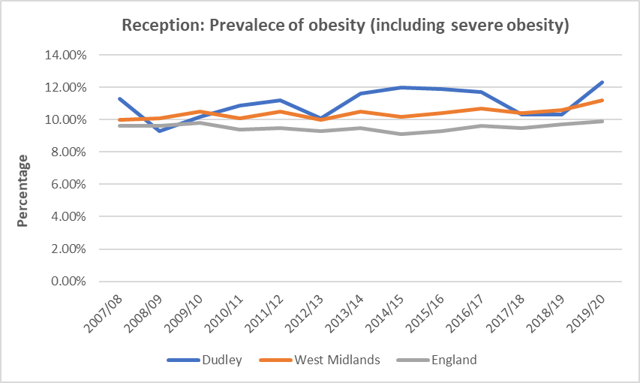

Key note

***Childhood obesity is an area of concern for Dudley. This has already been identified and is one of the transformation objectives to reduce the rate of obesity and consequent or potential SEND through health education and weight management programmes.***

#### Pre-disposition to SEND – Mental Health

In 2017, one in eight children aged 5 to 19 year olds (12.8%) met the criteria for at least one mental disorder based on a survey sample. The likelihood of having a disorder increased with age: from 9.5% of those aged (5 to 10), to 14.4% of those aged (11 to 16) year olds and 16.9% of young people aged 17 to 19.

Emotional disorders were the most common type of disorder examined in the survey of Mental Health of Children and Young People in England. One in twelve (8.1%) of children 5 to 19 year olds had an emotional disorder compared with 4.6% with a behavioural disorder, 1.6% with hyperactivity.

Emotional disorders have become more common amongst children with the rate going from 4.3% in 1999 and 3.9% in 2004 to 5.8% in 2017. All other types of disorder, such as behavioural, hyperactivity and other less common disorders have remained similar in prevalence since 1999.

One in twelve (8.1%) 5 to 19 year olds had an emotional disorder like anxiety or depression. This was more common in girls (10.0%) than boys (6.2%), and rates increased with age. Prevalence also increased with age: emotional disorders were present in 4.1% of 5 to 10 year olds, 9.0% of 11 to 16 year olds, and 14.9% of 17 to 19 year olds. Nearly one in four (23.9%) girls aged 17 to 19 experienced an emotional disorder[11].

About one in twenty (4.6%) of children and young persons aged 5 to 19 had a behavioural (or ‘conduct’) disorder with slightly more boys (5.8%) than girls (3.4%). About one in sixty (1.6%) of the same population had a hyperactivity disorder and about one in fifty (2.1%) were identified with other type of disorder, such as an eating disorder or autism.

Children living in families that struggle to function well are more likely to have a mental disorder than those from healthy functioning families, new analysis has shown. Some research on children aged 2 to 16 years, living in England found higher rates of mental disorders across all ages in those who lived in families that struggled to function well (unhealthy functioning)[12]. It showed that parental mental health was also a key factor in understanding the mental health of children, even when taking other factors such as household income and ethnicity into account.

Children with general poor health, special educational needs, or children with a parent with poor mental health or in receipt of a disability-related benefit, were more likely to have a mental disorder than other children. One in eight (12.8%) of children and young people aged between 5 and 19, surveyed in England in 2017, had a mental disorder according to a research undertaken by NHS digital in 2017[13]. Children of parents who had poor mental health or who had difficulties with their own mental health were more likely to have a mental disorder, when compared with children of parents who did not show signs of a common mental disorder. Children whose parents receive welfare benefits were more likely to experience a mental disorder as well as those from unhealthy families.

Mental disorders tended to be more common in children living in lower income households. This was evident for emotional, behavioural and autism spectrum disorders, but not for hyperactivity or eating disorders. Disorder rates tended to be higher in children whose parents were in receipt of low income benefits. Neighbourhood deprivation, however, was not associated with most types of disorder.

This needs assessment has also reviewed other additional factors which are linked to higher rates of mental health in children and young people. Children aged 2 to 10 years old living with step-siblings showed around double the rates of mental disorder, than those who did not live with step-siblings. But this higher rate could be associated with problems that may be related to family break-ups, such as divorce, moving house or changing schools.

England hospital statistics for 2014 recorded that there were 41,921 hospitalisations for self-harm in young people aged 10–24. Based on these rates, the prevalence for young people under 25 is estimated at 367 per 100,000 population in England – an increase from 330 per 100,000 population estimated in 2007–08.

School aged children (aged 5 to 16 years) from lone parent families experience greater rates of mental disorder, compared with those who live with married parents. This was most noticeable in secondary school aged children (11 to 16 years) of single lone parents (who have never been married)[14].

#### Pre-disposition to SEND - Low birth weight

Low birth weight (LBW) babies have a higher chance of infant mortality, morbidity and impaired cognitive development, alongside other health issues, compared with babies of normal birth weight. The children may suffer from low body weight which may cause physical or psychological delays in their developments. It can also lead to poorer health in later life, and is associated with increased risk of coronary heart disease, chronic kidney disease and diabetes in adulthood.

A high proportion of low birth weight babies are primarily related to poorer antenatal maternal health at population level. This can also be influenced to lifestyle choices of the mothers, such as smoking, drug and alcohol use during pregnancy, maternal health including pre-eclampsia, high blood pressure and nutrition, socio-economic position, pre mature births or multiple births which often times have lower birth weight than singleton births.

Smoking during pregnancy can cause serious pregnancy-related health problems. These include complications during labour and an increased risk of miscarriage, premature birth, low birth-weight and sudden unexpected death in infancy. Slightly fewer mothers are reported to smoke in Dudley (11.3%) at delivery compared with the West Midland (12.1%) average however the percentage is slightly higher (although not statistically significantly) than the England average, 10.4% (2019/20 PHE). Effective maternity services commissioned by the CCG can identify and address such issues within pregnancy. This also will include referral by maternity services to other relevant or third party organisations such as those supporting smoking cessation.

Even where the relevant service is not commissioned by a CCG, for example, smoking cessation, the identification and referral of women with a need for such support falls within the role of maternity services commissioned by CCGs.  
  
Public health policies which target maternal health, including socioeconomic factors and those relating to antenatal health care access and quality, will contribute to the reduction in the number of babies born with low birth weights. The World Health Organisation in 2012 set the target to reduce by 30% the number of low birth weight babies (those born under 2,500 grams) by the year 2025.

The Royal College of Paediatrics and Child Health and the NHS both say that underweight babies are more likely to develop some health conditions, such as heart disease or diabetes, in adulthood. The NHS also says that maternity services can identify mothers at risk of having underweight babies, and refer them for help and support.

This indicator is in line with the government's direction for public health on starting well through early intervention and prevention. It has also been included in the Department of Health business plan within the context of addressing issues of premature mortality, avoidable ill-health, and inequalities in health, particularly in relation to child poverty.

There is a strong association between LBW and the deprivation status of the mother. There are also were more live births and stillbirths to mothers resident in the most deprived areas than the least deprived areas. Reducing the number of babies born with low birth weight is therefore important in breaking the inter-generational cycle of health inequality.

Low birth weight is a factor that can affect health outcomes. In 2018, 3.78% of babies born at term in Dudley were with low birth weight, this is above England (2.86%) and West Midlands (3.31%) averages[15]. Rate of low birth weights per 1,000 live births in Dudley is within the top 25% nationally[16].

Table 4: Number of live births with low birth weights

|  |  |  |  |  |  |  |
| --- | --- | --- | --- | --- | --- | --- |
| **NHS Dudley CCG**  **Years** | **Number of live births** | **Live births at 37 weeks+ gestation with stated birth weight (Nos)** | **Live births at 37 weeks+ gestation with low birth weight (Nos)** | **Rate of low birth weights per 1,000 live births** | **Low birth weight Top 25% boundary** | **CCG Rank** |
| **2019** | 3,450 |  |  |  |  |  |
| **2018** | 3,569 | 3,283 | 124 | 37.8 | 31.7 | 17 |
| **2017** | 3,713 | 3,404 | 126 | 37.0 | 30.7 | 16 |
| **2016** | 3,816 | 3,518 | 126 | 35.8 | 30.1 | 18 |
| **2015** | 3,674 | 3,389 | 120 | 35.4 | 31.0 | 23 |
| **2014** | 3,758 |  |  |  |  |  |
| **2013** | 3,853 |  |  |  |  |  |

**Source:** ONS - Number of live births at 37 or over weeks gestation with low birth weight, by Clinical Commissioning Group. Low birthweight is classified as a birthweight of below 2,500g

Low-birth-weight babies often have problems. The baby's tiny body is not as strong as a baby of normal birth weight. He or she may have a harder time eating, gaining weight, and fighting infection. Low-birth-weight babies often have a hard time staying warm because they don't have much fat on their bodies.

Babies that are born premature often have complications. It is sometimes hard to tell if the problems are because they were born early, or because they are so small. In general, the lower the birth weight, the greater the risk for complications. The following are some of the common problems of low-birth-weight babies:

* + Low oxygen levels at birth
  + Difficulty staying warm
  + Difficulty feeding and gaining weight
  + Infection
  + Breathing problems and immature lungs (infant respiratory distress syndrome)
  + Nervous system problems, such as bleeding inside the brain (intraventricular haemorrhage)
  + Digestive problems, such as serious infection of the intestines (necrotizing enterocolitis)
  + Sudden infant death syndrome (SIDS)

Babies with very low birth weight are at risk for long-term complications and disability. Long-term complications may include:

* + Cerebral palsy
  + Blindness
  + Deafness
  + Developmental delay

One factor affecting the neonatal mortality rate is the number of babies born before 24 weeks gestation. ONS latest analysis shows that this number has increased in recent years. ”Taking a closer look at these trends is increasingly relevant for policy-makers and health practitioners in order to monitor progress against the government ambition to halve 2010’s stillbirth and neonatal mortality rates by 2025.”

Key note

***Mothers in Dudley were more likely to have full term babies with lower birth weight. Dudley rate of low birth weights per 1,000 live births is within the top 25% nationally. Likewise Dudley CCG is ranked in the top 20 compared to all local authorities in England. The Clinical Commissioning Groups (CCGs) should review reasons for high rate of full-term live births with a low birth weight and what actions would be taken to address this.***

***Regular prenatal care will help to prevent preterm births and low-birth-weight babies as well as raising awareness of causes of lower birth weight such as diet, smoking, alcohol etc.***

#### Pre-disposition to SEND - Genetic Disorders

It is estimated that 1 child in 25 is affected by a genetic disorder. This means that in the UK, 30,000 babies and children are newly diagnosed each year and more than 2.4 million children and adults are living with a genetic disorder[17]. While individual genetic disorders are rare, it is thought that there are currently more than 6,000 diagnosed disorders and new disorders are being identified regularly.

There are many thousands of different genetic diseases; the most common (Sickle Cell and Cystic Fibrosis) affecting a little over 10,000 people each, the rarest affecting maybe just one family, with maybe only a handful of cases in the whole world. But – together – all these rare diseases affect the lives of more than 3.5 million people. With advancing technologies and understanding about genomics the number of people with an underlying genetic cause for their condition will increase. Paramount to this is the increasing knowledge of the underlying genetic causes of some rare conditions which has enabled identification and to provide vital life-saving treatment for affected newborn babies.

Newborn screening is a long-established practice in the UK, checking newborn babies for potential medical problems or abnormalities at, or shortly after, birth to optimise their care. It incorporates checks for some rare inherited conditions. The national health visiting and maternity care screening programme ensures that all children benefit from new born ante-natal screening. All babies up to but not including their first birthday are eligible for Newborn blood spot (NBS) screening for the 9 conditions where families are offered the five mandated health visitor contacts, with vulnerable families offered more intensive support from health visitors as part of the Healthy Child Programme. Babies who are new to the country or are yet to have a blood spot test are eligible for testing up to a year old.

The NBS screening programme enables early identification, referral and treatment of babies with the following nine rare but serious conditions of which the last 6 conditions are [inherited metabolic diseases](https://www.gov.uk/government/publications/health-professional-handbook-newborn-blood-spot-screening/7-conditions#inherited-metabolic-diseases) (IMDs).

* [sickle cell disease](https://www.gov.uk/government/publications/health-professional-handbook-newborn-blood-spot-screening/7-conditions#sickle-cell-disease) (SCD)
* [cystic fibrosis](https://www.gov.uk/government/publications/health-professional-handbook-newborn-blood-spot-screening/7-conditions#cystic-fibrosis) (CF)
* [congenital hypothyroidism](https://www.gov.uk/government/publications/health-professional-handbook-newborn-blood-spot-screening/7-conditions#congenital-hypothyroidism) (CHT)
* [phenylketonuria](https://www.gov.uk/government/publications/health-professional-handbook-newborn-blood-spot-screening/7-conditions#inherited-metabolic-diseases) (PKU)
* [medium-chain acyl-CoA dehydrogenase deficiency](https://www.gov.uk/government/publications/health-professional-handbook-newborn-blood-spot-screening/7-conditions#inherited-metabolic-diseases) (MCADD)
* [maple syrup urine disease](https://www.gov.uk/government/publications/health-professional-handbook-newborn-blood-spot-screening/7-conditions#inherited-metabolic-diseases) (MSUD)
* [isovaleric acidaemia](https://www.gov.uk/government/publications/health-professional-handbook-newborn-blood-spot-screening/7-conditions#inherited-metabolic-diseases) (IVA)
* [glutaric aciduria type 1](https://www.gov.uk/government/publications/health-professional-handbook-newborn-blood-spot-screening/7-conditions#inherited-metabolic-diseases) (GA1)
* [homocystinuria](https://www.gov.uk/government/publications/health-professional-handbook-newborn-blood-spot-screening/7-conditions#inherited-metabolic-diseases) (HCU)

Some countries have seen a rapid expansion of their newborn screening panels; the US now has a recommended panel of 30 such conditions. The UK’s approach has been more conservative, but in January 2015 Public Health England added testing for four new rare genetic metabolic disorders such as maple syrup urine disease, isovaleric acidaemia, glutaric aciduria type 1; and homocystinuria. The World Health Organisation listed other conditions that are widely screen for and of which most are routinely screened in the UK and some other rear metabolic or genetic conditions[18].

* Alpha-1 Antitrypsin Deficiency (AATD)
* Bleeding and Clotting Disorders
* Cardiomyopathies & Arhythmias
* Down's Syndrome
* Gilbert's Syndrome
* Hereditary Haemochromatosis
* Huntington's Disease
* Patient with High Serum Lipids
* Marfan Syndrome
* Maturity Onset Diabetes of the Young (MODY)
* Muscular Dystrophy
* Neurofibromatosis Type 1 (NF1)
* Autosomal Dominant Polycystic Kidney Disease (ADPKD)
* More Information on Common Genetic Conditions

Without treatment, babies with inherited metabolic diseases can become suddenly and seriously ill. The rare diseases all have different symptoms, depending on which one affects the newborn, the condition may be life threatening or cause severe developmental problems. Most of these conditions can be managed and treated with a diet and in some cases with medicines.

# Local Picture

# Local Authority Profile and SEND

Dudley is a large industrialised market town and administrative centre in the West Midlands region, 6 miles south-east of Wolverhampton and 10.5 miles north-west of Birmingham. Dudley is also popularly known as the capital of the **Black Country** when it gained this name in the mid nineteenth century due to the smoke from the many thousands of ironworking foundries and forges plus also the working of the shallow and 30ft thick coal seams. Despite this industrial past the Black Country has a long association with the arts and literature.

Dudley Borough is the eight largest local authority districts in the West Midlands region based on the size of population. The borough borders Sandwell to the east, the city of Birmingham to the south east, Bromsgrove to the south in Worcestershire, South Staffordshire District to the west and the city of Wolverhampton to the north.

Chart 3: Total resident population (2019) by local authorities in West Midlands

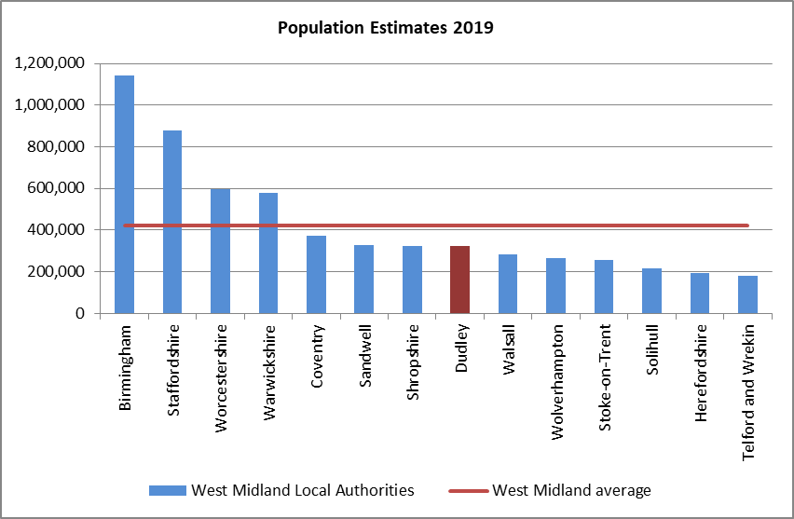

**Source name:**Office for National Statistics - Mid-year estimates 2019

## Total resident population in Dudley

Dudley population has remained relatively stable with slow but steady increases when compared with neighbouring local authorities. The total resident population of Dudley is estimated[19] at 321,597 in 2019 indicating an increase of 2.7% on the 2011 census count. This rate of population growth in Dudley is much slower than West Midlands (5.8%) and England (5.6%) averages over the same period.

Thirty percent of our population (97,400) are between 0 to 25 years old compared to 39.8% of those aged 50 and above. The median age of Dudley resident is 42 years which is above England average of 40 years.

Dudley population is projected to increase by 4% in the next decade whilst West Midlands and England population are estimated to increase by 6% and 5% respectively by year 2028 (*Projected population change for English regions, mid-2018 and mid-2028*).

Over the next 10 years, Dudley population growth will result from slightly more births than deaths. There are fewer international migrations with small internal migration-in (4%) over the ten years period. The number of deaths is projected to rise as those born in the baby boom after World War Two reach older ages and this faster than projected birth rates during the same period.

Chart 4: Dudley population estimates and projections

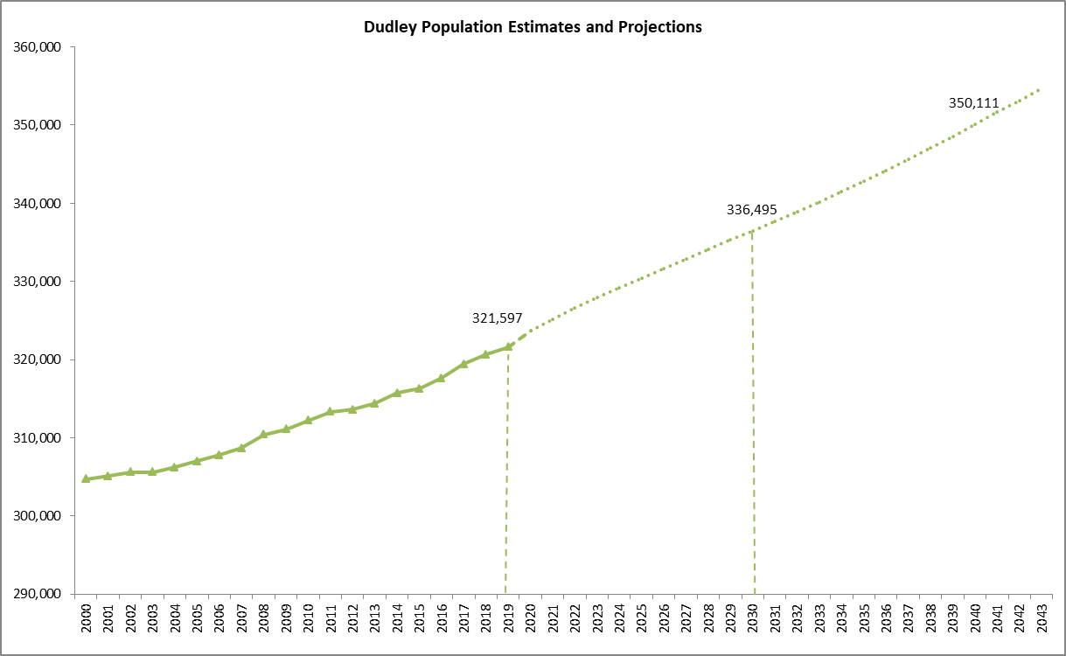

### Children and Young People in Dudley

97,400 children between the ages of 0 to 25 make up 30% of the population of Dudley. This compares with national average of 31% and 32% for the West Midlands indicating that overall Dudley’s population is slightly older.

There are slightly more males aged 0 to 25 than females and account for 51% and 49% of the local populations for their respective genders.

Chart 5: Gender distribution of children and young people ages 0 to 25

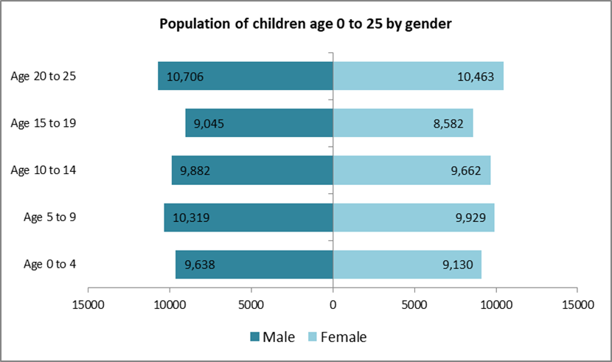

#### Birth rate

The fertility rate of women is slightly higher in Dudley (60.5/1000)[20] when compared with England (57.7) and West Midlands (59.6) averages in 2019. Infant mortality rate in Dudley (4.2 per 1,000 live births)[21] is below West Midland average (5.7) but above national rates of 3.9 per 1,000. Infant mortality rate in Dudley is comparable to the national median of 5.0.

The population of children and young adults aged 0-24 years is predicted to increase by 3.1 % by year 2030 indicating an extra 3,000 in ten years[22]. This projected increase is slightly faster than national rate for the same age group at 2% but below West Midland average of 4%. With this slight population increase, we expect increase in demand for all children services including services for children and young people with SEND.

Around 3,500 children are born each year in Dudley and this is projected to increase by 4% in the next decade indicating additional 150 children in total being born over the next decade.

In Dudley, the General Fertility Rate (GFR), this being the number of live births per 1,000 female population aged 15 to 44 is reducing along with most areas England. The rate of decline is slightly below the average rate for West Midlands but above national rate.

Chart 6: Live birth rates - trend

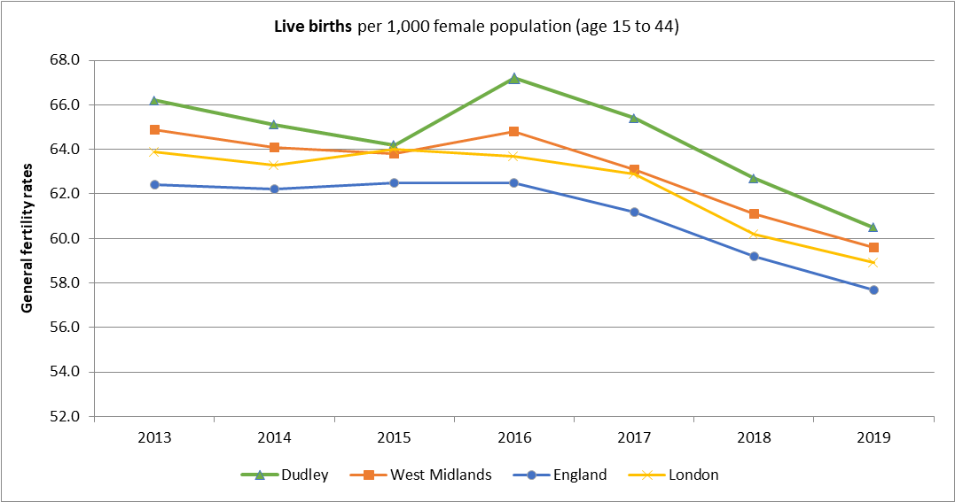

In 2019, the average number of live births measured as Total Fertility Rate (TFR) in England and Wales fell to 1.65 children per woman, a 2.9% decrease from 2018. TFRs have been decreasing year on year since 2013. The rate in Dudley is also reducing and is just above the lowest quarter of all local authorities in England. The average number of live births in Dudley has reduced from 2.00 children reported at the peak in 2013 to 1.76 at the end of 2019[23].

The trend suggests that women are progressively delaying childbearing to older ages and may be as a result of increasing participation of women in higher education, delaying marriage or partnership formation and focus on developing career before starting a family.

Other reasons for decrease in fertility rates include improved access to contraception, reduction in infant mortality resulting in women having fewer babies or lower levels of fertility or difficulties conceiving due to postponement in childbearing. Uncertainties in the labour market and threat of unemployment are also factors influencing fertility rates.

Chart 7: Total fertility rates - trend

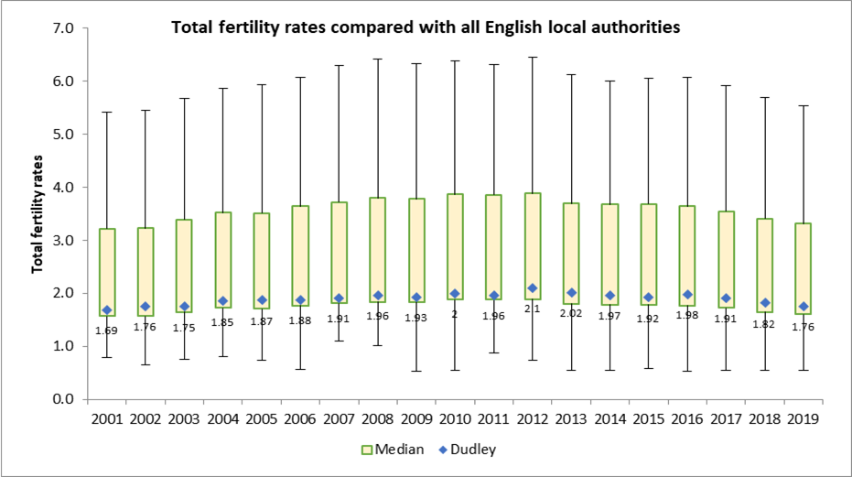

Key note

***Although there is a decline of birth rates in Dudley; birth rate and internal migration are the two main factors highlighted by the office of national statistics to contribute towards population growth in by 2030.***

#### Ethnicity

Nine in ten of Dudley residents are of white heritage. This is a very different picture when compared to neighbouring local authorities such as Birmingham with almost 40% of the population identified as Black, Asian and Minority ethnic. The proportion identified as White-British is also above national level of 79%.

Table 5: Dudley ethnic distribution – 2011 national census



The ethnic profile and distribution is however changing with the younger population in Dudley. In 2010, the proportion of children ages 0 to 24 from minority ethnic background account for 16% of the population. By comparison, the proportion of children from Black, Asian and minority ethnic background (BAME) i.e. excluding White British has increased steadily in the last five years. 27% of pupils in the last school census were from BAME heritage. Pupils from Asian Pakistani background is the largest of these groups at 7.5% in 2020.

Table 6: School children ethnic distribution – 2020 school census



#### Seventy-four percent of the children and young people for whom DMBC maintains their EHC plan (SEN2 population) are of White heritage and 9.5% are of Asian heritage. Both are comparable to 2020 school census ethnic breakdown. Deprivation

Deprivation affects all areas of life including health, education, employment and participation. There has been slowdown[24] of improvements in life expectancy with increase mortality in recent years compared with 2011. Review by the Department of Health and Social Care and Public Health England found that improvements in life expectancy had slowed in most areas of England and among all socio-economic groups, but the slowdown was greater among the most deprived groups and inequalities had widened. The slowing down of mortality improvements among people aged 50 years and over played a significant role.

Deprivation in an area is reported using the Index of Multiple Deprivation (IMD). This is a measure of relative deprivation based on weighted average of the seven IMD domains: Income Deprivation, Employment Deprivation, Health and Disability Deprivation, Education Skills and Training Deprivation, Barriers to Housing and Services, Living Environment Deprivation, and Crime[25].

The more deprived is an area, the higher the IMD score but the lower the rank. Dudley Metropolitan Borough Council is ranked 8th least deprived within the West Midland area. 11% of Dudley population reside in the 10% most deprived lower layer super output areas (LSOAs) in England . This is in line with national distribution but much lower than that of neighbouring borough of Birmingham that stands at 41%.

Source: Ministry of Housing, Communities & Local Government - Indices of deprivation. The map overleaf shows deprivation by Lower-layer Super Output Areas (LSOAs) in Dudley and proportionate distribution by national deciles rank; the darkest shading being the most deprived and lightest being the least deprived. LSOAs are small areas designed to be of a similar population size, with an average of approximately 1,500 residents or 650 households. There are 32,844 Lower-layer Super Output Areas (LSOAs) in England. The deciles are calculated by ranking the 32,844 LSOAs in England from most deprived to least deprived and dividing them into 10 equal groups.

Twenty-two lower layer super output areas (out of 201) in Dudley are within the 10% most deprived localities nationally and another 30 are within the 20% most deprived in England. Ten electoral wards have at least one LSOA identified as within the 10% most deprived areas in England and four have over 30% of their LSOAs amongst the most deprived; these are Castle and Priory (44%), St Thomas's (44%), Brockmoor and Pensnett (38%), Netherton, Woodside and St Andrews (33%)

Children identified as having SEND are more likely to experience poverty and have lower educational outcomes. Dudley electoral wards with higher proportion of pupils resident in the most deprived areas are shown to have more children with SEND (LA maintained and School Census).

#### Children in absolute low income families

In 2019, 11,782 children under age 16 are living in absolute low income families in Dudley, (19%) above the England average of 15.3%. The proportion of children living in relative low income families (23.8%) is also above 2019 England average of 18.4%.

Low income family is a family whose equivalised income is below 60 per cent of median household incomes nationally after adjustments for housing costs, household size and composition. Absolute low income is income in the reference year in comparison with baseline incomes in 2010/11 adjusted for inflation. A family must have claimed one or more of Universal Credit, Tax Credits or Housing Benefit at any point in the referenced year to be classed as low income in these statistics.  
  
Children are dependent individuals aged under 16; or aged 16 to 19 in full-time non-advanced education. The count of children refers to the age of the child on the 31st March of each year (Department for Work and Pensions).  
  
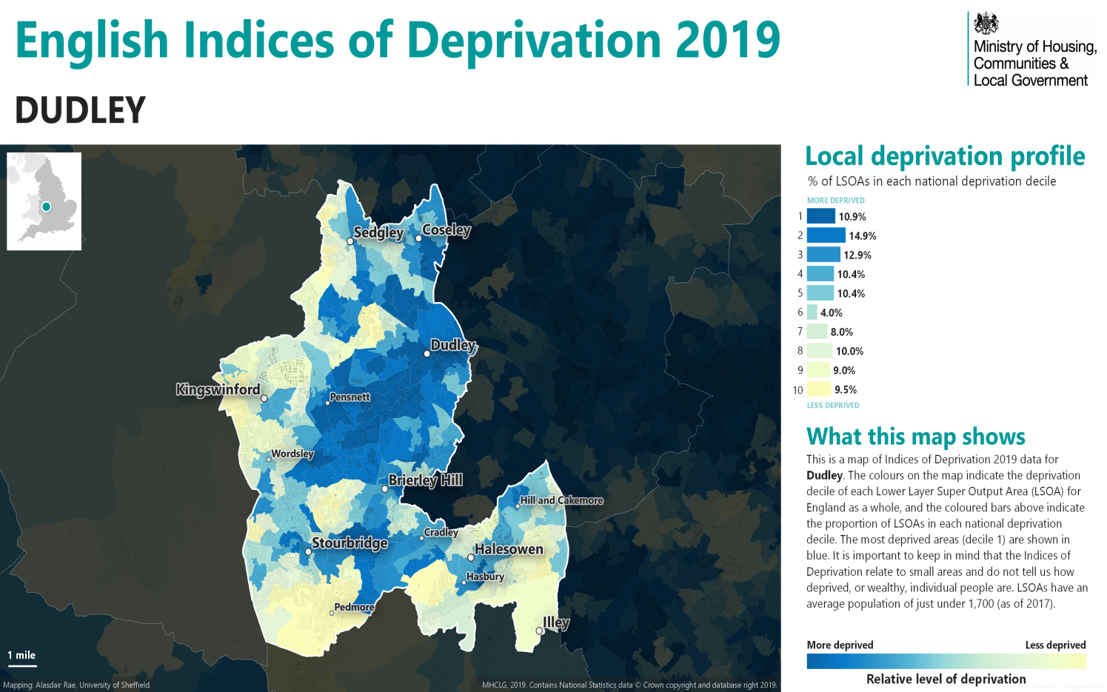

Prevalence of SEND - Disability in Dudley

Long-term illness is a strong predictor of higher use of health service resources. This information is used by central government for resource allocation and for local government service provision. It enables public bodies to meet statutory requirements, develop and monitor policies to allocate health funding and services at a national and local level.

It is also known that special educational needs and/or children with complex disabilities are surviving a lot longer and as such need specialist treatment for longer. The number of children with complex needs has increased over the last decade due to advancements in medicine and medical technologies. These have increased the survival rates of pre-term babies, those with severe illnesses as well as increasing life expectancy for children with complex disabilities.

The statistics generated are used to develop and monitor equality policy. These policies relate especially to the delivery of health care, assessment of progress towards better population health, and the reduction of health inequalities. Statistics on disability are also useful for devising policies to improve access to services, such as adult education and leisure facilities. This information is used to plan services and target resources, and allows public authorities to assess and tackle discrimination.

There are several methods to estimate the number of children with SEND. These include children with a limiting long term illness (Census 2011), CCG data on children with disability registered with general practitioners within Dudley, pupils with special educational needs (SEN Support), and those with Education Health and Care Plans (EHCP).

## Disability resulting in limited daily activities

In 2011 there were 4,318 children and young people (aged 0-24 years) with long-term health problem or disability which limits their daily activities. The rate of prevalence (4.6%) is slightly higher than national (4.5%) and West Midland (4.4%) averages.

Although there is no single reliable source of prevalence for children and young people with SEND, the proxy data used (Census 2011) indicates that the prevalence in Dudley is higher than that of benchmark groups. Please note that this data is a decade old and the local profile has most likely changed considerably. In addition, mild to moderate disability is based on self-identification resulting in under estimation of the actual numbers with disability.

Chart 9: % of children and young people living with disability by age group - 2011

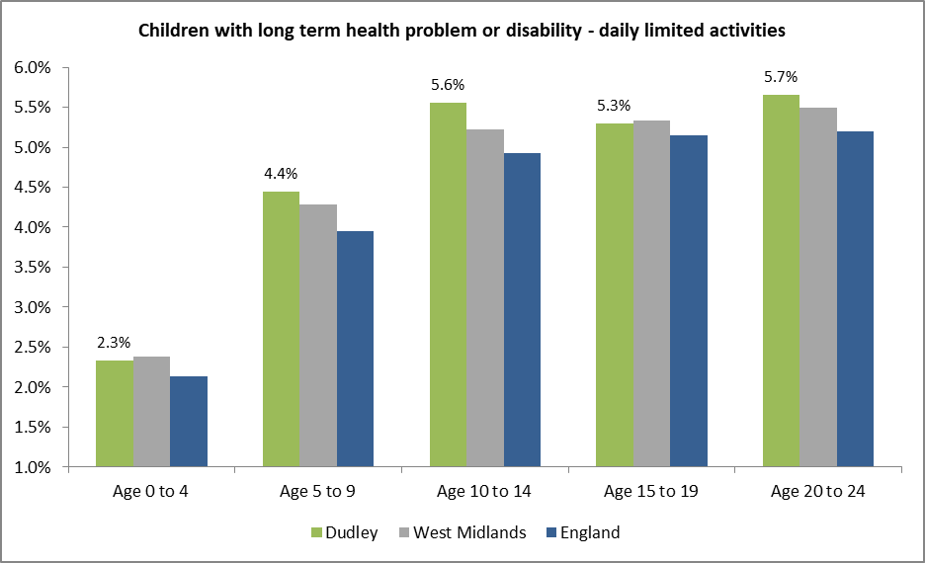

### Disability - Age and Gender breakdown

The proportion of the population with their day to day activities limited by disability is slightly higher in Dudley compared with national average. Noteworthy is the change is distribution with age and gender; for children aged 0-24, more males (5.5%) have long term health conditions or disability compared with females (3.8%). This then changes with age where proportion of older females (28%) with longer term health condition is slightly above that of males (24.4%).

Males were more likely to have disabilities that have impact on their daily living activities (census 2011)

Table 7: Children and young people living with disability



**Source:** Census 2011

Chart 10: % of children and young people living with disability by gender in Dudley - 2011

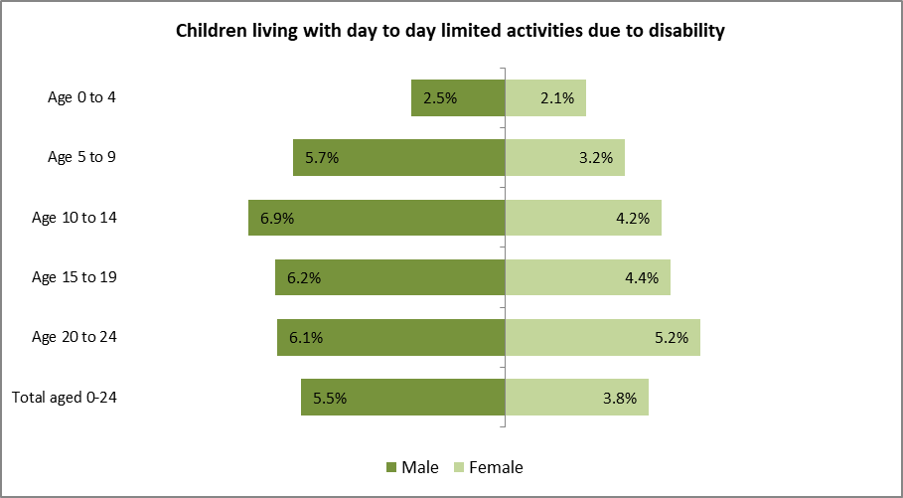

Not all children with disabilities have SEND, however there is strong correlation between these two factors and considering the impact on school attendance etc.

About 9,000 children and young people up to the age of 25 in Dudley (residents only) are known to their General Practitioners (GP) to have a disability, representing 7.6% of the population. Note, however that this part of the report does not include Dudley residents that are registered with GPs outside of Dudley CCG boundary.

One in six of children and young people identified above have multiple disabilities and of which 321 (3.6%) have 3 or more types of disabilities.

### Type of disabilities

Behavioural disabilities accounts for 46% of needs and of which seven in ten are males. This proportionate distribution is in line with 2019 national survey carried out by the Department for Work and Pensions reporting that reported 40% of disabilities amongst children and young people up to age 25are due to social and behavioural difficulties.

One in two of children and young people with behavioural difficulties are between the ages of 5 and 15. This rate is comparable to proportion of school children identified as having social, emotional and mental health needs *(SEN2 September register (synergy).*

A survey of mental health of children and young people in England 2017 found that one in twelve (8.1%) of children 5 to 19 year olds had an emotional disorder compared with 4.6% with a behavioural disorder, 1.6% with hyperactivity. Although the numbers of CYP with SEMH are not the largest group amongst school children in Dudley; the group has increased the fastest in two years. Parental mental health has been found to be a key factor in understanding the mental health of children, even when taking other factors such as deprivation, household income and ethnicity into account[26]. The number of parents/carers with mental health concerns at the time of children in need statutory assessment has increased slight.

**Table 8: Children and young people living with disability**

|  |  |  |  |  |
| --- | --- | --- | --- | --- |
| Distribution by gender | Female | Male | % Share | Number |
| Behavioural | 29% | 71% | 46% | 4,085 |
| Sensory | 48% | 52% | 32% | 2,900 |
| Developmental | 23% | 77% | 15% | 1,326 |
| Physical | 45% | 55% | 4% | 388 |
| Learning | 29% | 71% | 3% | 256 |
| Total disability (%) | 35% | 65% | - | 8,955 |
| Number | 3,145 | 5,810 | 8,955 | - |

**Source:** EMIS Web (Dudley CCG), Note that that includes those with multiple needs.

The number of statutory children assessments at which parent mental health is identified as a factor at the end of assessment increased nationally by 15%. The local pattern is not as dramatic with a modest increase of 2% to 286. However, the increase to last year was more significant at 35%. Overall, 21% of assessments identified family mental health as a concern (child, parent and others) in Dudley[27].

The unprecedented Covid-19 pandemic with increasing anxieties around health, income and mental health concerns are yet demonstrated in the data. It is estimated that the population of those with behavioural and mental health problems are more likely to double. The local authority, CCG and partners need to make provisions to meet these growing needs.

In Dudley, a total of 260 hospital admissions as a result of self-harm were coded 2019 for children and young people age 10 to 24 years (*Hospital Episode Statistics (HES))*. This is increase of 11 CYP on previous year with a rate of 480 admissions per 100,000 residents. Dudley’s rate for this measure is above England (444) and West Midland (467) averages.

Key note

***The current unprecedented Covid-19 pandemic compounded by increasing anxieties about income and mental health concerns is certain to increase the demand for support for families including children and young people. There are some services already available; however, the local authority, CCG and partners need to plan for increased capacity to meet these growing needs.***

Sensory needsare the 2nd most identified needs on GP medical records. This was rather surprising and the data has been rechecked again for confirmation. Those with hearing impairment account for 96% of this group and of which 76% (2,114) is as a result of hearing loss. 393 children and young people have deafness recorded (14%) of hearing impairment group but 4.4% of all reported disability.

Only 123 children and young people are recorded to have visual impairment representing 1.4% of total reported disability of 0-25 year olds resident in Dudley.

Developmental disability which comprises of those identified as having Autistic Spectrum Disorder (82%) and Asperger's syndrome account for 21% of all disability types amongst people aged the under 25[28]. As with behavioural problems; significantly more boys than girls have developmental needs. Interestingly, young people aged 20-25 are the largest group (32%) living with this disability. This demonstrated that CCG data is fully complimenting school and local register data, filling the data gaps.

Local SEN2 register shows that ASD needs are ranked 4th amongst school population and of which two in ten are aged 11 to 15 with two in twelve being between the ages of 20 and 25.

Autism spectrum disorder (ASD) is defined as a developmental disability[29]. Though it can cause significant social, communication and behavioural challenges, it is not a learning disability. People with ASD may communicate, interact, behave, and learn in ways that are different from most other people. The learning, thinking, and problem-solving abilities of people with ASD can range from gifted to being severely challenged. Some people with ASD need a lot of help in their daily lives, others need less.

A diagnosis of ASD now includes several conditions that used to be diagnosed separately: autistic disorder, pervasive developmental disorder not otherwise specified (PDD-NOS), and Asperger syndrome. These conditions are now all called Autism Spectrum Disorder.

Chart 11: Children and young people age 25 and under with disability

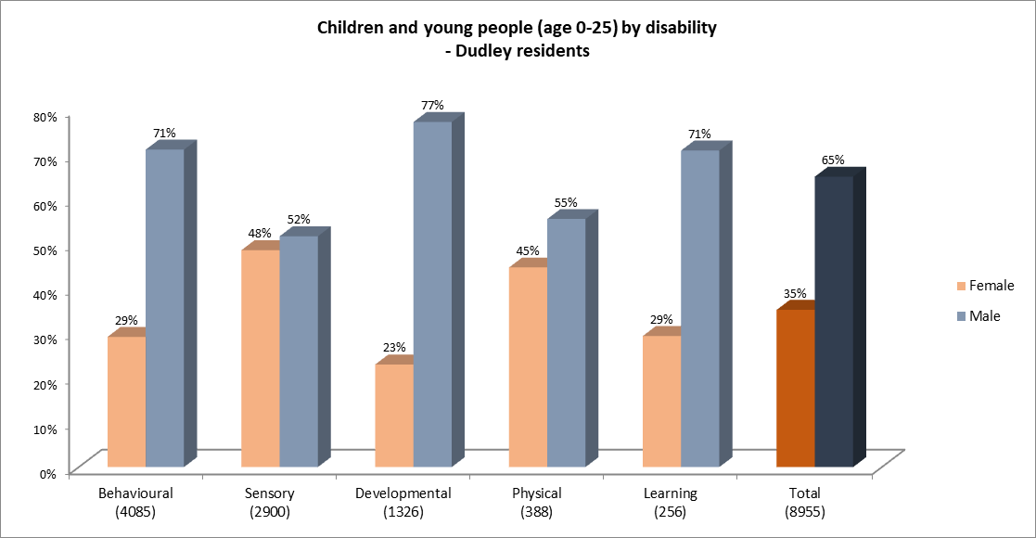

Data includes those with multiple needs

Physical disability is the 4th largest group know to General Practitioners. There are no significant gender differences when compared with other need. Young people aged 20 to 25 appear to be very slightly over represented.

Learning disability is documented for only a 256 children and young people. However, it has been well researched and documented the interrelationships between some developmental needs, social, behavioural and mental disabilities on learning disability.

Table 9: Broad disability types by age group

|  |  |  |  |  |  |  |
| --- | --- | --- | --- | --- | --- | --- |
| **Distribution by age group** | **Under 5** | **Age 5 to 10** | **Age 11 to 15** | **Age 16 to 19** | **Age 20 to 25** | **Total** |
| Behavioural | 2.3% | 25.7% | 26.8% | 21.0% | 24.2% | 4,085 |
| Sensory | 2.0% | 20.0% | 25.5% | 22.1% | 30.4% | 2,900 |
| Developmental | 2.3% | 22.9% | 21.7% | 20.4% | 32.7% | 1,326 |
| Physical | 0.5% | 23.2% | 26.3% | 21.6% | 28.4% | 388 |
| Learning | 0.0% | 14.5% | 19.5% | 26.6% | 39.5% | 256 |
| Grand Total | 2.1% | 23.0% | 25.4% | 21.5% | 28.1% | 8,955 |
| **Total** | **184** | **2,061** | **2,275** | **1,922** | **2,513** | **8,955** |

Caution - data includes multiple disability records

### Disability by electoral wards

There is a strong correlation between disability and deprivation. Four electoral wards have more than 30% of the lower layer super output areas amongst the most deprived 10% LSOAs in England. These wards also have more shares of children and young people with disability. Behavioural and mental health disability distribution demonstrates relationship with deprivation for some areas.

Table 10: Broad disability types by electoral wards

|  |  |  |  |  |  |  |  |  |
| --- | --- | --- | --- | --- | --- | --- | --- | --- |
| **Dudley Ward** | **Behavioural** | **Sensory** | **Develop-mental** | **Physical** | **Learning** | **Total** | **% share** | **% of LSOA in 10% most deprived** |
| Brockmoor and Pensnett | 56% | 27% | 12% | 2% | 3% | 632 | 7% | 38% |
| St Thomas's | 37% | 23% | 13% | 24% | 3% | 593 | 7% | 44% |
| Castle and Priory | 52% | 22% | 14% | 7% | 4% | 588 | 7% | 44% |
| Brierley Hill | 56% | 31% | 9% | 3% | 1% | 551 | 6% | 25% |
| Netherton, Woodside and St Andrews | 50% | 33% | 11% | 3% | 2% | 444 | 5% | 33% |
| Quarry Bank and Dudley Wood | 49% | 29% | 15% | 4% | 3% | 440 | 5% | 13% |
| Belle Vale | 44% | 37% | 14% | 2% | 3% | 431 | 5% | 13% |
| Hayley Green and Cradley South | 42% | 42% | 13% | 2% | 2% | 420 | 5% | 0% |
| Amblecote | 46% | 31% | 19% | 2% | 2% | 411 | 5% | 0% |
| Wordsley | 45% | 33% | 16% | 3% | 3% | 405 | 5% | 0% |
| St James's | 53% | 24% | 16% | 4% | 2% | 403 | 5% | 25% |
| Lye and Stourbridge North | 46% | 33% | 16% | 3% | 2% | 366 | 4% | 13% |
| Kingswinford South | 45% | 37% | 12% | 3% | 4% | 366 | 4% | 0% |
| Gornal | 38% | 42% | 13% | 3% | 3% | 356 | 4% | 0% |
| Kingswinford North and Wall Heath | 37% | 44% | 14% | 3% | 2% | 353 | 4% | 0% |
| Cradley and Wollescote | 49% | 30% | 15% | 4% | 2% | 347 | 4% | 0% |
| Pedmore and Stourbridge East | 43% | 33% | 17% | 5% | 2% | 301 | 3% | 0% |
| Wollaston and Stourbridge Town | 31% | 41% | 23% | 1% | 3% | 258 | 3% | 0% |
| Norton | 33% | 38% | 21% | 2% | 5% | 256 | 3% | 0% |
| Halesowen North | 42% | 38% | 14% | 2% | 4% | 221 | 2% | 0% |
| Sedgley | 41% | 31% | 22% | 2% | 4% | 209 | 2% | 0% |
| Coseley East | 53% | 25% | 18% | 0% | 4% | 203 | 2% | 13% |
| Halesowen South | 36% | 48% | 14% | 1% | 1% | 201 | 2% | 0% |
| Upper Gornal and Woodsetton | 44% | 29% | 23% | 2% | 4% | 200 | 2% | 0% |
| Outborough | 39% | 38% | 16% | 5% | 2% | 608 | 6.8% | - |
| **LA Total (%)** | **46%** | **32%** | **15%** | **4%** | **3%** | **8,955** | **-** | **11%** |
| **LA Total (No)** | 4,085 | 2,900 | 1,326 | 388 | 256 | 8,955 | 0 | - |

**Data source** – LA case management system and school census (2020), some children have multiple addresses

|  |  |
| --- | --- |
|  | Electoral wards with top 20 percentage share of disability types as well as most deprived areas. |

**Source:** EMIS Web (Dudley CCG)

Key note

***Local CCG data showed that eight in ten of children and young people on GP register and resident in Dudley are known to have needs have behavioural difficulties. This will be a joint area concern for the partnership.***

# What do we know locally about children with SEND

In 2020, a total of 16 children age 2 years old have EHC plan or are receiving SEN support and 566 children aged 3 & 4 year olds were also identified to have SEND. There are **8,380** pupils with special educational needs or disability attending Dudley schools, representing 17.3% of the school population. 1,659 children (in Dudley schools) have statutory Education, Health and Care Plan 3.5%.

The local authority maintains statutory Education, Health and Care Plan (EHCP) for **2,340** children and young people aged 0-25 years (SEN2, March 2020). Trend analysis for EHCPs maintained by the authority showed that there has been a significant increase (66%) in the number of children and young people with an EHCP in the last 4 years, however EHCPs are relatively new and the historic equivalent, a Statement, is not directly comparable. There has been a year on year average increase of 16% and the number of plans has increased to **2,645** by the end of September 2020 and is set to increase until the new SEND strategy has been fully embedded with associated change in attitudes. There are significantly more boys than girls with EHCPs and SEN support. Seven in ten of school children with SEN in this cohort are boys.

Young adults aged 16-19 are the fastest growing group averaging a year on year increase of 36% and account of 20% of total number of children and young persons with EHCPs. Some of the increase in the number of plans maintained by Dudley local authority can be attributed to the changed SEND code of practice to include young adults aged 20 and above. The rate of increase of this group is doubling year on year though the volume is low.

The prevalence of pupils with an EHCP in Dudley schools is 3.5% (e*xcluding independent schools)*. This is significantly higher than the national figure of 3.3% and 3.3% average for all local authorities in West Midlands. The proportion of pupils with EHCPs ranges from 1.3% to 5.5% across all English authorities.

#### Early Years

Early years education plays a pivotal role identifying SEN and preparing children who have SEND to be ready for school, further education and extra-curricular achievements.

All children benefit from newborn ante-natal screening with health visiting picking up blood spot tests for newborns. The tests identify nine conditions at a very early stage. At the two-year check, children seen receive an Ages and Stages Questionnaire (ASQ) assessment for child development. Children with suspected development delay then receive an ASQ SE2 assessment to assess further development needs and onward referrals to specialist services.

Providing early years support for children as early as possible helps to support their school readiness and narrowing of impact caused by disadvantage. 2-year-old children can access funded early years education if they are believed to meet the benefit, tax or universal credit eligibility criteria. The Department for Work and Pensions provides regular updates to the DfE on the number of eligible children and this is currently the best data available.

In Dudley, 72% of eligible 2-year old children benefitted from some funded early education in 2020. This is better than national (69%) and West Midlands (67%) averages. 94% of 3- and 4-year-old children in Dudley benefited from some funded early education and this is in line with national and West Midland averages[30].

2-year olds**:** In 2020, there were 1,066 eligible children aged 2 that benefited from funded early education in Dudley indicating 72% of the eligible population. This is an increase from the previous year and better than England (69%) and West Midland (67%) averages). None of the 2-year olds had an EHCP and 16 were receiving SEN support (1.5%). In Dudley the proportion of 2-year olds with SEND in Dudley is below that of benchmark groups West Midlands (3.1%) and England (2.9%) averages.

In 2020, almost all 2-year olds benefitting from funded early years education was because of economic disadvantage (97%). 3% (32) were as a result of being looked after or had left care.

3- & 4-year olds**:** In 2020, 7,228 children aged 3 and 4 were benefitting from funded early education, of these, 88 had an EHCP (1.2%) and 478 were receiving SEN support (6.6%). The proportion of 3 and 4 year olds with SEND in Dudley has been running above that of the benchmark groups in recent years and is beginning to plateau to a level of (7.8%) that is comparable to 2020 averages for West Midland (7.5%) and England (6.6%).

Although the proportion of children in early years with SEND is higher in comparison with benchmark groups, the actual number of children has dropped in the last 3 years. The majority of early year’s children with SEND are aged 3 to 4 years old.

Chart 12: Number and proportion of 2 to 4 year olds with SEND

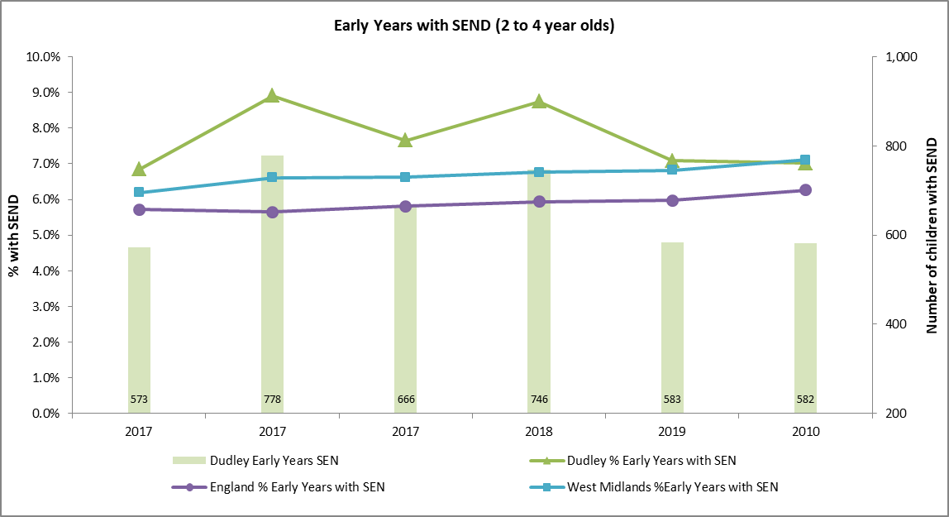

**Key note**

***Proportion of early years with SEND is high in Dudley compared with benchmark groups. There has been considerable work done with the early years team improve joint understanding of process and clarity of when to make referrals for assessment.***

Six funding streams make up the early years block of the Dedicated Schools Grant (DSG). They are:

* + Early years entitlement for disadvantaged two year olds
  + Early years universal entitlement for three and four year olds
  + Early years additional entitlement for three and four year old children of eligible working parents
  + Maintained Nursery School supplementary funding Schools (MNS)
  + Early Years Pupil Premium (EYPP)
  + Disability Access Fund (DAF)

#### Early Years Pupil Premium

The Early Years Pupil Premium (EYPP) gives schools and early years providers additional funding to support disadvantaged three and four-year-old pupils. Early year’s pupil premium applies only to 3 and 4-year-old children benefitting from the universal early education entitlement and this may not translate to pupil premium when they start compulsory education. In 2020, the number of three and four-year-old children accessing EYPP was 527 (49%) of the eligible population of 1072, which is an approximate number provided by DWP and has not changed since EYPP was introduced in 2018. In order to receive early year’s pupil premium parents must alert the provider that they meet the eligibility criteria which includes local authority care experience (current or post), economic factors such as benefit, tax or universal credit and receive the universal 15 hours entitlement.

# Special Educational Needs – Dudley Schools

There are **48,282** children on roll in Dudley schools (School Census 2020 as collected from all maintained nursery, primary, secondary, middle academies, free and special schools). Then number of pupils on roll increased marginally from 47,217 in 2015 to 48,282 in 2020. However, the total school population in Dudley has remained relatively stable in recent years. The rate of increase in Dudley (1.2%) is much slower than national (3.9%) and West Midlands (4.3%) averages.

It is noteworthy that the number of pupils now attending independent schools in Dudley increased by 48% over the last five years whilst the number reduced nationally by 1.1%. The number in Pupil Referral units grew by 9% in Dudley compared with 3.0% and 1.0% for England and West Midlands respectively. The rate of increase of primary and secondary school aged pupils has reduced significantly in Dudley when compared with benchmark groups and is reflected in the overall population growth.

In Dudley there are currently **8,292** (17.2%) children on maintained schools with SEND. Of those children with SEND; **6,633** (13.7%) qualify for SEN support and **1,659** (3.5%) have an Education, Health and Care Plan (EHCP).

The proportion of pupils on roll with SEND is above West Midlands average of 16.2% and 15.4% in England. The proportion of SEND that qualifies for SEN Support is also above benchmark groups, West Midland (12.9%) and England (12.1%). The proportion of children on SEN support ranges from 10.2% to 14.6% for West Midlands local authorities.

The proportion of pupils with EHCPs in Dudley schools is slightly higher than averages for West Midlands (3.3%) and England (3.3%). In the West Midlands, the proportion of pupils with EHCPs ranges from 2.8% to 3.7%. Dudley is ranked 4th highest in the region.

**Key note**

***Children with a disability are over twice as likely to have no formal qualifications as adult. The increasing rate of children with SEND in recent years is causing strain on the system and will not be sustainable in the long term. There is the need to understand the underlying factors, drivers and processes that may inadvertently be contributing to the high numbers in Dudley.***

Chart 13: Prevalence of SEND (EHCP and SEN Support) in Dudley Schools

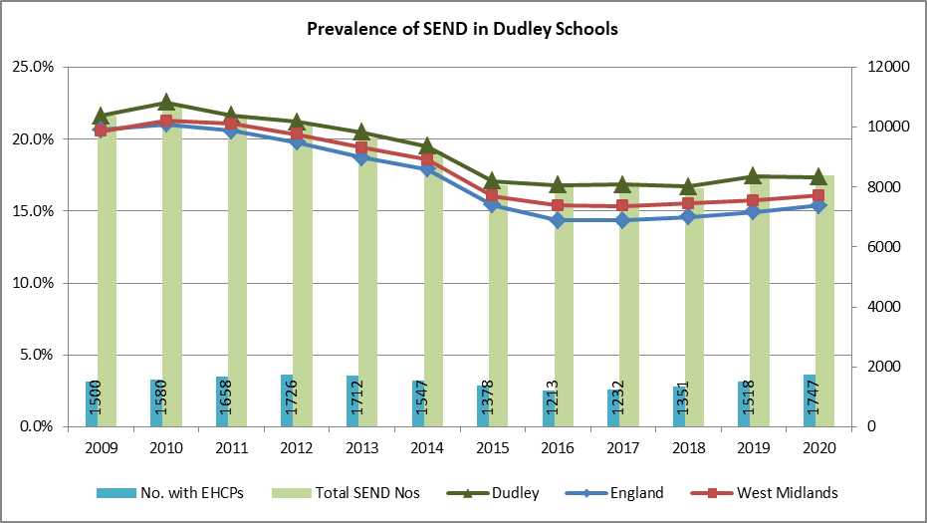

There has been a steady growth in the number of children with SEND in recent years up until last year. This increase is attributable to the numbers of children with EHCPs that has increased by 44% compared to 2016 figures. The rate of children with SEND in Dudley (all schools) continues to run above that of national and West Midland.

Table 11: Proportion of pupils with EHCP in Dudley Schools - Trend

|  |  |  |  |  |  |  |  |  |  |  |
| --- | --- | --- | --- | --- | --- | --- | --- | --- | --- | --- |
|  | EHC plans/Statements of SEN (percent) | | | | | SEN support (percent) | | | | |
|  | 2015/16 | 2016/17 | 2017/18 | 2018/19 | 2019/20 | 2015/16 | 2016/17 | 2017/18 | 2018/19 | 2019/20 |
| Dudley | 2.5% | 2.6% | 2.8% | 3.1% | 3.6% | 14.3% | 14.3% | 13.9% | 14.3% | 13.7% |
| England | 2.8% | 2.8% | 2.9% | 3.1% | 3.3% | 11.6% | 11.6% | 11.7% | 11.9% | 12.1% |
| West Midlands | 2.9% | 3.0% | 3.1% | 3.1% | 3.3% | 12.5% | 12.4% | 12.5% | 12.6% | 12.8% |

**Source**: January school censuses

#### Comparison with Statistical Neighbours

Dudley is ranked 3rd highest for proportion of SEND pupils amongst its statistical neighbours for the proportion of children with education, health and care plans attending Dudley schools. Following the SEND code of practice introduced in 2015; the proportion of children with an EHCP has been steadily increasing and is now above regional average.

This is a group of local authorities (ten) deemed to be most similar to Dudley as produced by the Department of Education. It includes LAs that deemed to be similar to Dudley in terms of socio-economic characteristics. The Statistical Neighbours (SN) include Bolton, Doncaster, Lancashire, Medway, Nottinghamshire, North Lincolnshire, Tameside, Telford and Wrekin, Rotherham and Wigan. Of these, Rotherham and Medway are ranked closest in similarity.

Chart 14: Proportion of pupils with SEND (EHCP and SEN Support) in Dudley Schools - Benchmarked

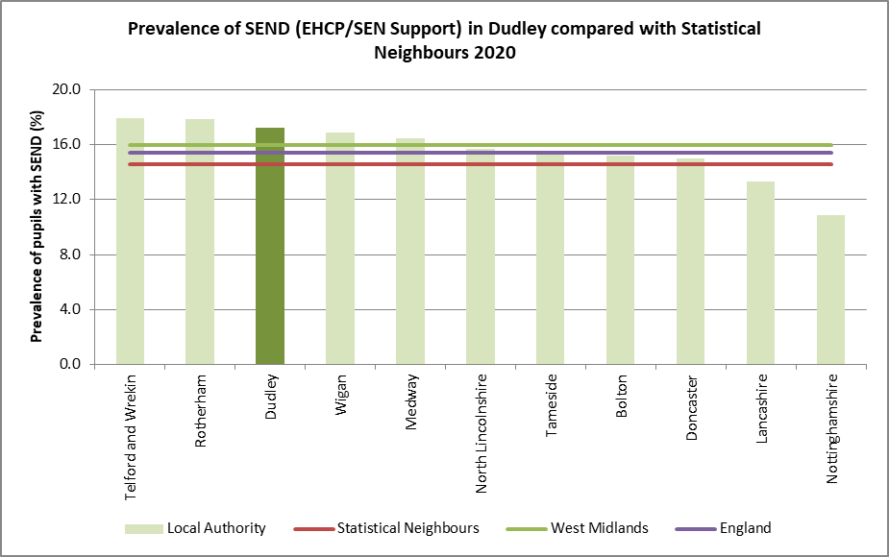

**Key note**

***Although the number and proportion of children and young people with disability are a minority within the population of Dudley, these are increasing year on year. The proportion of SEND pupils in Dudley schools is above national rates in 2020.***

### Incidence of Education, Health and Care Plans (EHCP)

Education, Health and Care Plans (EHCP) were introduced from September 2014 as part of a range of SEND reforms. A pupil has an EHCP when a local authority issues one following a formal assessment. This document sets out the child's needs and the extra help they should receive to support their learning.

The number of young people with an EHCP increased significantly over the five years period by 446 in maintained schools from 1,213 (2.5%) in 2016 to 1,659 (3.5%) in 2020. Note that additional 88 children with EHCPs were attending independent schools as reported at the January 2020 school census. During the same five year period, the national rate of EHCPs had increased by only half a percentage point to 3.32% *(Maintained schools only).* The proportion of children with EHCPs is greater in Dudley than national and West Midland averages.

Chart 15: Prevalence of EHCP in Dudley Schools- Benchmarked

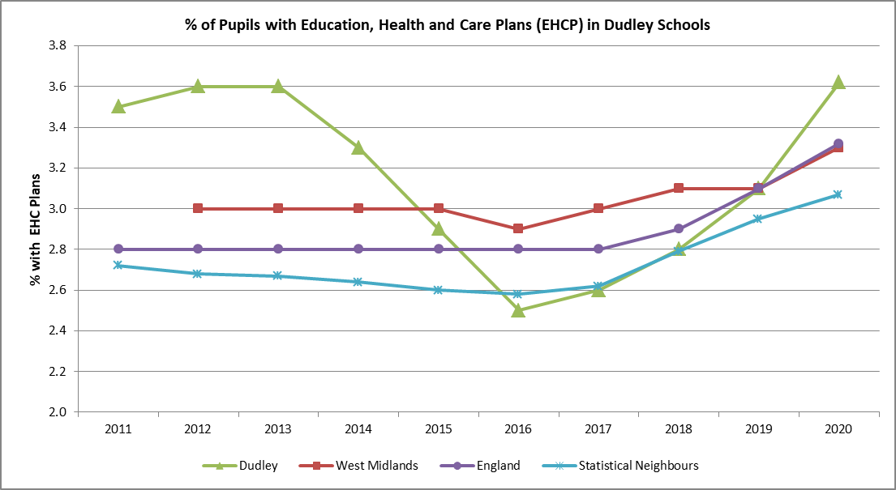

**Source**: January school censuses

The proportion of children with statutory statement of special educational needs or EHCPs in Dudley has generally been higher than national, statistical neighbours and average for local authorities in the West Midlands. The rate dipped in 2016 but has since returned to previous and similar high rates pre 2014 and prior to changes in special educational needs categorisation. Dudley LA is ranked 3rd highest amongst its statistical neighbour for this group of children.

Chart 16: Proportion of pupils EHCP in Dudley Schools - Trend

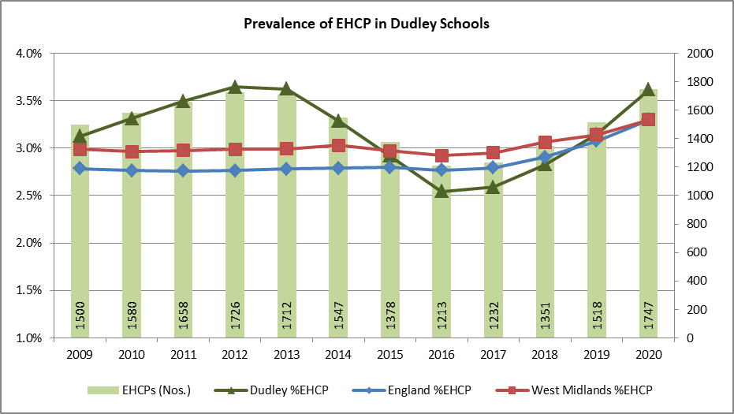

**Source**: January school censuses.

Chart 17: Proportion of pupils with EHCPs in Dudley Schools - Benchmarked

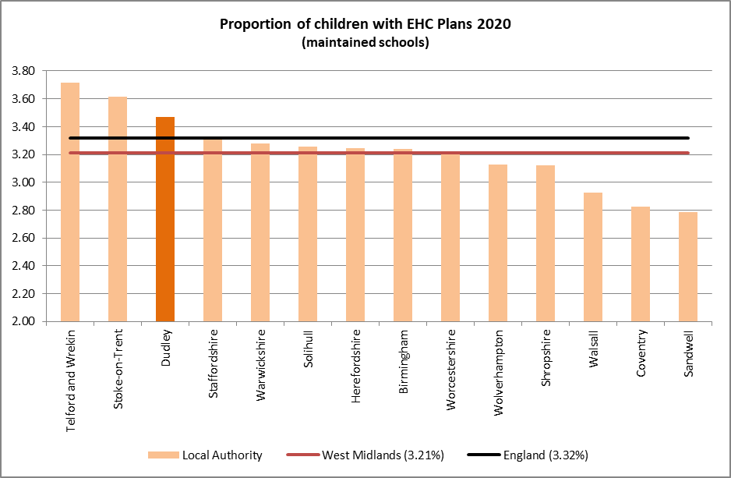  
Source: January school censuses

Key note

***This proportion of children with EHCPs is expected to continue increase when one considers the increasing number of referrals for assessments, the number of new plans being issued and the referral to plan conversion rates that is greater than that of benchmark groups. There is also evidence of increasing number of other contributory factors in Dudley such as children born with low birth weight, mental health issues, childhood obesity and of course the positive impact of healthcare advancement where more children are surviving with more complex needs.***

### Incidence of SEN Support

The number of children eligible for SEN support attending Dudley schools decreased by 175 (-2.6%) between 2016 and 2020 whilst in England and the West Midlands it increased by 8.8% and 6.9% respectively. This is in contrast to the increasing number of children with EHCP plans over the same period. This is reflected by the lower proportion of the school population on SEN support in Dudley when compared with benchmark groups.

Chart 18: Proportion of pupils EHCP in Dudley Schools - Trend

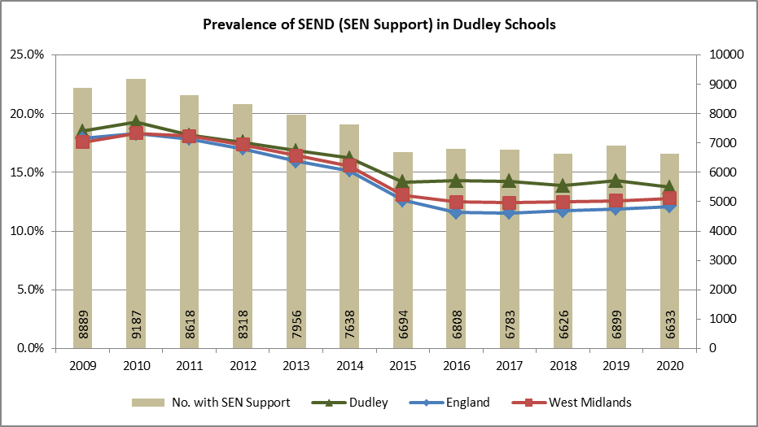

**Source**: January school censuses.

#### Provision by school and settings in Dudley

The number of students attending maintained special schools increased by 17% over the last five years to 889 in 2020 and special schools now cater for 51% of all Dudley MBC responsible children with EHCP. There has been a slow reduction in the proportion of children attending special schools compared with four years ago (62%).

Table 12: Proportion of pupils with EHCP by school settings in Dudley Schools - Trend



Source: January school census, 2020

The number of children attending independent schools in Dudley (special and other) almost doubled in one year and now provide for 5% of all children with an EHCP however this remains below England and West Midland averages. Interestingly, is the fact that bigger proportions of children with EHCP attend independent schools in Dudley (19.7%) compared with benchmark groups. There are 5 independent schools (2 special schools) with a total of 466 children on roll in January 2020 and of which 88 had EHCPs and 59 eligible for SEN support. By comparison, the five independent schools in Dudley probably caters for more children with SEN that those in other areas.

Of all pupils attending independent schools the percentage of pupils with an EHCP is higher in Dudley (19.7%) when compared with national (3.3%) and West Midland (5.2%). This growth in number of children attending Dudley independent schools is very significant increasing to 19.7% over the last five years from a low baseline of 1.7% in 2016 (January school census 2020).

Key note

***One in two of children with EHCP attending schools in Dudley are educated within special school settings***

## Characteristic of children and young pupils with SEND in Dudley schools

#### Primary needs

Children with special educational needs and disabilities in schools are classified by their ‘***primary type of need***’; this is classified into 13 categories in the SEND code of practice. Where a pupil has more than one type of need they are categorised by that which impacts most significantly on their learning and education. The 13 categories include:

Table 13: Primary needs to SEND broad groupings

|  |  |  |
| --- | --- | --- |
| SEND Primary Need | SEND Broad Group | Acronym |
| Autistic Spectrum Disorder | Communication and Interaction | ASD |
| Speech, Language and Communications needs | Communication and Interaction | SLCN |
| Moderate Learning Difficulty | Cognition and Learning | MLD |
| Profound & Multiple Learning Difficulty | Cognition and Learning | PMLD |
| Severe Learning Difficulty | Cognition and Learning | SLD |
| Specific Learning Difficulty | Cognition and Learning | SPLD |
| Social, Emotional and Mental Health | Social, Emotional and Mental health | SEMH |
| Hearing Impairment | Sensory and/or Physical Needs | HI |
| Multi- Sensory Impairment | Sensory and/or Physical Needs | MSI |
| Other Difficulty/Disability | Sensory and/or Physical Needs | OTH |
| Visual Impairment | Sensory and/or Physical Needs | VI |
| Physical Disability | Sensory and/or Physical Needs | PD |
| SEN support but no specialist assessment of type of need | Unknown primary need | NSA |

Almost one in two children with special educational needs and or disability have communication and interaction needs. The proportion in Dudley is slightly above national and West Midland averages. This category includes children diagnosed with autistic spectrum disorder and those with speech, language and communication needs (January 2020).

Three in ten children require support with cognition and learning. This includes all those with learning needs (moderate, profound, specific or severe). The overall average of children with cognition and learning in Dudley is slightly below that of West Midlands. However, when one compares the individual primary needs; higher proportion of children have moderate learning needs in Dudley compared with England average.

The proportion of children with social, emotional or mental health needs in Dudley is comparable with that of benchmark groups. Please note that this category is very wide and include young people with challenging behaviours, depression, self-harming behaviour, those diagnosed with Attention Deficit Hyperactivity Disorder (ADHD) as well as those with specific mental health needs etc.

Local CCG data revealed that eight in ten of SEND children and young adults age 0-25 have behavioural difficulties (4340) and of which males account for 70%. This distribution is in line with school SEND population.

Chart 19: Proportion of pupils with EHCPs in Dudley Schools by broad primary needs - Benchmarked

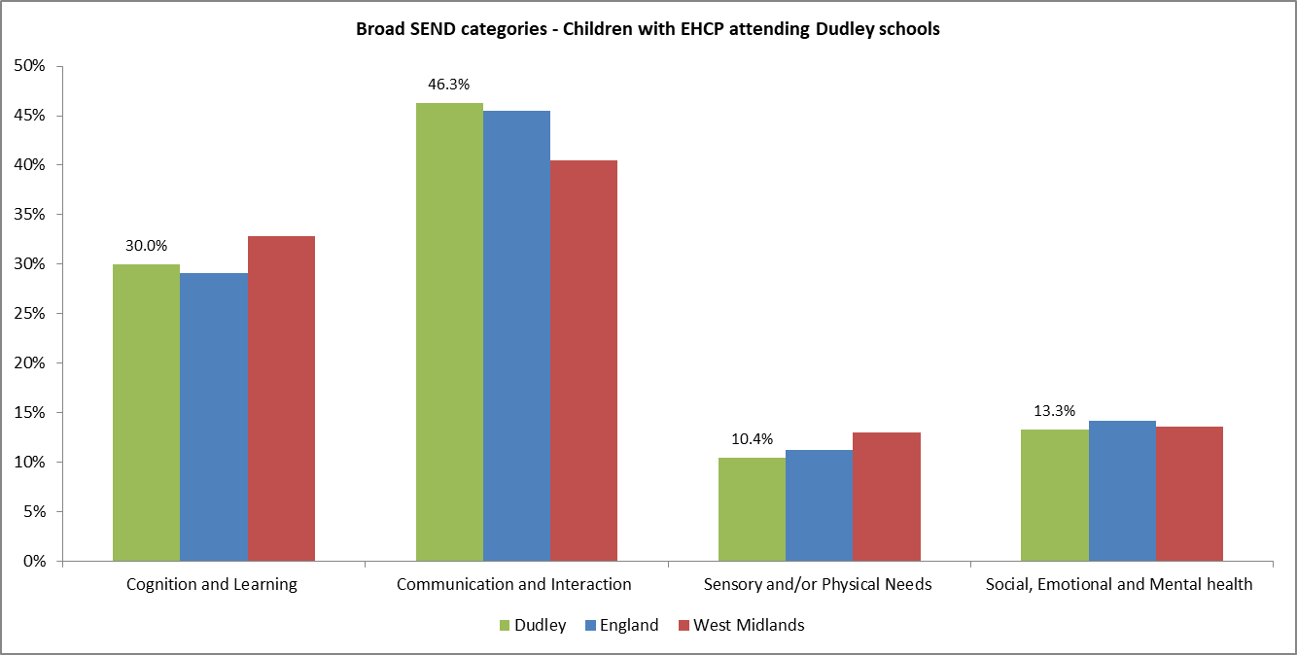

Key note

***Other data evidence including that held by the CCG indicates that children with behavioural difficulties are on the increase. The LA will need to think of additional provisions to enable the meeting this increasing demand such as counselling and nurturing centres where specialist mental health support will be provided as early intervention and prevent the escalation of severity and negative impacts.***

Table 14: Children with special educational needs – National and Dudley 2020



Speech, language and communication together with moderate learning needs are the two most predominant needs of children and young people with SEND in Dudley. There has been steady but slow increase in the number of children and young people identified as having a special educational need and or disability in Dudley. The numbers have increased by 5%, indicating additional 300 in the last five years.

Chart 20: Proportion of pupils with EHCPs in Dudley Schools by primary needs

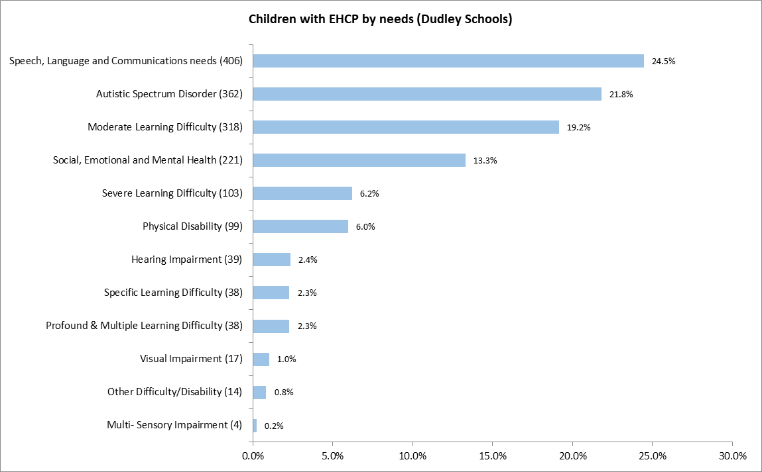

Source: January school census, 2020

Over the same period, the proportion with moderate learning difficulties dropped by 11% to 2,283 and accounts for 28% of all SEND types and is above 2020 England average.

On the increase however, is the proportion of SEND pupils with social, emotional and mental health needs which has increased by 20% (+213) and now accounts for 15% of the SEND population.

The proportion of children with Autistic Spectrum Disorder has also increased by 34% (+148) to 577 and accounts for 7% of all children with SEND in Dudley. This proportion is also below national average in 2020.

Number of pupils with speech, language and communication needs also increased by 8% (+160) to 2,117 and account for 26% of primary SEND types. The proportion is above national average.

Chart 21: Trend of SEND primary needs in Dudley Schools

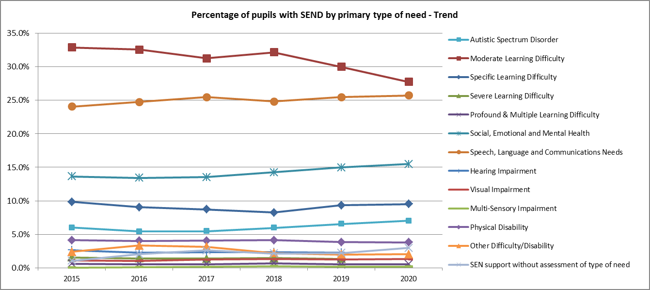

|  |  |  |  |  |  |  |
| --- | --- | --- | --- | --- | --- | --- |
| Year | 2015 | 2016 | 2017 | 2018 | 2019 | 2020 |
| No. with SEND | 6,877 | 7,914 | 7,896 | 7,864 | 8,267 | 8,233 |
| Year on year growth |  | 15.1% | -0.2% | -0.4% | 5.1% | -0.4% |

#### Primary need by school settings

The type of primary SEN needs of children within Dudley state-funded schools varies between primary, secondary and special schools. The majority of children in primary schools have speech, language and communication needs. This is different in secondary schools with moderate learning needs and special schools have autistic spectrum disorder.

Table 15: Distribution of SEND primary needs by school types 2020

SEND Primary Needs 2020 proportionate share is bolded where this is above or equal to LA average

Note: Primary needs were not available or provided for pupils attending independent schools.

The above table depicts that pupils with social, emotional and mental health are over represented within the Pupil Referral Units (PRUs) and may be linked to exclusion. Exclusion analysis (covered later in this report) has showed that higher proportions of SEMH pupils were absent from school due to exclusion and PRU’s might be where they are provided for.

#### Primary schools

Six in ten of children with SEND in Dudley are educated within state funded primary schools. The majority of children with special educational needs and disability have speech, language or communication needs (35%) followed by those with moderate learning needs (25%). Broad analyses indicate that four in ten children with SEND taught in Dudley primary schools have communication and interaction needs.

Eight in ten of children without EHCPs and with speech, language and communication needs are taught within primary schools.

#### Secondary schools

Three in ten of children with SEND are educated within secondary school settings where moderate learning disabilities and specific learning needs are the two most predominant needs. Broad analyses indicate that five in ten children with SEND taught in Dudley secondary schools have cognition and learning needs.

The majority of pupils with specific learning needs and without EHCP plans are taught within secondary schools.

#### Special schools

One in ten children with SEND (this includes EHCPs as well as SEN support) are educated within special schools in Dudley; however half of all the children with statutory EHCPs are educated in special schools settings. All children attending Dudley maintained special schools have an Education, Health and Care Plan (EHCP).

A quarter of children in special schools have Autistic Spectrum Disorder (ASD) followed by Speech, language and communication needs account for 23% moderate learning needs (21%). When one compares provisions by setting for primary needs; six in ten children with ASD are educated within special schools, indicating complexity of their needs and the need to be in special school setting. Almost all children with severe and profound learning needs are educated within special schools.

Charts 22 and 23: Distribution of EHCP and SEN support by primary needs and provision settings

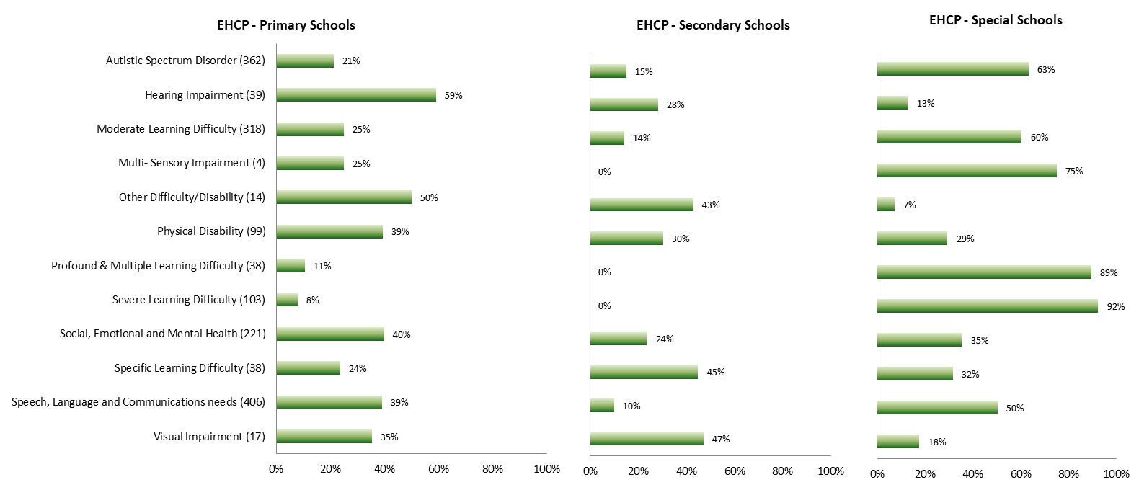

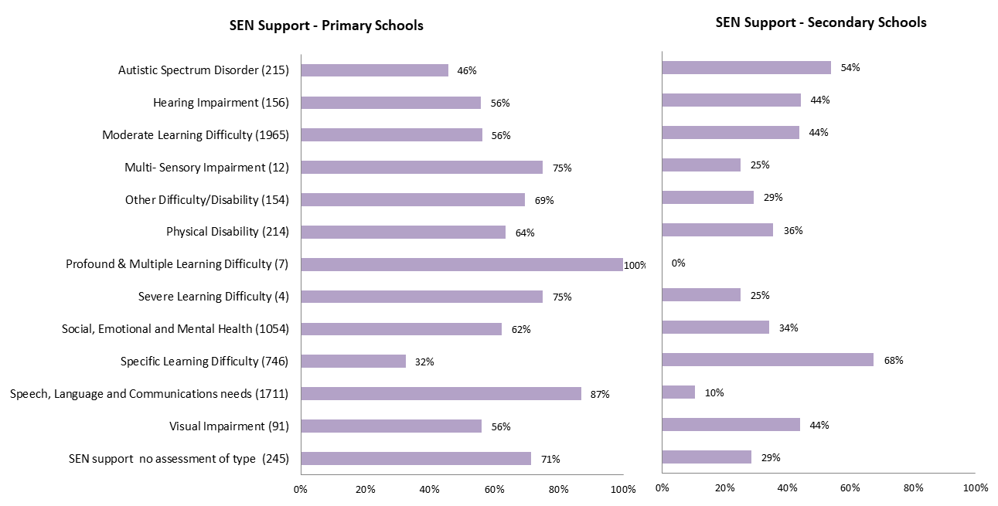

### Broad SEND primary needs – Dudley Schools

This presents the breakdown of needs by the four SEND broad groupings. Four in ten of children in primary schools have communication and interaction needs (Speech, Language and Communication Needs (SLCN) together with those with Autistic Spectrum Disorder (ASD)).

**Source:** School census return 2020

### SEND and gender

SEND is more prevalent in boys than girls and this is reflected nationally. Of the **8,233** children in Dudley schools with SEND; 65% are males and 34% are females. There are **4,188** (64%) boys receiving SEN support compared to 36% of girls and significantly more boys **1,191** (72%) have an EHCP compared with 28% of girls.

This proportionate distribution by gender is similar to National with 73% boys reported to have EHCP and West Midland average of 72%.

It is unclear why boys are more likely to be receiving SEN support than girls but it may relate to the number of genetic conditions which are more common in boys. There is also evidence to suggest that girls’ needs may go unrecognised as they tend to exhibit less typical and intrusive behaviours in response to their difficulties. In addition, evidence suggests that there is an under-diagnosis of some primary types of need such as Autism Spectrum Disorder in girls. Theories to explain the gender split in terms of autism include differences in terms of girls special interests which are often more age appropriate e.g. dolls, make-up etc… and therefore, camouflage the autism. It may also relate to the fact that girls tend to find socialising easier than boys as well as the more general exaggerations of gender differences.

Chart 24: Gender distribution and comparison

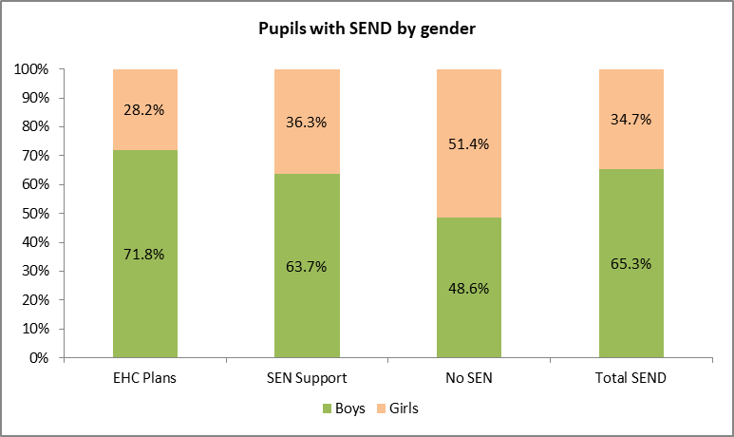

Source: January school census 2020

# Characteristics of children with EHC plans maintained by Dudley

A total 2,340 children and young people’s EHC plans were maintained by Dudley including early years and post-16 EHCPs as at January 2020. Trend analysis for EHCPs maintained by the authority show the numbers of children and young people with an EHCP increased by 83% over the last 5 years indicating additional 1,060 children and young people on the local register (Synergy). The number of children aged 0-19 have increased by 939 (74%) over the same period.

Children aged 5 to 10 have experienced the fastest growth with additional 403 children (78%) in 5 years. It is believed locally that this may be as a result of local policy to only issue plans when they start school and by which they have turned 5 years old.

They are followed by young adults aged 16-19 that have also increased by 237% (+322) to 458 in 2020. Young people (age 20 and above) also increased from a lower baseline in response to recent changes to the SEND code of practice whereby they become eligible for EHC plans.

Chart 25: Trend of Education, Health and Care Plans maintained by Dudley

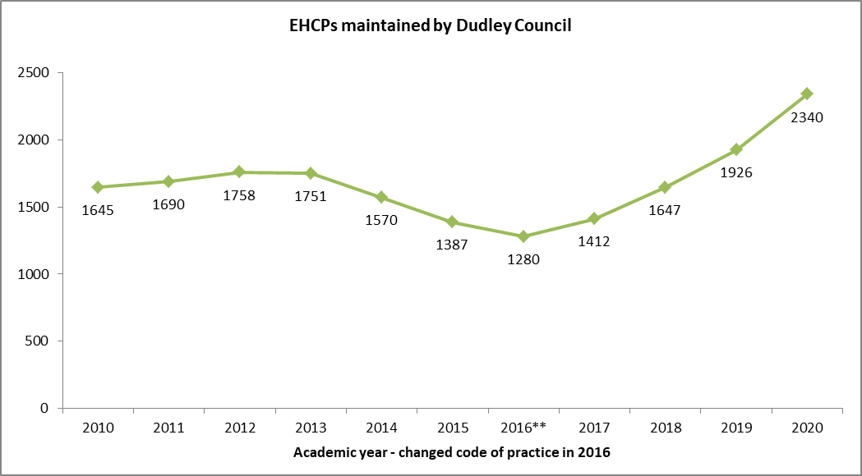

**New code of practice and changes to EHCP

### SEND by age group

The percentage of pupils who have SEN increases as age increases through primary years, peaks at age 10 and then declines through secondary years. The majority of children with EHC plans maintained by DMBC are between the ages of 5 and 10. Slightly more children are within this age group when compared with England average. Dudley has consistently had higher proportions of children between the aged of 5 to 10 than national average over the last decade.

Table 16: Distribution of SEND by age group

|  |  |  |  |  |
| --- | --- | --- | --- | --- |
| Age band | England  March 2020 | Dudley  March 2019 | Dudley  March 2020 | Dudley  September 2020 |
| Under 5 | 4% | 3.9% | 5% | 5% |
| Age 5 to 10 | 33% | 39% | 39% | 38% |
| Age 11 to 15 | 35% | 32% | 35% | 31% |
| Age 16 to 19 | 21% | 20% | 16% | 20% |
| Age 20 to 25 | 6% | 5% | 5% | 6% |
| Total | **390,109** | **1926** | **2340** | **2645** |

Source: SEN2 statutory return, January

### SEND (EHCPs) by Primary Needs

Almost three in ten of children and young people with EHC plans maintained locally have speech, language and communication needs (SLCN), followed by those with moderate learning needs (MLD) and Social, Emotional and Mental Health. One in six children and young people have Autistic Spectrum Disorder.

Chart 26: Children and Young People (CYP) with EHCPs maintained by Dudley

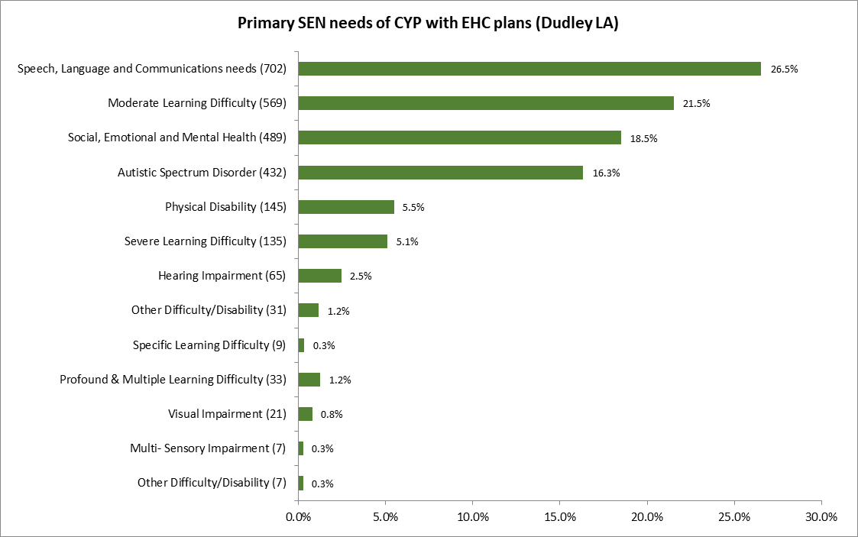

**Source:** local EHCP database September 2020

#### Predominant primary needs by age group

Incidence of primary need is slightly different by age group with children of primary school age having speech, language and communication need ranked the most prevalent.

Moderate learning needs is ranked top most for compulsory secondary school aged children and young adults aged 20 and above.

Young adults in post 16-education, have social, emotional and mental health needs (SEMH) as the top most.

**Source:** SEN data register – September 2020

Chart 27: Children and Young People (CYP) with EHCPs by age group and broad SEN need categories

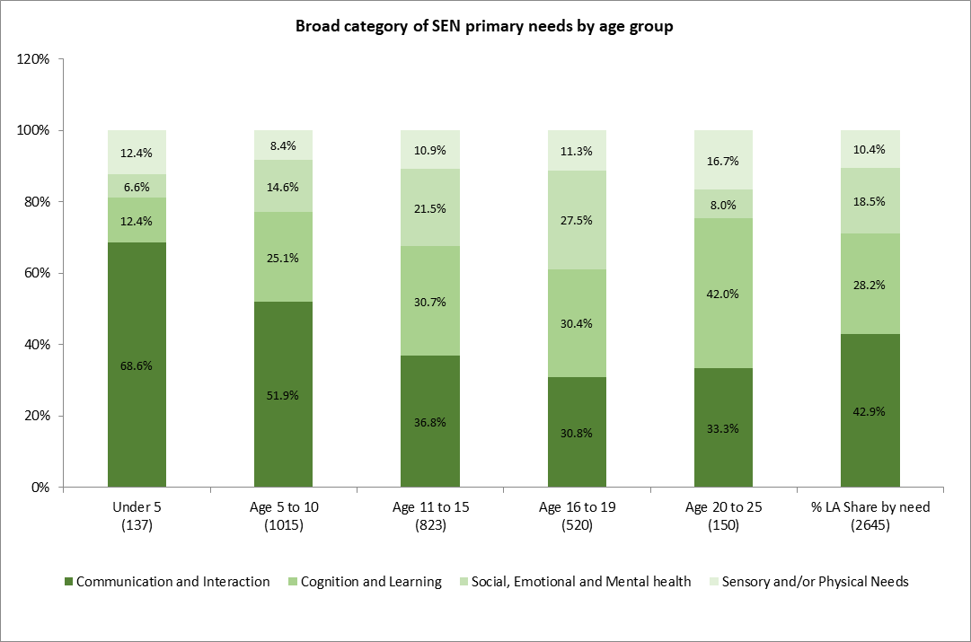

Source: local EHCP database September 2020

## Electoral Wards - Distribution of SEND by area of residence

There are 24 electoral wards within Dudley Metropolitan Borough Council (DMBC). Ten have at least a lower-layer super output areas (LSOAs) identified as amongst the top 10% most deprived. Four electoral wards have over three in then of LSOAs as most deprived; these are Castle and Priory (44%), St Thomas's (44%), Brockmoor and Pensnett (38%), Netherton, Woodside and St Andrews (33%).

There is a strong relationship between deprivation, health, special educational needs and disability as demonstrated by the table below. Children with SEND were shown to be twice as likely to reside in most deprived areas of the authority; 20% compared with Dudley average of 11%.

Electoral wards with high deprivation levels are show to be in the top 20% (highlighted in green) distribution for children with SEND. This includes resident children and young people for which Dudley maintains their statutory EHCP plans as well as attending Dudley maintained schools.

Table 17: Distribution of SEND primary needs electoral wards - 2020

|  | **EHCPs maintained by Dudley – SEND needs** | | | | | | | | | | **School Census** | | | | | **CCG** |
| --- | --- | --- | --- | --- | --- | --- | --- | --- | --- | --- | --- | --- | --- | --- | --- | --- |
| EHCP - September 2020 School census - January 2020 CCG Disability data - September 2020 | SLCN | MLD | SEMH | ASD | PD | SLD | Other needs (<100) | Total EHCP | % EHCP Share | **EHCP - 10% most deprived LSOA** | Dudley schools (EHCP) | SEN support  (% share) | School SEND % | **School SEND - 10% most deprived LSOA** | School SEND (Nos) | CCG Disability Data Age 0-25 |
| St Thomas's | 39 | 38 | 27 | 23 | 9 | 11 | 18 | 165 | 6.2% | 49.1% | 6.1% | 6.7% | 6.6% | 55.5% | 544 | 7.7% |
| Castle and Priory | 56 | 63 | 40 | 35 | 10 | 5 | 8 | 217 | 8.2% | 59.9% | 7.3% | 6.3% | 6.5% | 68.9% | 540 | 7.4% |
| Brockmoor and Pensnett | 44 | 29 | 29 | 24 | 6 | 11 | 10 | 153 | 5.8% | 47.1% | 6.4% | 5.8% | 5.9% | 48.4% | 492 | 7.5% |
| Netherton, Woodside and St Andrews | 54 | 37 | 24 | 15 | 8 | 11 | 15 | 164 | 6.2% | 48.2% | 6.2% | 5.8% | 5.9% | 40.7% | 489 | 5.1% |
| Brierley Hill | 34 | 43 | 24 | 14 | 8 | 7 | 12 | 142 | 5.4% | 33.1% | 6.2% | 5.3% | 5.5% | 30.7% | 453 | 6.5% |
| Quarry Bank and Dudley Wood | 31 | 34 | 18 | 26 | 3 | 11 | 5 | 128 | 4.8% | 16.4% | 4.7% | 5.3% | 5.2% | 16.1% | 429 | 5.1% |
| St James's | 49 | 22 | 37 | 18 | 7 | 5 | 9 | 147 | 5.6% | 30.6% | 5.3% | 4.4% | 4.5% | 27.4% | 376 | 5.1% |
| Cradley and Wollescote | 31 | 30 | 27 | 20 | 5 | 6 | 10 | 129 | 4.9% | 1.6% | 4.3% | 4.3% | 4.3% | 5.0% | 357 | 3.8% |
| Belle Vale | 40 | 19 | 23 | 28 | 3 | 6 | 6 | 125 | 4.7% | 15.2% | 4.1% | 4.2% | 4.2% | 22.7% | 344 | 4.5% |
| Lye and Stourbridge North | 22 | 20 | 16 | 14 | 5 | 7 | 9 | 93 | 3.5% | 14.0% | 3.6% | 4.2% | 4.1% | 20.8% | 341 | 4.2% |
| Upper Gornal and Woodsetton | 40 | 32 | 36 | 17 | 4 | 7 | 4 | 140 | 5.3% | 7.9% | 4.6% | 3.5% | 3.7% | 9.4% | 308 | 2.4% |
| Gornal | 25 | 19 | 14 | 10 | 8 | 2 | 2 | 80 | 3.0% | 0.0% | 3.4% | 3.4% | 3.4% | 0.0% | 284 | 3.4% |
| Coseley East | 31 | 23 | 24 | 26 | 5 | 4 | 5 | 118 | 4.5% | 15.3% | 4.2% | 3.2% | 3.4% | 20.0% | 280 | 2.6% |
| Kingswinford South | 19 | 15 | 14 | 22 | 9 | 4 | 3 | 86 | 3.3% | 0.0% | 3.1% | 3.5% | 3.4% | 0.0% | 280 | 3.8% |
| Wollaston and Stourbridge Town | 15 | 16 | 17 | 12 | 3 | 4 | 5 | 72 | 2.7% | 0.0% | 3.3% | 3.4% | 3.4% | 0.0% | 279 | 2.6% |
| Amblecote | 21 | 18 | 20 | 16 | 6 | 6 | 4 | 91 | 3.4% | 0.0% | 3.4% | 3.2% | 3.2% | 0.0% | 268 | 4.7% |
| Wordsley | 27 | 10 | 12 | 23 | 3 | 2 | 6 | 83 | 3.1% | 0.0% | 3.5% | 2.9% | 3.0% | 0.0% | 250 | 4.2% |
| Sedgley | 21 | 22 | 11 | 12 | 5 | 7 | 6 | 84 | 3.2% | 0.0% | 2.8% | 3.0% | 3.0% | 0.0% | 246 | 2.4% |
| Pedmore and Stourbridge East | 13 | 18 | 13 | 13 | 10 | 3 | 7 | 77 | 2.9% | 0.0% | 2.0% | 2.8% | 2.6% | 0.0% | 219 | 3.2% |
| Halesowen North | 21 | 15 | 13 | 10 | 4 | 4 | 6 | 73 | 2.8% | 0.0% | 2.6% | 2.7% | 2.6% | 0.0% | 219 | 2.2% |
| Kingswinford North and Wall Heath | 21 | 17 | 5 | 12 | 7 | 2 | 3 | 67 | 2.5% | 0.0% | 1.9% | 2.5% | 2.4% | 0.0% | 197 | 3.2% |
| Hayley Green and Cradley South | 14 | 14 | 15 | 17 | 7 | 5 | 8 | 80 | 3.0% | 0.0% | 2.5% | 2.3% | 2.3% | 0.0% | 193 | 4.0% |
| Norton | 21 | 7 | 11 | 12 | 7 | 4 | 7 | 69 | 2.6% | 0.0% | 2.3% | 2.0% | 2.1% | 0.0% | 173 | 2.6% |
| Halesowen South | 12 | 6 | 9 | 10 | 3 | 1 | 4 | 45 | 1.7% | 0.0% | 1.3% | 1.8% | 1.7% | 0.7% | 138 | 1.8% |
| Outborough | 1 | 2 | 10 | 3 |  |  | 1 | 17 | 0.6% | 0.0% | 4.9% | 7.5% | 7.0% | 0.0% | 579 | - |
| **LA Total/Average** | **702** | **569** | **489** | **432** | **145** | **135** | **173** | **2645** | **-** | **20.5%** | **1660** | **6618** | **8278** | **21.8%** | **8278** | **5813** |

**Data source** – LA case management system and school census (2020), some children have multiple addresses

|  |  |
| --- | --- |
|  | Electoral wards with top 20 percentage share of SEND pupils resident in most deprived areas |

Key note:

***There is a strong relationship between deprivation, health, special educational needs and disability as demonstrated by the table below. Children with SEND are twice as likely to reside in most deprived; 20% compared with Dudley average of 11%.***

### Complex needs – triangulation

Three in ten of children with EHCP plans are eligible for free school meals and 26% are from Black, Asian and minority ethnic origin (BAME). This indicates that the children of BAME origin is in line with overall January 2020 BAME school population of 27%.

Almost half of children and young people (42%) with EHCP are white, not eligible for free school meals and are not receiving social care support. One can infer that their cause of SEND is not directly related to deprivation (FSM) of family disruption/stress but may relate more with medical needs together parental rights and knowledge.

Three in ten children and young people with EHCPs are eligible for free school meal, of these, 164 receive social care support (LAC or CIN). The most vulnerable children include 4% from white heritage and 2% from Black, Asian and other minority origin.

Chart 28: Triangulated needs of Children and Young People (CYP) with EHCPs – September 2020

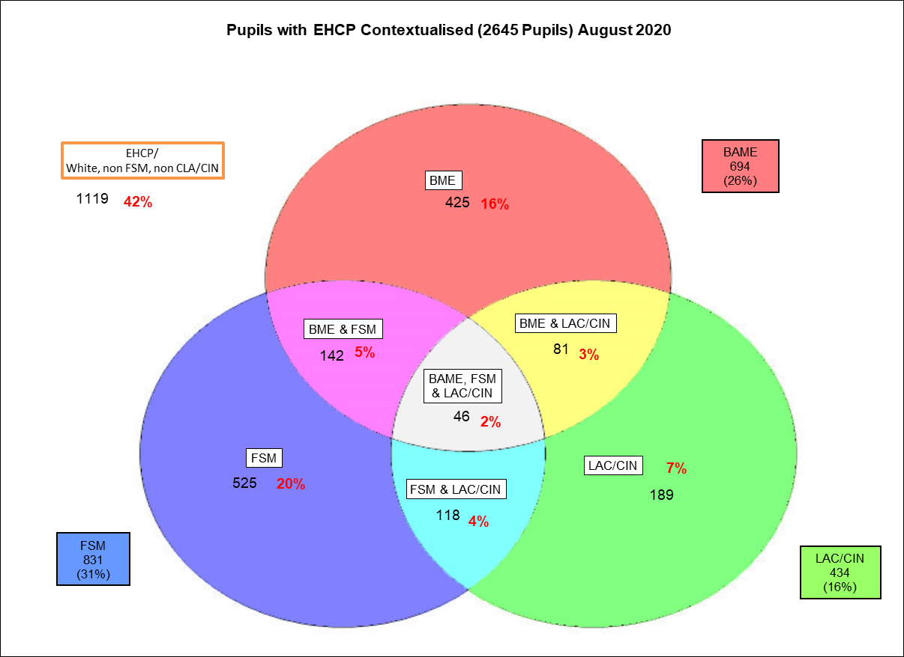

**Please note-** Children known to social care and are either looked after or in need of support is under reported due to data matching limitations.

#### Looked after children

Looked after children are defined as those looked after by the local authority for one day or more. The number of children looked after by the authority has been reducing over the last five years with 659 children looked after as at 31st March 2019. In spite of this decline, Dudley’s rate has remained significantly higher than national and West Midland rates.

Four on ten (44.9%) of children and young people looked after (for over 12 months) receive SEN support, this rate is slightly below West Midlands average of 47.2%. The proportion of children looked after in Dudley for 12 months or more (376) and with an EHC plan is comparable to West Midlands average.

The number of children looked after at any time during the year ending 31 March who were only looked after exclusively under a series of short term/breaks placements by Dudley has been reducing with only 15 placements reported in 2017. Numbers reported since 2018 have been below 5 and suppressed in public publications. This will need to be updated with local information.

Significantly more looked after children experience worse mental health than all other children. The average emotional and behavioural health of children aged 4 to 16 looked in Dudley was 13.9; this is on the upper end of normal and is better than national (14.2) and statistical neighbour’s average (14.76). A score of: 0 to 13 is considered normal; 14 to 16 is borderline; and 17 to 40 is a cause for concern.

Chart 29: Proportion of Looked After Children (LAC) with SEND

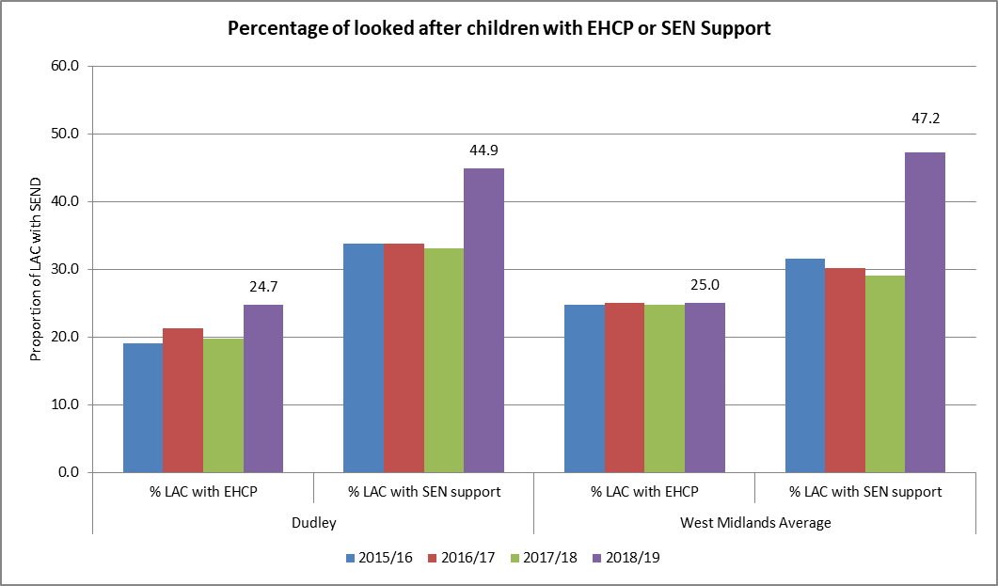

**Source:** Department of Education and children looked after for 12 months or more

#### Children in need with SEND

Children in need are defined in law as children who need local authority services to achieve or maintain a reasonable standard of health or development, need local authority services to prevent significant or further harm to health or development, or are disabled. They include children that are referred to children’s social care and had assessment to identify if the child is in need of services, which Dudley Council has an obligation to provide ***under*** ***section 17 of the Children Act 1989***. These services can include, for example, family support (to help keep together families experiencing difficulties), leaving care support, adoption support or disabled children’s services (including social care, education and health provision).

The number of children in need has dropped since the high levels reported in 2016. The number of children in need with a SEN statement of EHC plan has reduced significantly in recent years. In 2013/14, over 400 children had statutory statement plans compared with just over 200 EHCPs in 2019.

In Dudley, 19.7% of children in need have an EHCP and 25.3% of children in need are on SEN support. This compares with West Midland average of 24.2% of children in Need with EHCP and 23.9% on SEN support. The proportion of children in need with SEND in Dudley is slightly below that of the regional benchmark.

Chart 30: Proportion of Children in Need with SEND

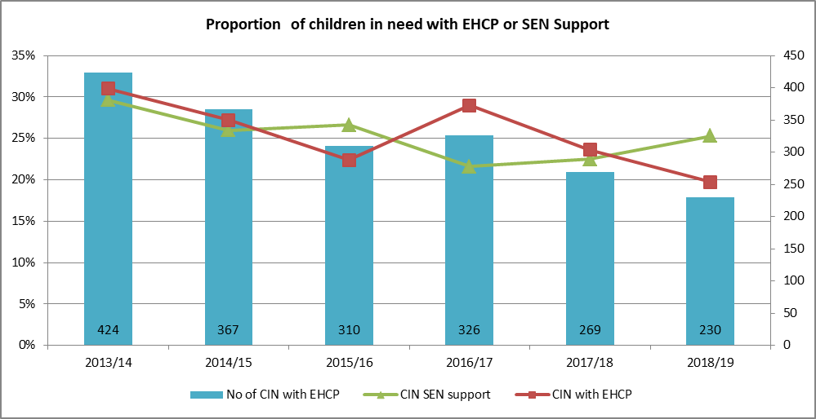

**Source:** Department of Education

#### Children in need with disability

The number of children in need (CIN) has dropped from the high levels reported in 2016 and appears to have stabilised. Alongside this trend is the number of children in need with recorded disability which has almost halved to about 300 in 2019. Consequently, the proportion of CIN with disability is now in line with national and West Midland averages.

Chart 31: Proportion of Children in Need with disability

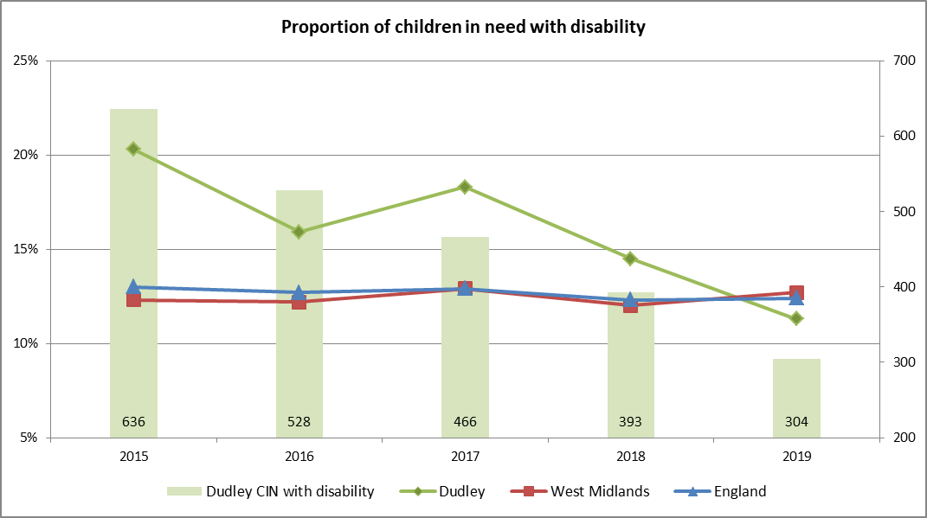

|  |  |  |  |  |  |
| --- | --- | --- | --- | --- | --- |
|  | 2015 | 2016 | 2017 | 2018 | 2019 |
| Dudley CIN | 3,134 | 3,329 | 2,551 | 2,715 | 2,699 |

Source: Department of Education

The Disabled Children’s Team (DCT) has on register about 300 CYPs and this number has remained relatively consistent in recent years. The team continues to work with virtual school heads and other colleagues to ensure appropriate provision, opportunities for education, learning and training for this group of vulnerable children. The majority of these children receive short breaks and provided with personal budget payments.

# Educational outcomes

Analysing pupil level data on children with SEND will help to provide deeper understanding of performance of individual or groups of SEND pupils over time, inform appropriate interventions to ensure SEND pupils make the necessary progress as well as facilitate a better understanding of the impact of different types of interventions and provision on SEND pupils’ progress. The latest Ofsted SEND Inspection in 2019 highlighted the following areas for improvement. It states that;

1. There has not been a clear enough focus on improving outcomes for children and young people with SEND in Dudley. A *range of outcomes are lower than those achieved by other pupils*.
2. Aspirations are not high enough. **Effective *strategies to improve attainment and challenge for the most able pupils with SEND*** to achieve well have not been in place. Schools do not routinely benchmark the achievement of pupils with SEND against all pupils nationally.
3. In every key stage, pupils with SEND achieve less well than pupils with similar starting points. Their rates of progress are below national averages for all pupils.
4. Very few young people with learning difficulties and/or disabilities in Dudley move onto paid employment. Employer engagement is underdeveloped, and some staff are not clear about how they can help young people prepare for adulthood.
5. Absence rates for pupils with SEND are higher than those of other pupils in Dudley and all pupils nationally.
6. Although they are starting to decline, exclusions for pupils who are identified as SEN support are higher than other pupils in Dudley and all pupils nationally.

## School Exclusions and Pupil absences

Nationally both absence and exclusion rates are higher in pupils with SEND than those without. These inequalities are more evident in Dudley with SEND pupils being twice as likely to be excluded from schools as their peers without SEND. They are also more likely to be persistent absentees and experience high rates of school absences.

Recent public health concerns with Covid-19 have in no doubt added extra strains and pressures on children, families, schools and the local area partnerships. Unfortunately, this is expected to further widen the educational inequality gaps with long term effects on life opportunities.

Central Government, local authorities, other public sector organisation and the third sector are working to minimise the negative impact of Covid-19 on the already very vulnerable groups of children with SEND, particularly those with ASD, and those who suffer generally with anxiety including those with SEMH who flourish better with familiar structures and events round them.

Fixed period exclusion refers to a pupil who is excluded from a school but remains on the register of that school because they are expected to return when the exclusion period is completed. A fixed period exclusion can involve a part of the school day and it does not have to be for a continuous period. A pupil may be excluded for one or more fixed periods up to a maximum of 45 school days in a single academic year.

Rate of fixed term exclusions are generally high in Dudley, running above England and West Midland averages. However, rates are similar to that of Dudley’s Statistical Neighbours which have similar characteristics in terms of deprivation, employment and ethnic profile.

In 2019, 9.1% of pupils experienced fixed term exclusions in Dudley, representing over 2,000 more exclusions reported than in 2018. This rate of fixed term exclusion increase is higher than all benchmarked groups - England (5.36%), Statistical Neighbours (8.8%) and the West Midlands (5.01%).

Chart 32: Fixed term exclusions – Dudley compared with benchmark groups

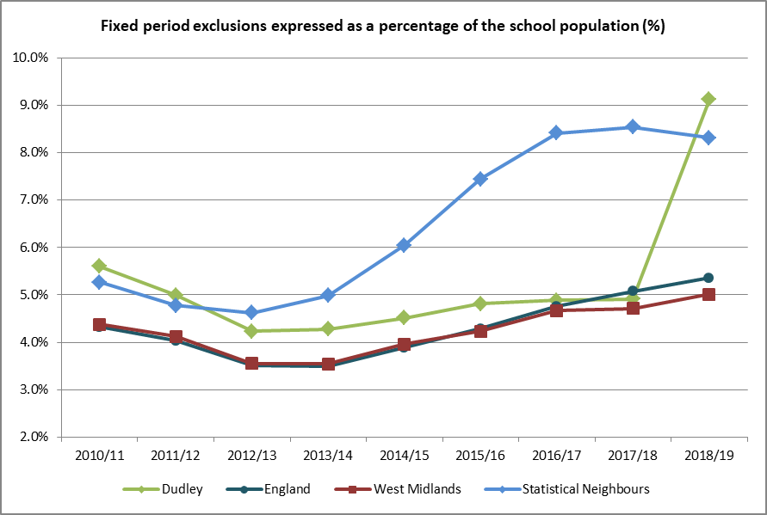

Source: annual school census returns

The rate of fixed term exclusions for Dudley pupils is generally higher than the national average and this is reflected in the population of children with SEND. Pupils with SEND are twice as likely to be excluded, in 2019, 19.8% experienced period of fixed term exclusions compared with 6.9% of their peers without SEND. The fixed period exclusion rate is also higher in Dudley for pupils eligible for SEN support 20.7% compared with 15.7% for pupils with EHCP and 3.5% for those not eligible for SEND. However, the rate of exclusions for pupils without SEND has remained relatively above that of England and West Midlands averages.

Fixed period exclusions in pupils with EHCP in Dudley schools (15.69%) and this is in line with England average of (16.3%) and West Midland (13.3%) averages in 2019. Proportion of those eligible for SEN support excluded on fixed term period is much higher in Dudley compared with benchmark groups.

Chart 33: Fixed term exclusions by SEND status

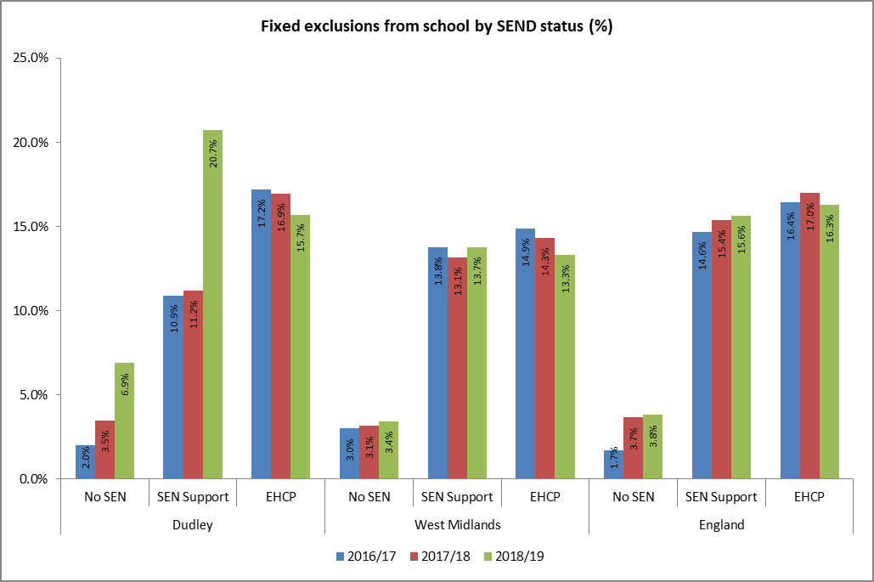

Persistent disruptive behaviour accounts for the 49% of all fixed term exclusions in 2019 representing 2,114 exclusions and is over 1,400 exclusions above the numbers in 2018. The rate of exclusion due to behavioural issues is above England (32%) and West Midlands (29%) averages.

Chart 34: Reasons for fixed term exclusion 2019

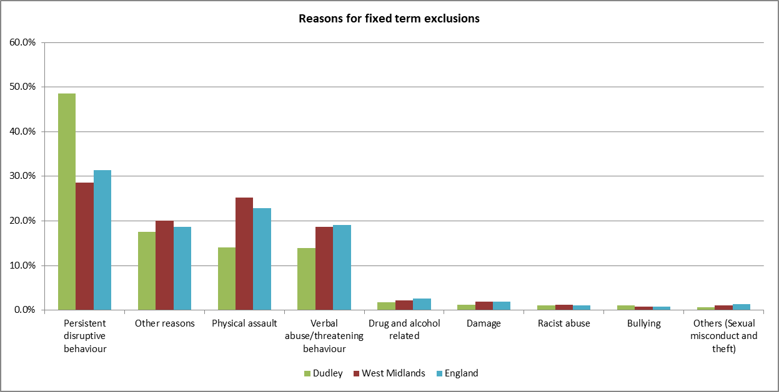

Nationally, almost half (46%) of pupils with SEMH needs experience a fixed term exclusion in 2019. They are followed by those with other disability (13%) and moderate learning difficulties (12%).

Permanent exclusion refers to a pupil who is excluded and has their name removed from the school register. Such a pupil would then be educated at another school or via another form of provision.

In Dudley, a total of 98 pupils were permanently excluded in 2019 indicating a rate of 2 per 1,000 pupils being excluded. Although this is a small decline from the very high level in 2017 where 117 pupils were excluded; rate of permanent exclusions in Dudley remains significantly above that of all benchmark groups. Pupils in Dudley are twice as likely to be permanently excluded compared to their peers nationally.

Pupils aged 13 and 14 are also more likely to be excluded from Dudley schools than other year groups. They account for 50% of excluded cohort. Unfortunately, the rate of exclusion continues to increase.

Table 18: Number of pupils permanently excluded from Dudley schools by age

|  |  |  |  |  |  |  |  |  |  |  |  |  |  |  |  |  |
| --- | --- | --- | --- | --- | --- | --- | --- | --- | --- | --- | --- | --- | --- | --- | --- | --- |
| **Academic years** | **Age 4 & under** | **Age 5** | **Age 6** | **Age 7** | **Age 8** | **Age 9** | **Age 10** | **Age 11** | **Age 12** | **Age 13** | **Age 14** | **Age 15** | **Age 16** | **Age 17** | **Age 18** | **Total** |
| 2012-13 |  |  |  |  |  |  |  | 3 | 9 | 22 | 11 | 6 |  |  |  | 51 |
| 2013-14 |  |  | 1 | 4 |  | 2 |  | 4 | 11 | 28 | 25 | 7 |  |  |  | 83 |
| 2014-15 | 1 |  |  | 2 | 2 | 3 | 3 | 11 | 11 | 29 | 28 | 12 |  |  |  | 103 |
| 2015-16 |  | 3 | 2 |  | 3 | 3 | 5 | 11 | 14 | 18 | 20 | 3 |  |  |  | 82 |
| 2016-17 | 3 | 2 | 3 | 4 | 3 | 7 | 3 | 7 | 28 | 21 | 24 | 12 |  |  |  | 117 |
| 2017-18 | 1 | 1 | 3 | 8 | 3 | 3 | 4 | 5 | 9 | 25 | 26 | 5 |  |  | 1 | 94 |
| 2018-19 | 1 |  | 4 | 1 | 5 | 2 | 3 | 11 | 14 | 21 | 30 | 6 |  |  |  | 98 |

Chart 35: Permanent exclusions – Dudley compared with benchmark groups

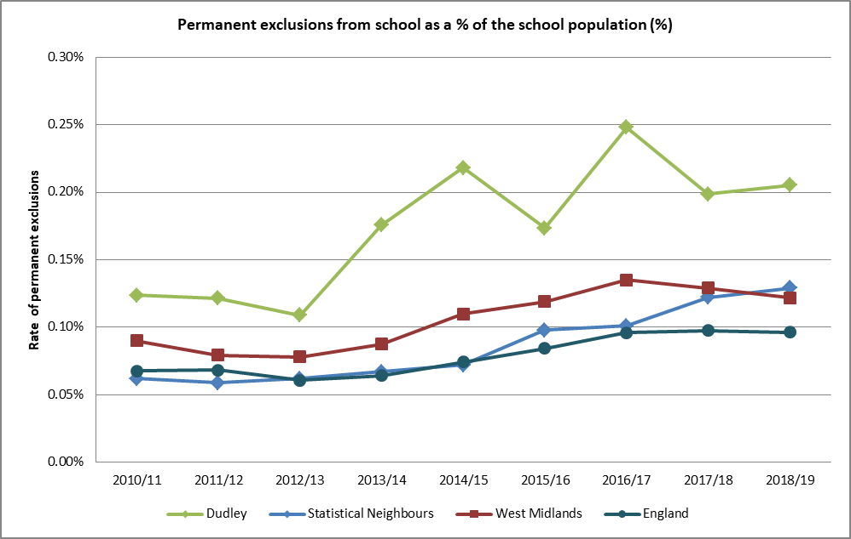

Almost 0.6% pupils with SEND were permanently from Dudley schools in 2019 compared with 0.1% of their peers without SEND. However this rate is slightly below that of previous years of 0.61%. Children with SEND were twice as likely to be excluded in Dudley and in 2019; they represented 46% of all excluded pupils.

The permanent exclusion rate for SEN pupils with an ECHP was 0.48% in 2019, indicating a small drop from previous years and indicates one child less than 2018.

Children In Dudley eligible for SEN support appear to experience permanent exclusions at 0.57% (39 pupils). This also came down slightly from rates in 2018 which involved 40 pupils. Rates of exclusion of this group of children appear to be coming down but not fast enough to meet that of benchmark groups, England (0.32%) and West Midlands (0.42%).

Chart 36: Permanent exclusion from Dudley schools by SEND status

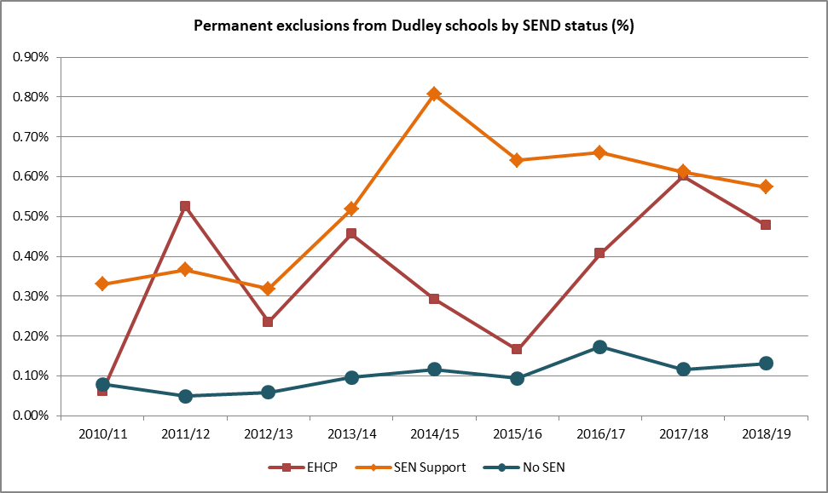

Chart 37: Permanent exclusion from schools by SEND status in comparison with benchmark groups

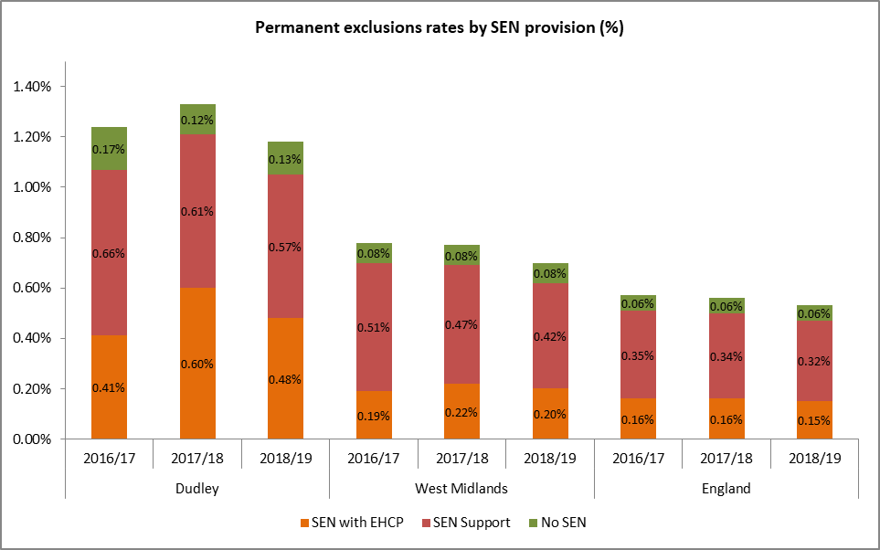

As with fixed term exclusion, the majority of children were permanently excluded because of persistent disruptive behaviours accounting for 59% of all exclusions in Dudley in 2019. This compares with England (35%) and West Midlands (38%). In Dudley, two in ten pupils permanently excluded were excluded as a result of physical assaults against pupil and adults.

Pupils with primary need of SEMH were also more likely to be permanently excluded and 0.9% of them were excluded nationally in 2019. The situation with fixed term exclusions is similar. Considering that this group of pupils are projected to increase nationally and in Dudley, early and effective strategies to support this vulnerable group is imperative.

Chart 38: Reasons for permanent exclusions from schools

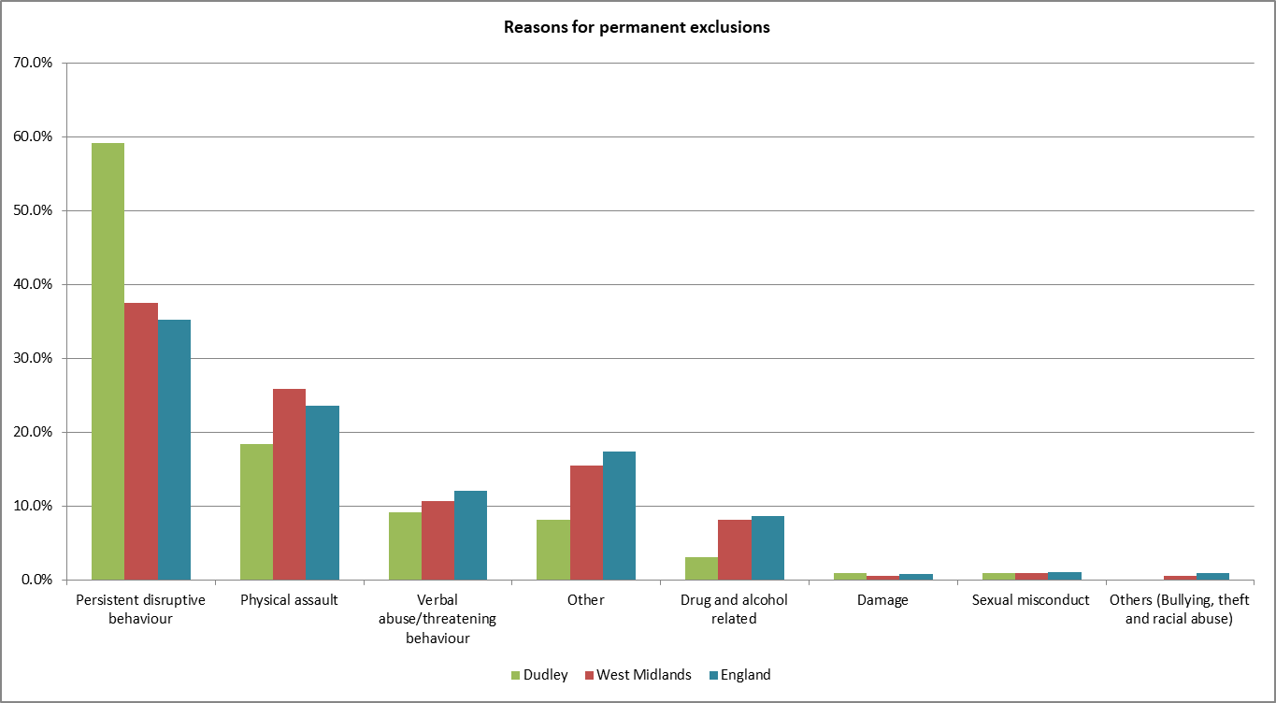

Key note

***Absence and exclusions rates are particularly high among children with special educational needs and/or disability (SEND). Behavioural issues are the main reason why children are excluded from Dudley schools. Early identification and support is recommended to improve behavioural management in schools before it leads to exclusion and the consequent impact on learning, employment and life chances***

### Pupil Absence

In Dudley, 5% of all possible schools sessions were missed by pupils in 2018/19, this is slightly higher than the benchmark groups - England (4.7%), West Midlands (4.8%) and statistical neighbours (4.7%). It is apparent from the following chart that more children experience school absences in Dudley and absence rates have been running above that of England, Statistical Neighbours and the West Midlands averages for almost a decade.

Chart 39: Overall pupil absence in comparison with benchmark groups

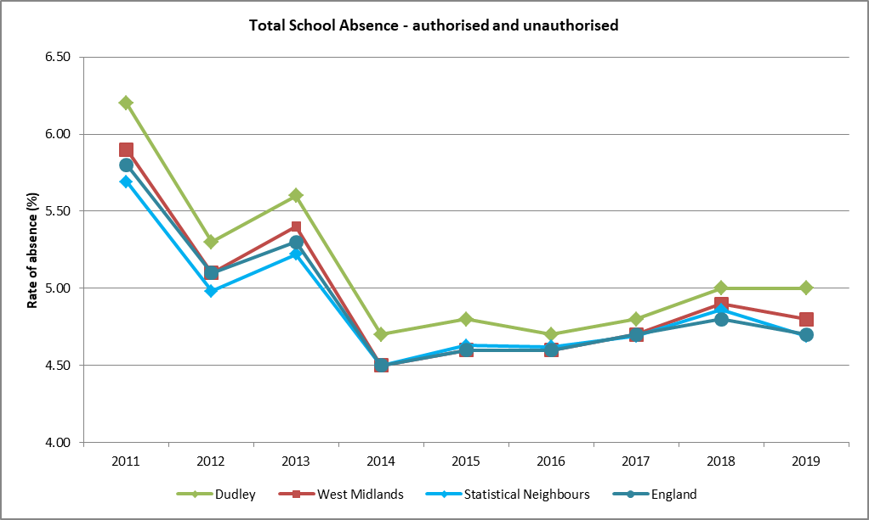

Pupils with SEND experienced more absences from school in 2019. 8.7% of possible sessions were missed by pupils with EHCPs compared with 6.3% for pupils receiving SEN support and 4.6% for pupils without SEN. The rates of absences by SEN status in Dudley are generally above that of England.

Of pupils who have missed 10% or more of their possible overall schools sessions. One in four pupils with EHCP (24.5%) are identified as absentees, compared to 20% for pupils receiving SEN support and 18.2% for pupils without SEND.

Chart 40: Pupil absence by SEND status

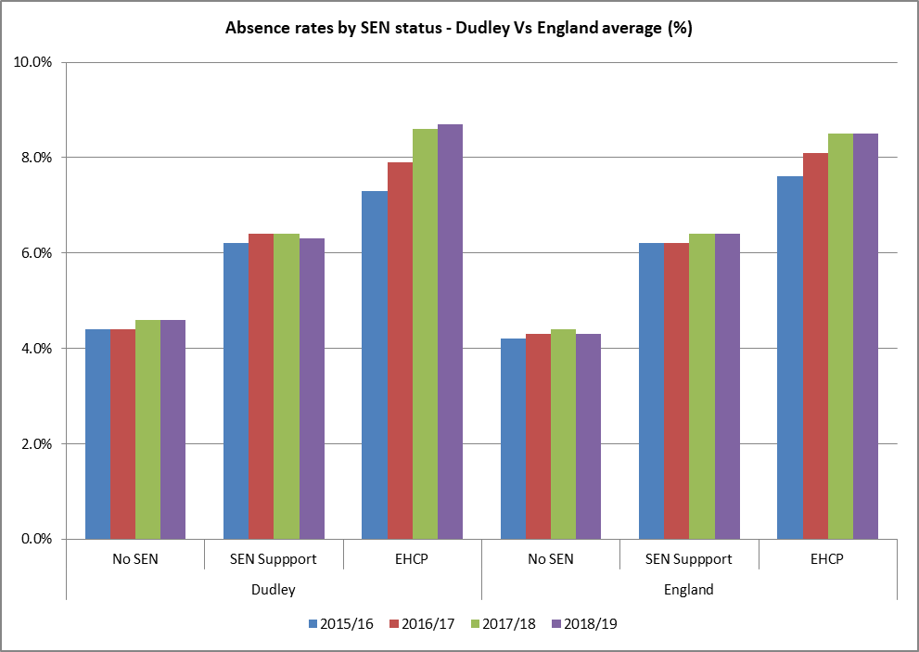

Pupils identified as having Profound and Multiple Learning Difficulties (PMLD) were most likely to be absent from school in 2018/19; missing 20% of all sessions and of which 48% was as a result of illnesses. However, when one reviews number of children with SEND by volume and broad category of SEN needs, higher proportions of those with Social, Emotional and Mental Health needs (SEMH) experienced school absences compared to other groups. The main absence reasons for the SEMH cohort was illness (34%), unauthorised other reasons (27%) and exclusions (12%). Not surprising, one in four of the SEMH cohort are known to be persistent absentees.

Chart 41: Pupil absence by broad SEND primary needs groups and status - 2019

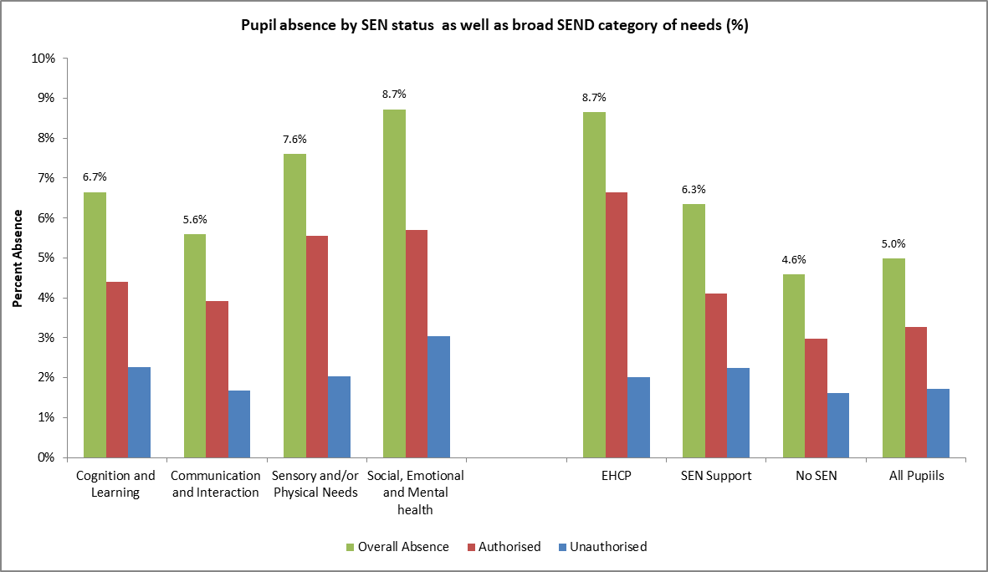

Looking at the absence reasons given for pupils with SEND compared to their peer without SEN; children with SEND have a lower proportion of absences recorded for illness than their peer without SEN. However, they have more absences due to medical/dental appointments and exclusions. It is also notable that 4.5% of sessions missed by children with SEND is because of exclusion (fixed period). The most of these children are placed temporarily in one of Dudley’s alternative provisions and this is reflected in previous analysis of primary needs by school type where a third of those in the PRU have SEMH.

Chart 42: School absence reasons by SEND status

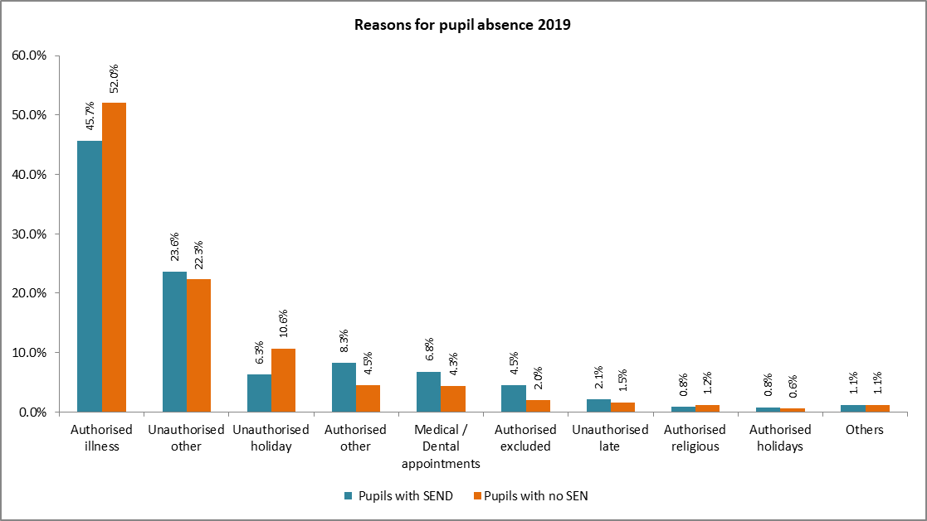

Key note:

***The overall absence rate for Dudley pupils is generally above that of benchmark groups (Statistical Neighbours, West Midlands, and England). Pupils with SEND are more likely be identified as persistent absentees.***

***The proportion of children permanently excluded from Dudley schools is twice the national average and is higher than rates for Statistical Neighbours and West Midlands averages. Persistent disruptive behaviour accounts for five in ten of all exclusions.***

## Attainment of pupils with SEN

It is widely known that children with special educational needs and disabilities may experience a number of educational inequalities when compared with their peers; including lower levels of attainment, lower rates of sustained education, and higher rates of absence or exclusion. These may in turn affect their employability, wellbeing and life chances in generally.

Early Years Foundation Stage - The proportion deemed to be school ready is measured by the proportion of children age 5 achieving the expected good level of development at the Early Years Foundation Stage Profile (EYFSP). This is based on assessment in 7 areas of learning covering 17 early learning goals (ELGs). A child is scored 1 for emerging, 2 for expected, and 3 for exceeded.

In 2019, 67% of children in Dudley achieved a good level of development and this is below all of benchmark groups. School readiness performance is one of the key areas of weakness to be addressed in Dudley considering the cascading effect on future key stages of educational attainments.

Chart 43: School readiness by % achieving good level of development at EYFS

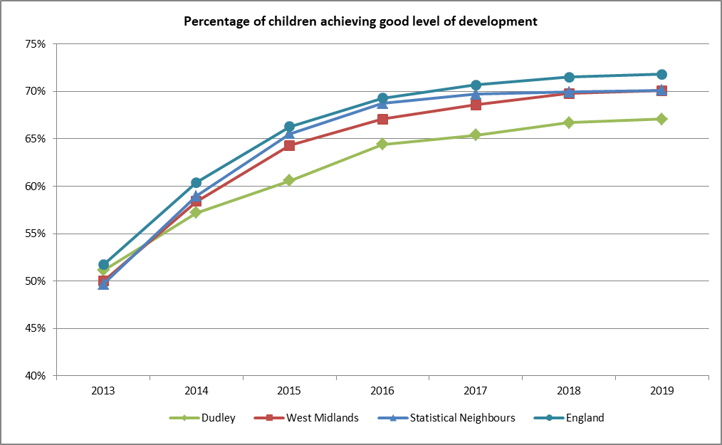

A smaller proportion of pupils with EHCPs achieved a good level of development compared with the national average; however performance in Dudley is almost in line with statistical neighbour average.

On the good note however is that slightly higher proportion of children eligible for SEN support attained good level of development compared with all benchmark groups.

Chart 44: School readiness - % achieving good level of development at EYFS by SEND status 2019

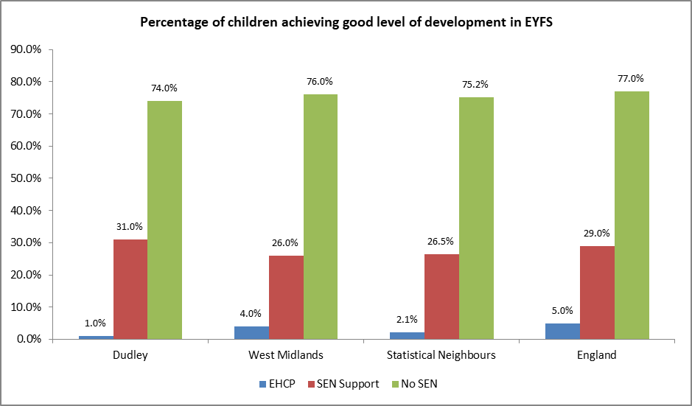

Phonics - The phonics approach teaches children to decode words by sound, rather than recognising whole words. The phonics screening check is designed to confirm whether pupils have learnt phonic decoding to an appropriate standard. This typically takes place when children are 6 years old and are allowed to retake the assessment the following year if they failed to meet the standard.

In Dudley, 79% of all children met the expected standard compared with England average of 82%. This relative performance is reflected in pupils with SEND.

Chart 45: Proportion of pupils achieving the expected standard of phonics decoding

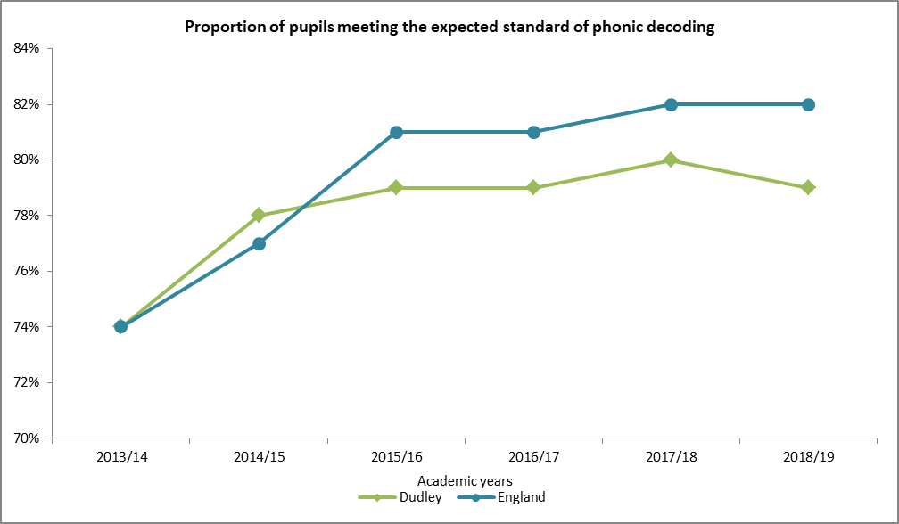

In 2019, 48% of pupils with SEN Support met the expected standard of phonic decoding compared with 87% of their peers without SEN. Both of these performance levels are in line with England average. However, a smaller proportion of those with an EHCP achieved this level in Dudley compared with national average where 20% of children with an EHCP achieved the phonics decoding standard.

Chart 46: Proportion of pupils achieving the expected standard of phonics decoding by SEND status

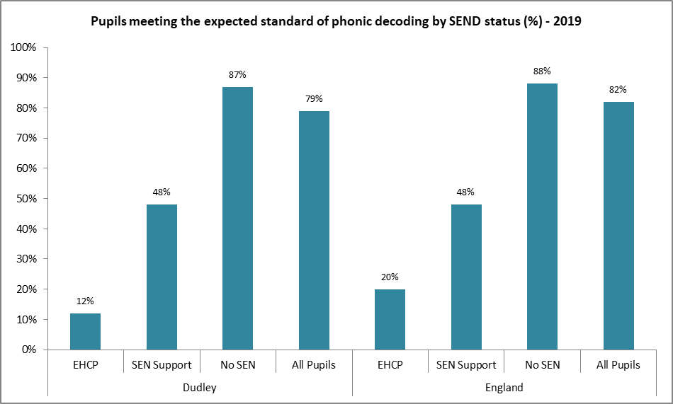

Key Stage 1 Assessments are taken at age 7 for reading, writing, maths and science. Performance of Dudley pupils is marginally below that of national for reading, writing and maths.

As with all other assessments; SEND pupils are underperforming compared with their peers without SEND. Only one in ten pupils with EHCP achieved the expected level I mathematics compared with eight in ten of their peers without SEND. Children in Dudley receiving SEND support are performing slightly above the national average in reading, writing and maths however pupils with an EHCP are performing worse in all three domains than the national average.

Chart 47: Proportion of pupils achieving the expected standard at key stage 1 by SEN status

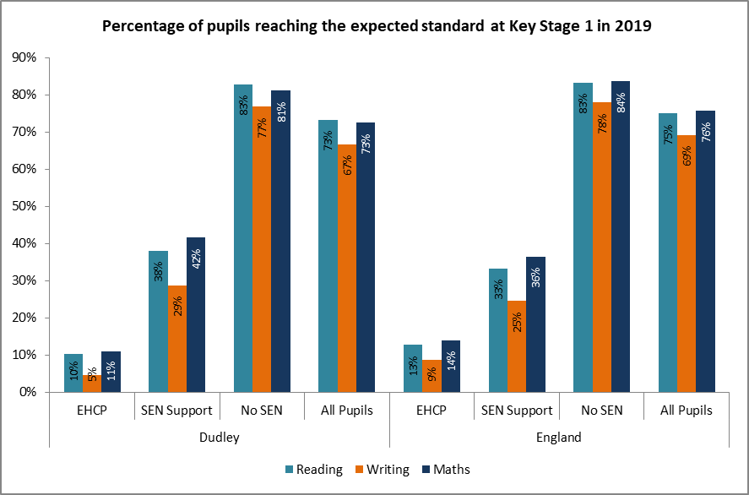

Key Stage 2 (KS2) assessments are taken at the end of primary school phase (year 6) and at age 11. All pupils take national curriculum tests in mathematics, English reading, and English grammar, punctuation and spelling. Pupils are given a scaled score for each subject to show whether they have reached the expected standard.

The proportion of children at the end of key stage 2 reaching the expected standards in reading, writing and mathematics (RWM) has improved in by 10% over the last 4 years. The pace of improvement is below that of benchmark groups further widening the attainment gap compared to the England average.

In 2019, 59% of children achieved the expected standard in reading, writing and mathematics (RWM) in Dudley and this performance is 6 percent below the national average and lower than the average for Dudley’s statistical neighbours and the West Midlands.

Chart 48: Proportion of pupils achieving the expected key stage 2 standards in reading, writing and maths

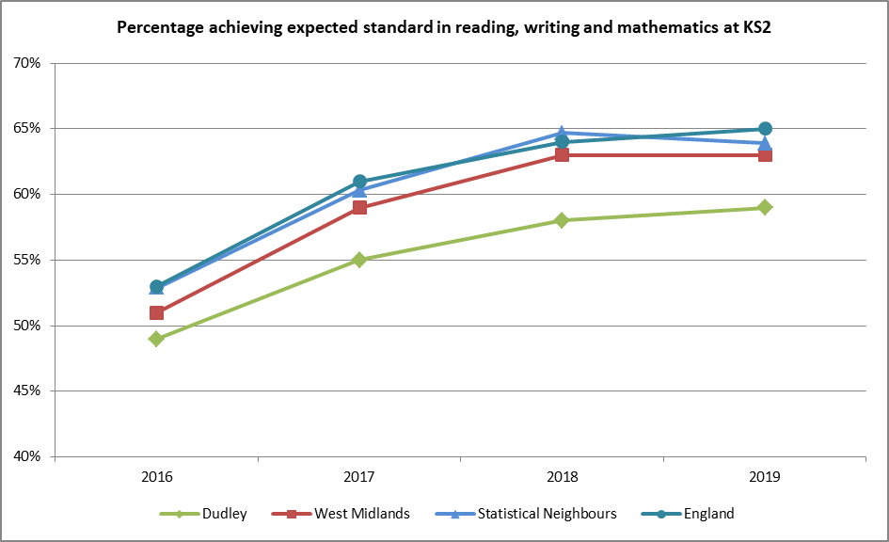

On the good note, higher proportions of children eligible for SEN support in Dudley achieved the expected KS2 standards in RWM compared to all benchmark groups (2019). Performance all other groups are below England average.

Table 19: Proportion of pupils achieving the expected KS2 standard in reading, writing and maths by SEN status

|  |  |  |  |  |  |  |  |  |
| --- | --- | --- | --- | --- | --- | --- | --- | --- |
|  | EHCP | | SEN Support | | No SEN | | All Pupils | |
| KS2 by SEND status | 2018 | 2019 | 2018 | 2019 | 2018 | 2019 | 2018 | 2019 |
| Dudley | 6% | 5% | 21% | 26% | 67% | 69% | 58% | 59% |
| West Midlands | 7% | 8% | 22% | 22% | 72% | 73% | 63% | 63% |
| Statistical Neighbours | 8% | 8% | 23% | 24% | 74% | 74% | 65% | 64% |
| England | 9% | 9% | 24% | 25% | 74% | 74% | 64% | 65% |

Chart 49: Proportion of pupils achieving the expected standard at key stage 2 by SEN status

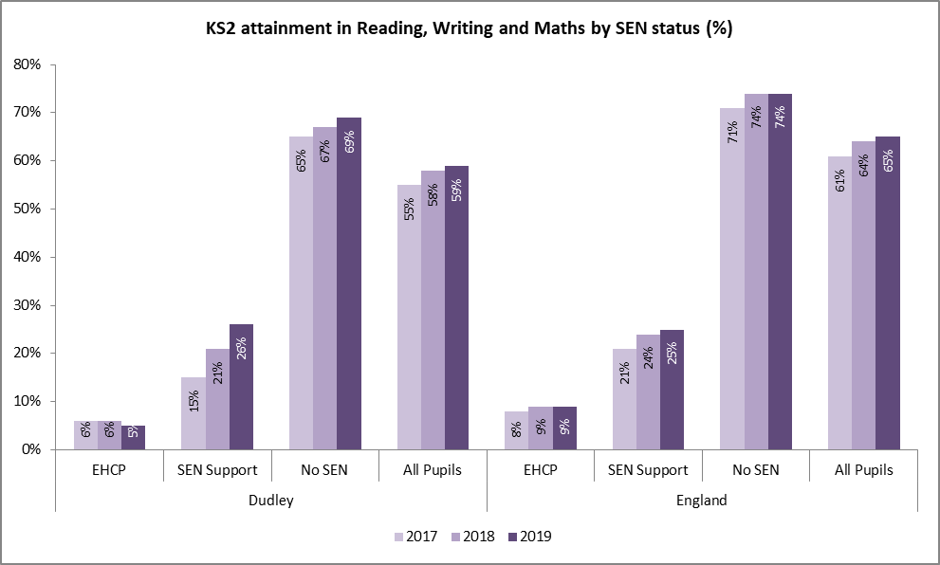

Key Stage 4 (KS4)/GCSE is the legal term for two years of secondary school education (Year 10 and Year 11), which incorporate GCSEs, and other examinations. Pupils are usually aged 16 by 31st August of their Year 11. (In some schools, KS4 work is started in Year 9). General Certificate of Secondary Education (GCSE) is the qualification taken by 15 and 16 year olds to mark their completion from the KS4 phase of secondary education in England, Northern Ireland and Wales.

Attainment 8 is one of several performance measures reported at the end of KS4. It is the average achievement of pupils in up to 8 qualifications including English, mathematics, three further qualifications that count in the English Baccalaureate (EBacc) and three further qualifications that can be GCSE qualifications (including EBacc subjects) or any other non-GCSE qualifications on the DfE approved list.

Points are allocated according to grades the pupil achieves for all 8 subjects and added together to give the Attainment 8 score. English and mathematics point scores are double weighted to signify their importance. Points are allocated on a 1-9 point scale corresponding to the new 1 to 9 grades, e.g. a grade 9 will get 9 points in the performance measures.

In Dudley, the average attainment scores have remained below that of benchmark groups including Dudley’s Statistical Neighbours in recent years. Pupils in Dudley achieved at least a grade (1.5) less than their peers. This also means that more disadvantaged pupils are less likely to achieve good GCSE grades including those with SEND and/or from deprived backgrounds.

Chart 50: Average Attainment 8 score per pupil - Trend

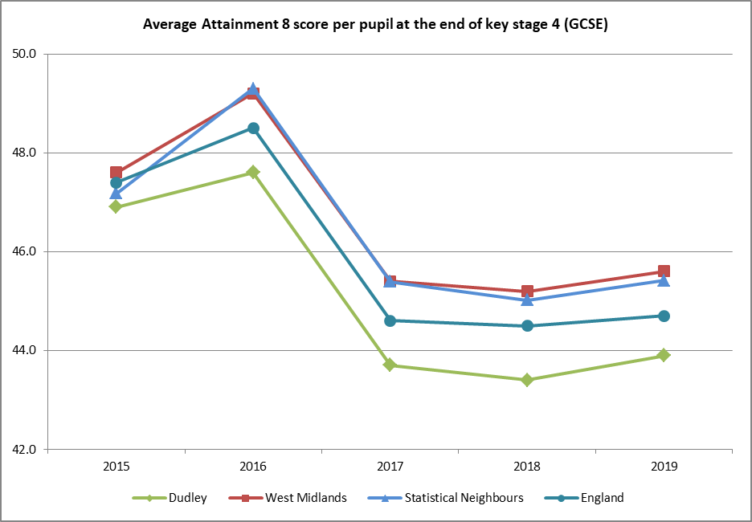

All pupils in Dudley including those with SEND attained less than their peers from the benchmark groups. Pupils with SEND attained about 2 points below national peers in 2019.

4.5% of pupils with EHCP and 10.1% of pupils eligible for SEN support in Dudley achieve grades 9-5 in English and maths at KS4 in 2019. This compares to England average of 5.6% for pupils with EHCPs, and 17.0% for pupils on SEN support. For comparison, 41.1% of pupils with no SEN in Dudley and 48.0% in England achieve grades 9-5 in English and mathematics at KS4.

In 2019, the average attainment 8 score of young people with an EHCP was 11.7 compared to 13.8 for similar children nationally. Pupils eligible for SEN support also experienced similar performance gaps with their peers nationally (29.0: 32.6).

Chart 51: Average Attainment 8 score per pupil – SEND status

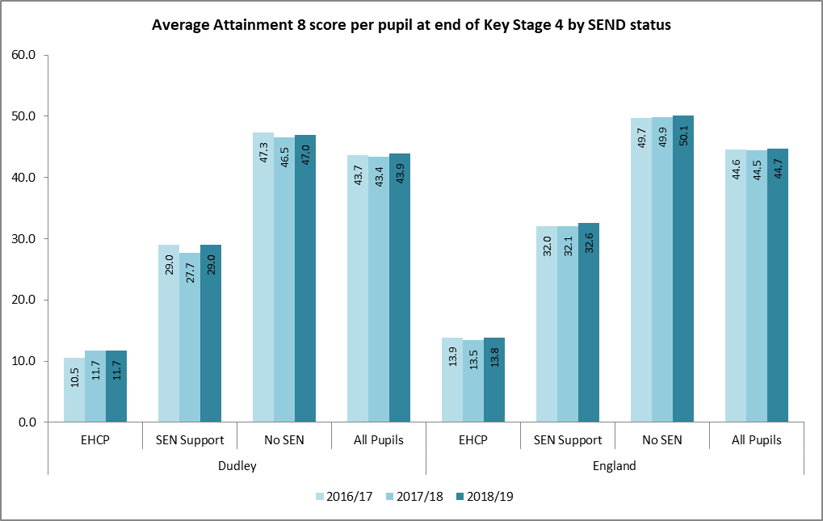

Post 16 participation (education, employment or training) includes pupil destination and activities after their GCSE year. The key stage 4 measure is based on activity the year after the young person finished compulsory schooling.

The cohort includes all young people included in the end of KS4 performance tables and their destination tracked in the following academic year October to March for sustained participation. This means they are attending for all of the first two terms of the academic year at one or more education providers; spending 5 of the 6 months in employment or a combination of the two. Please note that this measure is subject to time lag as the Destination Measures requires higher education (HESA) data to be matched to the pupil data in the National Pupil Database.

In Dudley 93% of young adults age 16 to 17 year olds were in education, employment or training (EET) in 2018. This is in line with that of Dudley’s Statistical Neighbours but slightly below England and West Midlands averages. The proportion of young people remaining in education was 85% and in line with benchmark groups.

The proportion of KS4 pupils remaining in education or employment has improved significantly and was in line with England average until the most recent year of data available.

Chart 52: KS4 destination - proportion remaining in education, employment and training (EET)

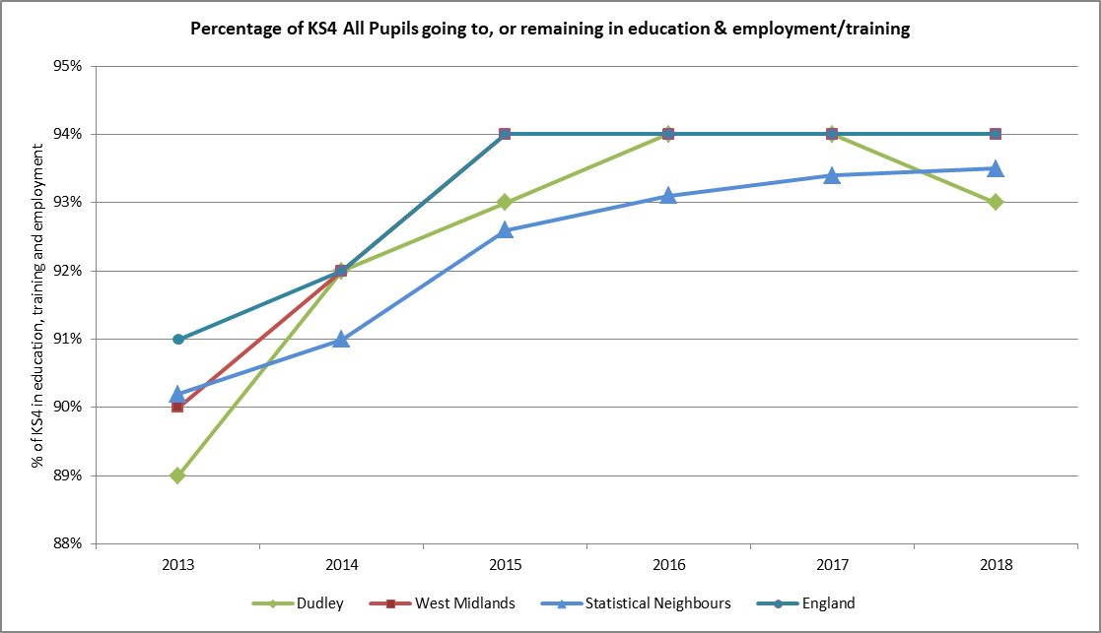

Children with SEND are less likely to remain in education, employment or training than those with no identified SEN. In Dudley, the proportion of KS4 cohort with SEND (EHCP and SEN support) remaining in remaining in education, employment or training (EET) is significantly below that of their peers in benchmark groups.

Chart 53: Post 16 participation – proportion of KS4 remaining in education, employment and training (EET)

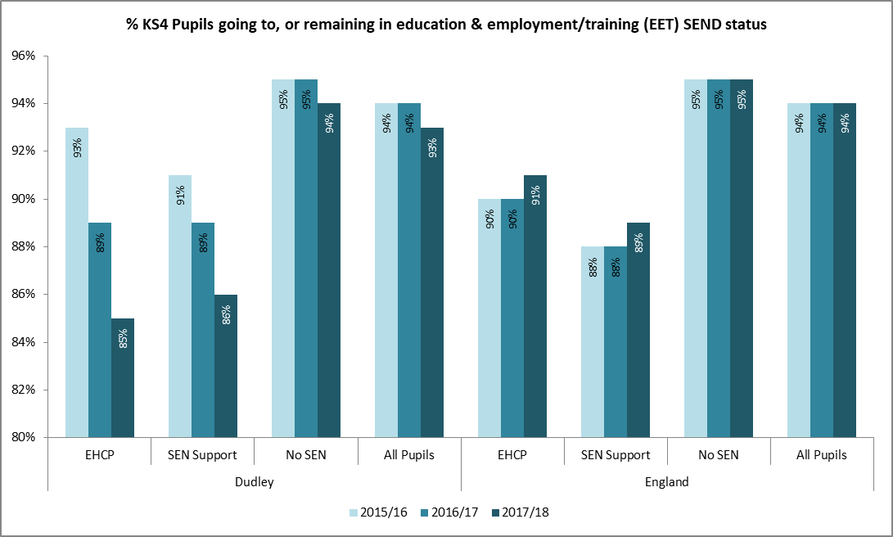

Post 16 attainment at age 19 reports on qualification progress made by young people after completing their GCSEs. Young adults’ between the ages of 16 and 18 are expected to either be in education or undertaking an apprenticeship or traineeship. This means that many more students with SEND will require additional support with their education after the age of 16.

Attainment of Level 2 equates to achievement of 5 or more GCSEs at grades A*-C /1-5, or a Level 2 vocational qualification of equivalent size. Attainment at Level 3 equates to achievement of 2 or more A-levels or equivalent size vocational qualifications.

Eight in ten young adults in Dudley achieved Level 2 and above by age 19. This rate is broadly in line with that of benchmark groups. However, the proportion achieving similar qualification including English and Maths is significantly lower at about 20 percentage points below and this measure is also below that of all benchmark groups.

Chart 54: Post 16 – Attainment of level 2 and above including English and Maths by age 19

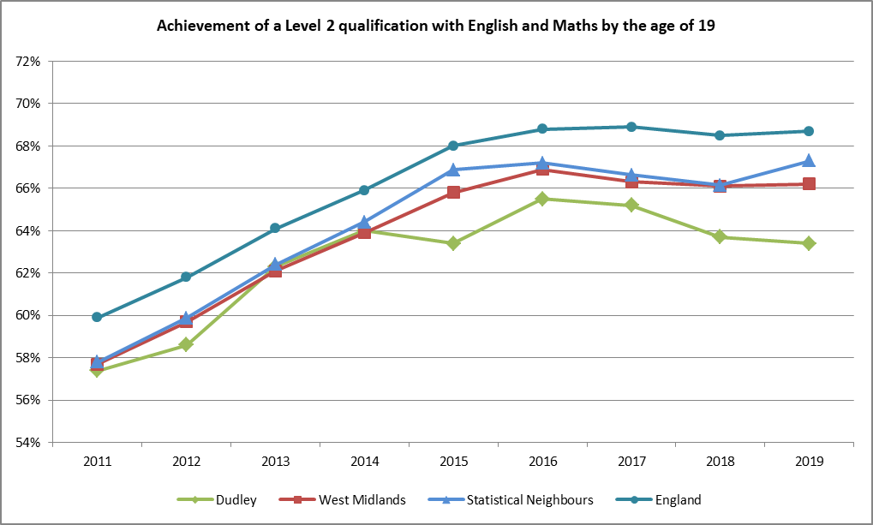

The proportion of young adults with SEND (EHCP and eligible for SEN support) at age 15 and who reached Level 2 with English and Maths by age 19 is below that of their peers without SEND. In Dudley, a smaller proportion of pupils with SEND – EHCP (13.7%) and SEN support (28.5%) attained Level 2 at age 19 and this is below that of benchmarked groups.

Chart 55: Post 16 - Attainment of level 2 including English and Maths by age 19 by SEND status

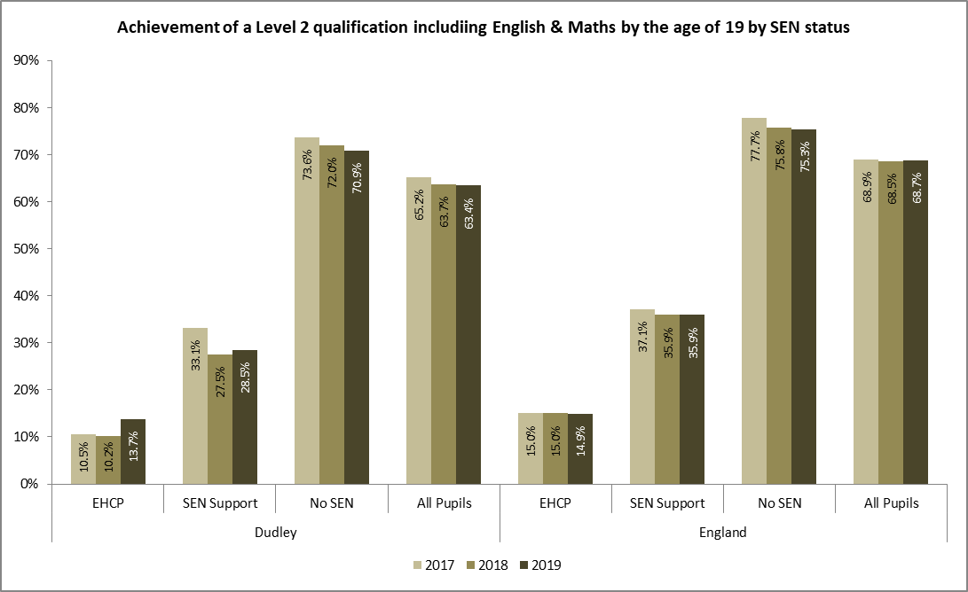

Of all young aged 19 in Dudley 51.5% achieved level 3 qualifications and this is below that of all benchmarked groups England (56.9%), West Midlands (54.9%) and Statistical Neighbours (SN) (52.6%).

Of the young people with EHCP; 10.5% achieved level 3 qualifications which is lower than Statistical Neighbours (12.3%) and England (12.5%) averages. 28% of SEN pupils eligible for SEN support attained level 3 in 2019 and is better than average for Statistical Neighbours (25.1%).

Chart 56: Post 16 participation – Attainment of level 3 by age 19 by SEND status

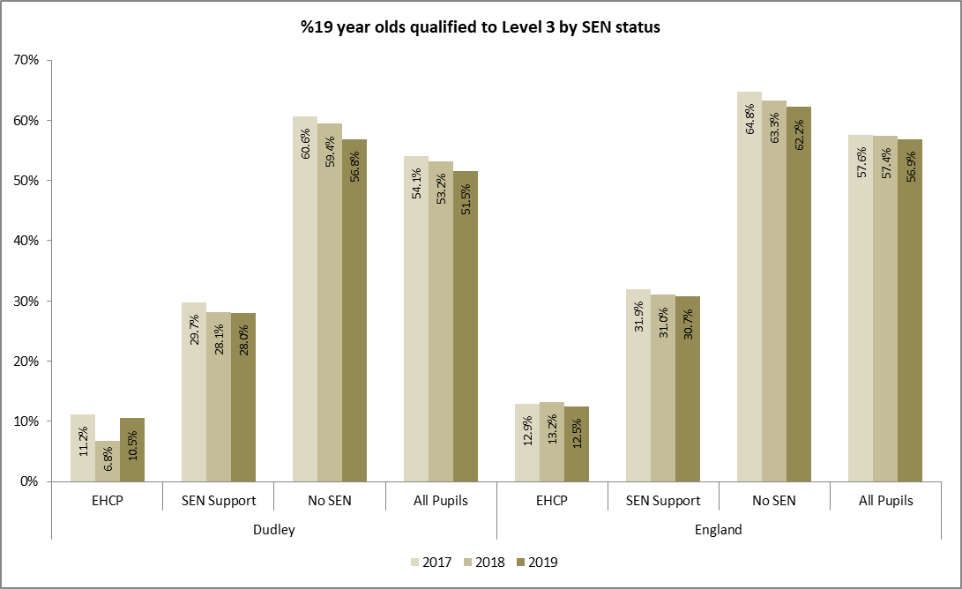

Key note:

***Educational attainment all stages including Early Years Foundation to KS4 for all pupils in Dudley is generally below that of benchmarked groups. Pupils with SEND in Dudley do worse than their peers with similar background characteristics in England. Pupils with an EHCP are particularly affected with lower performance when compared with peers with EHCPs. However, attainment for SEN support pupils in Dudley at the end of KS2 is slightly better than England average for similar peers in 2019.***

## Preparation for adulthood

The SEND reform place increased emphasis on supporting children and young people with SEND to make a positive transition to adulthood, including paths to employment, good adult health, independent living and making positive participation.

Continuation of EHCPs post-19 should not be automatically discontinued based on chronological age but be assessed on individual needs basis. Efforts should also be made to access Adults services.

Transition from children to adults’ services is an important stage to consider for children and young people with special educational needs. Transition should be a purposeful and planned process including education, health and social care. Good practice dictates that this should be planned early enough when aged 13 to 14.

Having high aspirations are crucial to successful transition and should include setting of longer term goals that start before young person gets to year 9; around age 13 to 14. These goals will focus on the child or young person’s strengths, aspirations, needs and capabilities and the outcomes they want to achieve.

Preparing for adulthood means preparing for:

* higher education and/or employment which includes exploring different employment options, such as support for becoming self-employed, supported internships and help from supported employment agencies.
* independent living whereby young people have choice, control and freedom over their lives and the support they have, their accommodation and living arrangements, including supported living
* participating in society, including having friends and supportive relationships, and participating in, and contributing to the local community
* ensure young adults with SEND are as healthy and resilient as possible in adult life

There is also the NICE guidance on transition from [children’s to adult’s services](https://www.nice.org.uk/guidance/qs140) for young people using health or social care services which is relevant for some young people with SEND.

Participation of 16 and 17 year olds – With the expansion of compulsory school age to 18, increasing number of young people are staying on in education including those with SEND. In March 2019, 88.3% of 16-17 year olds with an EHCP in Dudley were in education and training. This is 3.5 percent lower than those without a SEN (91.8%). However, participation of EHCP pupils in Dudley is in line with England (88.6%) average and there was significant narrowing of participation gap compared to 2018 (9.0 percent gap).

Nationally, 23.1% of young adults under 19 with self-declared learning difficulties and/or disabilities were participating in Further Education (FE). This compares with 17.2% of those aged 19 and over with self-declared learning difficulty and/or disability (LDD) in the 2018/19 academic year

Destinations measures show the percentage of students with sustained participation in education destinations including schools, further education or sixth-form colleges and higher education institutions (HEI); those that went into apprenticeships and employment.

**After Key Stage 4 -** 85% of pupils with an EHCP in Dudley were in a sustained education or employment/ training destination six months after completing Key Stage 4 (2 terms after GCSE); this is below England average of 91%. The proportion of pupils eligible for SEN support is slightly higher at 86% but this is also below England average (89%) for peers with similar characteristics (2017/18 destinations).

**At age 17** **-** In Dudley, 88% of KS4 pupils identified with SEN were in education, employment or training (EET) at age 17 compared with 94% of those without. 82% of those with an EHCP were in EET at age 17 (the year after completing KS4 studies). This compares to the previous period of 97% and England (91%), West Midlands (90%) averages. Of those eligible for SEN support; 90% were in education, employment or training at 17 compared with England average of 89% (2018/19 destination).

Table 20: KS4 (GCSE) destination by SEN status

|  |  |  |
| --- | --- | --- |
| **KS4 destination** | **Dudley** | **England** |
| % KS4 cohort with EHCP in EET | 82 | 91 |
| % KS4 cohort with SEN Support in EET | 90 | 89 |
| % KS4 cohort with no identified SEN in EET | 94 | 95 |

**After Key Stage 5** is the period of education covering pupils aged 16-18. SEN students in mainstream schools had destination outcomes similar to all other students in 2019. 100% of the eighteen 16 to 18 year olds with SEN in Dudley progressed to sustained education, employment or training six months after completing their KS5 studies compared to 92% without (2017/18 destination). Latest figures for 2018/19 shows a drop in performance to 80% but this could be related to the small cohort size for this group of pupils. Nationally, 86% of pupils with SEN in mainstream schools progressed to a sustained education, employment or training destination six months after completing Key Stage 5, compared to 88% of those without SEN (2018/19 destination)[31].

In Dudley, 76% students with self-declared Learning Difficulties or Disability (LDD) in colleges progressed to a sustained education, employment or training (EET) destination compared with 80% of their peers without LDD. This compares to England average of 78% with LDD and 77% without LDD progressing to sustained EET.

Progression to higher education In 2017/18, 18.4% of pupils identified with special educational needs nationally in year 11 entered HE by age 19, compared to 48.0% of pupils who were not identified with special educational needs in year 11. For those with an EHCP in year 11, 8.5% had entered HE by age 19 and for those with SEN support in year 11, 20.8% had entered HE by age 19. All groups have seen increases in these percentages in recent years.

### Learning disability in employment

Proportion of adults with learning disabilities in paid employment - The measure shows the proportion of all adults (aged 18-64) with a learning disability who are known to the council, who are recorded as being in paid employment. The definition is restricted to those adults with a learning disability (with a primary support reason of LD) who have been assessed or reviewed by the council during the year. This is irrespective of whether or not they receive a service or who should have been reviewed but were not. The measure is focused on paid employment only.

Paid employment is measured using the following two categories:

* Working as a paid employee or self-employed (16 or more hours per week); and,
* Working as a paid employee or self-employed (up to 16 hours per week).

The proportion of adults with learning disabilities in paid employment in Dudley was 3.9% in 2019 compared with England average of 5.6%. Dudley’s performance in this measure has remained consistently below national average for the last 5 years.

Chart 57: % of adults with learning disability in paid employment

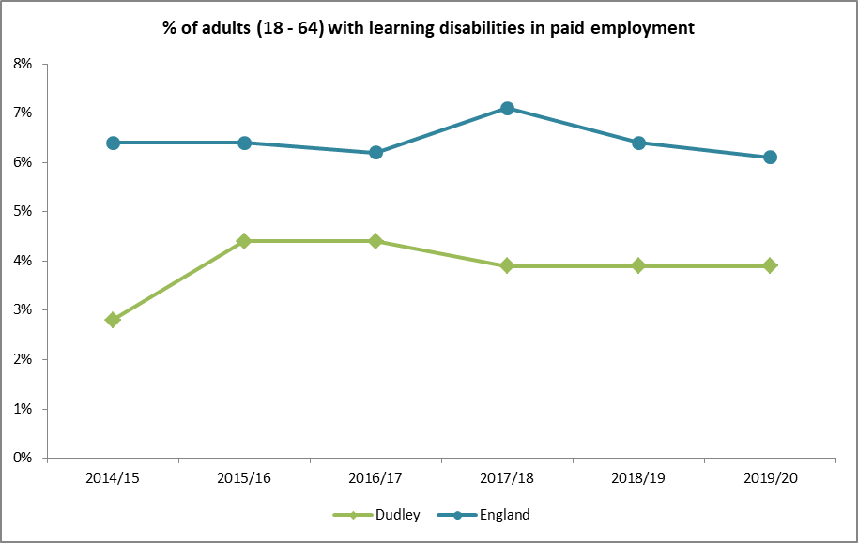

### Independent living

The measure shows the proportion of all adults (aged 18-64) with a learning disability who are known to the council, who are recorded as living in their own home or with their family. The definition is restricted to those adults with a learning disability (with a primary support reason of LD) who are receiving long term support from the council during the year. This is irrespective of whether or not they receive a service or who should have been reviewed but were not.

Living on their own or with their family describes arrangements where the individual has security of tenure in their usual accommodation, for instance because they own the residence or are part of a household whose head holds such security.

In Dudley, 64.2% of adults (defined as 18-65 year olds) with learning disabilities who were receiving support from social services lived in their own home or with families, compared to England average of 77.3% in 2019/20. Performance has remained relatively the same in the last five years and is also below England average.

Chart 58: % of adults with learning disability living independently

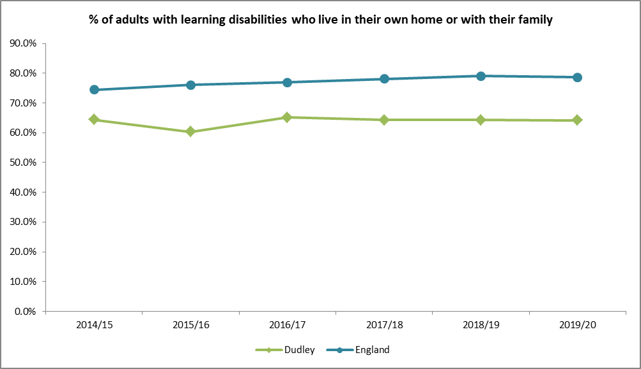

Key note:

***Provision of adequate accommodation for the most disadvantaged together with paid employment opportunities is an imperative focus for Dudley. Good educational experience and attainments will help in securing good quality paid employments for pupils with learning disabilities.***

# EHCP Process - Assessments and New Plans

Education, Health and Care Plans (EHCPs) for children and young people aged up to 25 were introduced on 1 September 2014 as part of the Special Educational Needs and Disability (SEND) provisions in the Children and Families Act 2014. However, the legal test of when a child or young person requires an EHCP remains the same as that for a statement under the Education Act 1996.

The proportion and number of **children and young people (aged 0-25)** for whom EHCP were made for the first time during the calendar year has remained consistently high in Dudley compared with benchmark groups.

## New Education, Health and Care Plans

A total of 493 initial requests for EHCP assessment were made during the 2019 calendar year, an increase of 33% from the volume in 2018. This is significantly faster than the West Midlands (8%) and England (10%) rates.

7% of initial requests for an EHCP assessment in Dudley were refused in 2018 and only 2 requests refused in 2019; these are below West Midland (25%) and national average of 23% in 2019. This calls to question our decision threshold and consistency of approach. Massive communication and workforce strategy are being implemented to learn and address these issues.

There has been steady increase in the number of children for whom EHCPs are issued for the first time in Dudley. A total of 444 children and young people had EHCPs issued for the first time during the 2019 calendar, indicating additional 202 (74%) children compared with numbers five years ago.

Slightly more cases were referred for mediation than previous years; however the number going to tribunal regarding new plans was negligible (only one in 2019).

Table 21: Number of new EHCPs issued per calendar year - Trend

|  |  |  |  |  |  |  |  |  |  |  |  |
| --- | --- | --- | --- | --- | --- | --- | --- | --- | --- | --- | --- |
| **Calendar year** | **2010** | **2011** | **2012** | **2013** | **2014** | **2015** | **2016** | **2017** | **2018** | **2019** | **2020 (YTD)** |
| **No. of new EHCPs** | 266 | 231 | 190 | 99 | 95 | 121 | 242 | 272 | 335 | 444 | +305 |
| Year on year growth | - | -13.2% | -17.7% | -47.9% | -4.0% | 27.4% | 100.0% | 12.4% | 23.2% | 32.5% | -31.3% |

The number of new EHCPs for CYP aged 5 to 10 increased the fastest at rates above benchmark groups. However, their proportionate share of new plans is comparable to that of benchmark groups.

Table 22: New plans by age group

|  |  |  |  |  |  |  |  |  |  |  |  |  |
| --- | --- | --- | --- | --- | --- | --- | --- | --- | --- | --- | --- | --- |
|  | **Dudley** | | | | **West Midlands** | | | | **England** | | | |
|  | **2016** | **2017** | **2018** | **2019** | **2016** | **2017** | **2018** | **2019** | **2016** | **2017** | **2018** | **2019** |
| Under 5 | 26% | 21% | 25% | 20% | 26% | 24% | 25% | 23% | 25% | 23% | 23% | 23% |
| Age 5 to 10 | 44% | 47% | 41% | 45% | 46% | 48% | 45% | 45% | 45% | 46% | 46% | 47% |
| Age 11 to 15 | 18% | 22% | 21% | 23% | 22% | 22% | 25% | 26% | 22% | 23% | 25% | 25% |
| Age 16 to 19 | 6% | 4% | 7% | 10% | 5% | 5% | 4% | 5% | 6% | 6% | 4% | 5% |
| Age 20 to 25 | 6% | 6% | 7% | 2% | 1% | 1% | 1% | 1% | 2% | 2% | 1% | 1% |
| No of new EHCPs | 242 | 272 | 335 | 444 | 4,130 | 4,424 | 4,714 | 5,096 | 36,094 | 42,162 | 48,907 | 53,899 |

### Timeliness

The proportions of new EHCPs issued during calendar year’s and within the expected timescale of 20 weeks (excluding cases where exceptions apply) have dropped significantly in the last 3 years. This has been very challenging for Dudley due to operational issues including capability, workforce, quality of plans, increased workload as demonstrated by the number of requests and concerns about leadership. These issues were reflected in the May 2019 SEND inspection and to which a Written Statement of Action (WSoA) is now in place.

During 2019, 42% of plans were issued within the expected time limit in Dudley (excluding exceptions); this is well below national (60.4%), Statistical Neighbours (73%) and West Midland (54%) averages. When including cases where exceptions apply, 48% were issued in Dudley and is below national average of 58.7%.

Chart 59: Proportion of EHCP assessments completed within expected timeframe

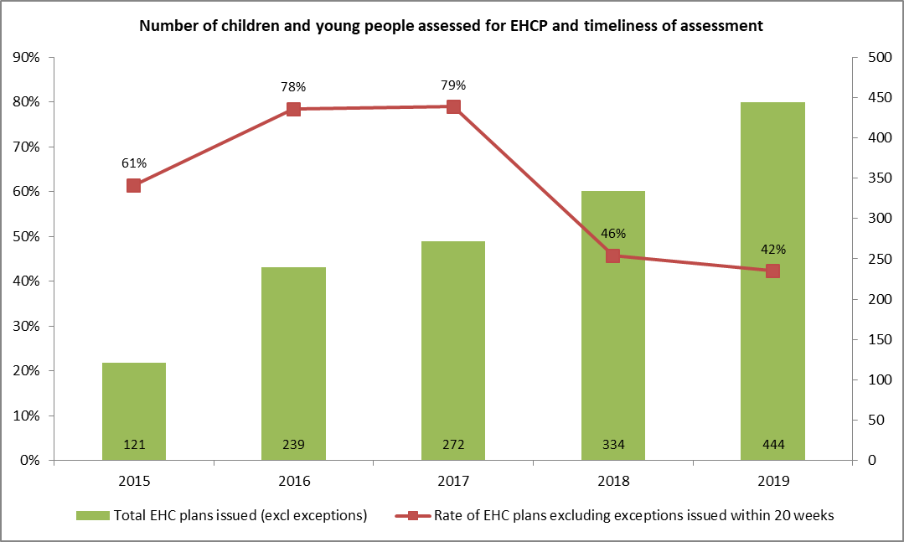

Key note:

***The impact of the high conversion rate of requests to plans along with the increasing number of requests received is reflected in key performance indicators such as timeliness and is a big challenge for Dudley with regards to resources, capacity and sustainability.***

## EHCP Process - experience of the system and quality assurance

A central aim of the reforms was to ensure that the experience of gaining support was positive for children, young people and their families. If a child’s parent or the young person is dissatisfied with their EHC needs assessment or plan, they can appeal to the First-tier (Special Educational Needs and Disability) Tribunal. The tribunal hears appeals against decisions made by the local authority.

Early and continued parental involvement in the EHCP assessments process is integral for planning and meeting the needs of children and young people with SEND. This includes dispute resolution and addressing of concerns through local mediation before going through the appeal process.

The appealable decisions are: refusal to carry out an EHC needs assessment (and refusal to reassess); refusal to issue an EHCP; refusal to amend an EHCP following a review or reassessment and a decision to cease to

maintain an EHCP. There are also rights of appeal about the contents of an EHCP which can be about: (i) The child or young person’s special educational needs; (ii) The special educational provision specified in the EHCP; (iii) The school or other setting named in the EHCP or the type of school or setting; (iv) If no school or other setting is named, that fact.

The number of 'appealable decisions' is the sum of number of initial requests for EHC assessments refused, number of assessments completed and decision made not to issue an EHCP, number with an P as January each year and number of EHCPs ceased because the special educational needs of the child or young person are being met without an EHCP. Mediation is when an impartial person, who is trained to deal with two opposing sides, acts as a referee in a dispute. Effective mediation provides a cost effective alternative in resolving disputes between parents, young people, health services and/or local authorities concerning the provision made for children with SEND.

In 2019, a total of 7 new EHC cases went through mediation in Dudley. One case indicating [12.5](https://derivation.esd.org.uk/?metricType=4864&period=cal_2019&area=E08000027&outputType=both&organisationID=&withArea=&withPeriod=&methodType=none)% went on to appeal following mediation in the same calendar year.

A total of 63 SEND tribunal appeals (existing cases) were held in 2019 indicating a rate of 2.7% with compares to West Midland average of 1.4%. Tribunal can be made in relation to a number of different decisions made by the local authority including refusal to assess a child with special educational needs, refusal to issue a EHCP following assessment, type of school placement offered or the contents of the EHCP once it has been finalised.

### Quality of EHCPs

The number of initial requests of EHC assessments increased rapidly by 85% over the last four years to 493. In Dudley an EHC assessment is more likely to result in the issue of an EHCP. In 2019, less than 1% of EHC assessments resulted in an EHCP being declined. This was 6.3% and 7.5% for West Midland and England respectively. Very few requests for assessments have been refused and this has dropped to two from the high number of 62 in 2017. The reasons for high conversion rates in Dudley are unclear and call to question our threshold management.

EHCPs can utilise personal budgets to enable greater personalisation and provide choice and control. The number of children and young people issued has increased progressively and almost 200 people were in receipt of personal budget in 2019.

The law requires all EHCPs are reviewed at least annually by the local authority and this often referred to as Annual Review. The exception to this is in Early Years, where EHCPs should be reviewed every 3 to 6 months. Performance of annual reviews has dropped consistently in recent years and this is an identified concern being rectified. It is accepted that it will take a few months/years before the positive effect of new strategy to be reflected in this KPI.

**Annual EHCP reviews** - Andy Kinsella/Ian Cope to add trend data

|  |
| --- |
|  |

## Reported expenditures

Chart 60: Average spend per population of 0 – 17 year old on children with disabilities.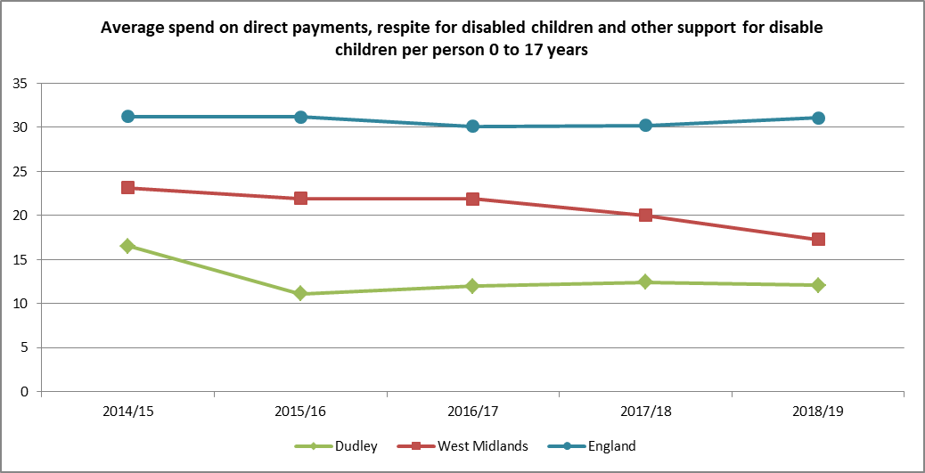

Outturn weekly expenditure per child on special educational needs (SEN) includes s251 budget lines for SEN support services, Direct Payments (SEN and disability); SEN Transport, Home to school transport (pre-16): SEN transport expenditure, SEN Admin, assessment and coordination and monitoring.

Average weekly expenditure on SEN; that is on children and young people for whom Dudley maintains their EHCP is £120 compared with last year’s average of £125. Dudley average expenditure in 2019 is higher than England (£105) and the West Midlands (£95) in the same period.

### Personal budgets

The SEND reforms enabled greater personalisation of support through the use of a personal budget. This provides children and young people with real choice, flexibility and control over the design of their care and education package.

The personal SEN budget is sum of money made available by the local authority when if it is clear that without this additional (top-up) funding, it will not be possible to meet the child’s learning needs. Through personal budget, SEND children and young people with EHCPs are able to take charge of the support they require to live independently, see how much money is available to buy the care they need that best meets their needs and help to achieve their aspirations for the future.

In Dudley, a total of 191 personal budgets were taken up by children and young people (aged 0-25) where an Education, Health and Care EHCP has been issued, transferred or reviewed in the year in 2019, indicating additional 32 payments compared to the previous year. All recent payments were committed through integrated services and were taken up via direct payment giving greater flexibility and control.

Chart 61: ***Uptake of direct payments due to education, health and care plans***

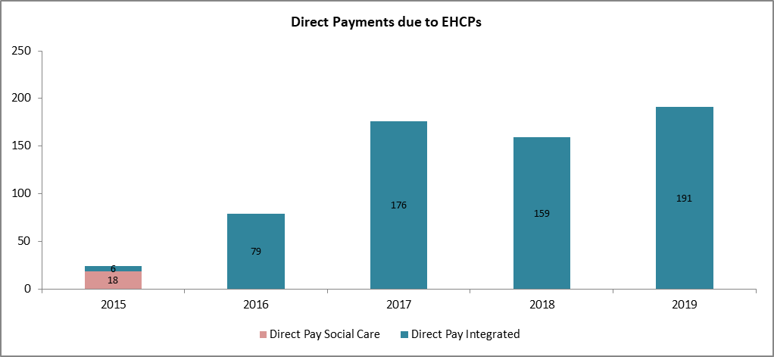

### Disability Living Allowance (DLA) claimants

Some individuals identified as having a disability may be eligible for statutory benefits such as the Disability Living Allowance (DLA), access charity aid, voluntary services or some condition specific benefits.

A total of 2,710 children and young people were in receipt of disability living allowance in Dudley (ONS data, November 2018). As with all previous data sets; almost seven in ten are males and 44.3% are aged between 5 and 10 years. Distribution of DLA claimants is skewed towards children of compulsory school age 5 to 15 accounting for eight in ten of all claimants in Dudley and benchmark groups.

Table 23: Disability living allowance claimants 2018

|  |  |  |  |  |  |  |
| --- | --- | --- | --- | --- | --- | --- |
| Age | Male | Female | Dudley Total | Dudley % share | West Midlands | England |
| aged under 5 | 220 | 120 | 330 | 12.2% | 11.3% | 10.6% |
| aged 5 to under 11 | 860 | 340 | 1,200 | 44.3% | 42.2% | 41.2% |
| aged 11 to under 16 | 700 | 340 | 1,040 | 38.4% | 40.2% | 38.7% |
| aged 16-17 | 70 | 30 | 100 | 3.7% | 3.6% | 3.5% |
| aged 18-24 | 20 | 10 | 30 | 1.1% | 2.7% | 6.0% |
| Total | **1,870** | **840** | **2,710** | **2,710** | **50,600** | **456,690** |

Source: ONS benefit data 2018

## EHCP process - experience of the system and user views

Partners (Education, Health, Social Care, Integrated Specialist Providers etc.) work together to maximise benefits to each and every child. Many of the services outlined are jointly funded by Dudley Local Authority and Dudley Clinical Commissioning Group and there are joint transformational activities taking place that consider the overall pot of funding for the service and collaboratively design future system approaches.

Children and young people receive specialist support linked to their special educational needs and/or disability. Where an EHCP is in place, the provision will be specified.

Strong collaborative working with parents, carers and young people with disabilities helps to identify what works well, their unmet needs and identify improvement options that lead to effective Co-production. Recent Ofsted inspection (2019) identifies this area for improvement, reporting a great deal parental dissatisfaction, that co-production with parents is week and needs wider strategic ownership.

It is imperative that the perceptions of children, young people, their parents and other stakeholders are identified in terms of unmet needs and working together to address these gaps.

# Local Offer

A key element of the SEND Code of Practice is the provision of a Local Offer. The Local Offer aims to provide clear, comprehensive and accessible information about what services and provisions are available for children, young people and their families in Dudley.

[Dudley Local Offer](https://www.dudley.gov.uk/residents/dudleys-local-offer/) is a collation of information about services, support and leisure activities for all children and young people with SEND from early years to transition into adulthood.

The Local Offer gives children and young people with special educational needs or disabilities, and their families, information about what support services are available in the local area and how to access these services.

The right **support** from professionals – such as GPs, paediatricians (doctors who specialise in treating children), speech and language therapists, physiotherapists, educational and clinical psychologists and social care – helps **people** with a **learning disability** live as full and independent a life as possible. Strength base support using well-evidenced interventions targeted at areas of difficulty and where necessary specialist equipment or software will be provided.

Information, advice, and guidance regarding provision across education, health and social care for children and young people with SEND can be found in the online [Dudley Local Offer directory](https://www3.dudley.gov.uk/Synergy/LocalOffer/Enquiries/Search.aspx?searchID=33). For ease of accessibility, written version is also available for children and families who prefer this version.

Some of the services listed are provided by the council, but others come from external organisations such as health services, voluntary sector organisations, or businesses.

It is accepted that the Local Offer as it is may be underused and difficulties in navigating the site. As part of the written statement of action developed after the recent Ofsted inspection; the website is planned to be refreshed encouraging contributions for users, parents, health, education and social care professionals and relevant stakeholders.

The Local Offer outline includes information, advice and guidance on areas such as:

* Early Years Support
* Pre and post-natal maternity– smoking cessation, diet and general well-being
* Special Educational Needs Coordinators (SENCOs)
* Safeguarding and strengthening families focusing on early intervention and support in addressing issues such as worklessness, domestic abuse, mental health etc.
* Child, young carers and family respite services through short breaks
* EHCP process – expectations, time line, complaints, appeals and compliments/feedback
* Community services and referrals such as CAMHS, Audiology
* Specialist/Therapeutic Services including occupational therapy, speech and language, physical and behavioural
* Health services – diagnosis and treatment
* Community nursing services, health visitors, school nurses, paediatric and genetic condition specialist etc.
* Preparing for adulthood – training, education and employment access opportunities
* Personal and direct payment opportunities promoting control, independence and choice
* Participation, involvement and contribution – voice of the child, young person and parents.
* Links to voluntary and community organisations that provide support

### Dudley Early Years Area SENCO’s

Dudley Area SENCO’s are available to provide support and guidance to settings and childminders to ensure that they are providing standard inclusive practice as part of their universal offer. Their advice and guidance is also available to settings when considering the level of an individual child’s needs. A SENCO’s will support applications for Emerging and Lower Level needs funding.

### Specialist Early Years’ Service (SEYS)

The Specialist Early Years’ Service (SEYS) provides targeted support to individual children within settings. SEYS will support applications for Higher and More Complex Needs funding

**The Phoenix Centre** is an independent charity in a self-contained centre which runs a Pre-school and Play group for children with an additional need, developmental delay or disability who live within the borough of Dudley.

**The Leapfrog Group** is a specialist group based within Netherton Park Nursery School. The school is part of Dudley [Specialist Early Years’ Service](https://www.dudley.gov.uk/residents/care-and-health/dudley-disability-service/children-with-disabilities/specialist-early-years-service/) (SEYS) and provide education and care for children with complex communication needs.

**Brockmoor** specialist nursery is a nursery for children with severe and complex special educational needs. It currently caters for 10 children in the morning and 10 children in the afternoon. Brockmoor specialist nursery delivers the Early Years Foundation Stage Curriculum differentiated to meet the individual needs of children attending.

### Therapeutic family support

* Speech and Language Therapy Services – SALT
* Assessing and identifying need, reviewing and working with families and schools to support.
* Receptive language, cognitive skills and high targeted needs
* Named therapist at each school
* Specialist training for school workforce

### Occupational therapists

* Dudley Children’s Occupational Therapy: Children and young people aged 0-18 in Dudley who have a physical, sensory or perceptual difficulty which affects their independence and daily life.

### Other services

There are a range of services within the Dudley Borough that will offer advice, support and guidance in addition to SEYS and Dudley Area SENCO’s, these include;

* Visually Impaired Service
* Hearing Impaired Service
* Physically Impairment and Medical Inclusion Service
* Educational Psychology Service

Other services are available to support families and children with SEND. More information can be found on the [Local Offer enquiry database](https://www3.dudley.gov.uk/Synergy/LocalOffer/Enquiries/Search.aspx?searchID=33).

Feedback from young people with SEND and their families in Dudley on existing Local Offer indicates that the website needs to have more links to social media, be more visual, and to include more details on services including opening hours.

### Dudley Voices for Choice

There are organisations such as [Dudley Voices for Choice](https://www.dudleyvoicesforchoice.org.uk/) which is a user led charitable organisation that supports people with learning disabilities and autism to speak up for themselves. The organisation works with the various parents /carers groups/forums to give a coordinated voice in addressing the needs of children and young people with disabilities.

As well as providing information, support and advice to parents, parent representatives attend strategic and commissioning meetings, helping to

* Advocate for parents and service users;
* Employment and training opportunities for people with learning disabilities and autism ‘Experts by Experience’;
* Ensure information available for children and young people with disabilities is relevant, accessible and fit for purpose.
* Learning disability awareness trainings

The organisation is committed to addressing OfSTED inspection finding to harness the passion and commitment of the various parent groups/forums as many parents feel disengaged with the system

You can access Dudley’s local offer here: Local Offer

### Other relevant and helpful links to some key documents:

The government sets out a [range of guidance materials](https://www.gov.uk/topic/schools-colleges-childrens-services/special-educational-needs-disabilities) for schools, colleges and children’s services in providing for children and young people with SEND. This is encapsulated in the [SEND Code of Practice for 0 to 25 years](https://assets.publishing.service.gov.uk/government/uploads/system/uploads/attachment_data/file/398815/SEND_Code_of_Practice_January_2015.pdf), however specific guides are also provided for schools, social care professionals, parents etc.

Further guidance is given on subjects such as supported internships, [short breaks](https://www.gov.uk/government/publications/short-breaks-for-disabled-children), and education for children who cannot attend school. Early years provision and the identification of SEND, as it applies to children under primary school age, is discussed in the [Early Years guide](https://www.gov.uk/government/publications/send-guide-for-early-years-settings) and statutory framework.

Transition from [children’s to adults’](https://www.nice.org.uk/guidance/qs140) services quality standards was developed by the National Institute for Care and Excellence (NICE) in 2016. It is aimed at service providers and addresses the needs of young people with [mental health problems](https://www.nice.org.uk/guidance/qs142), disabilities and long-term, life-limiting or complex needs, and those in secure settings or under the care of local authorities.

# SEND (Education, Health and Care Plan) - Projections

The impact and extend of support for special educational needs are not solely based on numbers as each case varies in complexity and severity. However, it is much more difficult to evidence an increase in the severity and complexity of need as opposed to simply an increase in numbers. A good example is the group with cognition and interaction or specifically ASD which is a broad spectrum and there is no marker for identifying severity or complexity within the school and SEN2 statutory data collections. At the moment, level of complexity is based on the need to attend special schools because these cannot be met in mainstream settings in spite all additional adaptations and resources.

This section attempt to review the impact of increasing EHCP demands, estimate potential future numbers and inform demand management, assessment and provision planning.

Dudley local authority and partner agencies have a statutory duty to ensure there is enough suitable school places for all children, including those with Special Educational Needs and Disabilities (SEND). It is important that DMBC is able to plan effectively for this group of pupils, not least because they are a vulnerable group, are growing in number and often require very costly provision.

Data on children with EHCP is slightly better for this exercise than that on those with disability. This is because of difficulties in identifying and quantifying CYP with disability and their level of needs may be mild to moderate, hence may not be known to partner organisations (health, education or social care). Coding and system differences together with definitions also play in part in the lack of common understanding. Medical information and codes used in health systems do not easily translate to social care or education. However, one common denominator with regards to SEND is where it affects the everyday and learning experiences.

National census records the number of children with a long-term health problem or disability which limits daily activity. In 2011, there were 4,318 children and young people (aged 0-24 years) with disability that limits daily living activities. This number is expected to increase as the overall population increases together with improved identification and categorisation of needs. It is estimated that about 8% of children population (2019 national Family and Resources Survey (FRS)[32]) have a form of disability which can be extrapolated to 8,000 children and young people in Dudley.

Key data sources used to inform projected EHCP include;

* Number of children and young people with EHCP in place at the end of January for the years 2016 to 2020;
* Dudley’s 0 to 25 year old population projection figures from the Office of for National Statistics (ONS) 2018 based population projections [33]and;
* Live birth rates (ONS - Births in England and Wales: 2019).
* Net population migration (ONS 2018).

The forecast and projections are conservative based on the ‘to be’ approached reflecting impact of current interventions and additional supports.

The number of children and young people for whom the authority maintains their plan has increased significantly in recent years with over 2,600 records currently live on the LA system (September 2020), demonstrating continued growth. (There is question on the live information as this may include legacy data quality errors that are being worked through, hence using actual outturn datasets). The number of EHC plans is estimated to exceed 2,500 in 5 years’ time; indicating need for additional 200 places by then.

Chart 62: Projection of children and young people with EHCPs

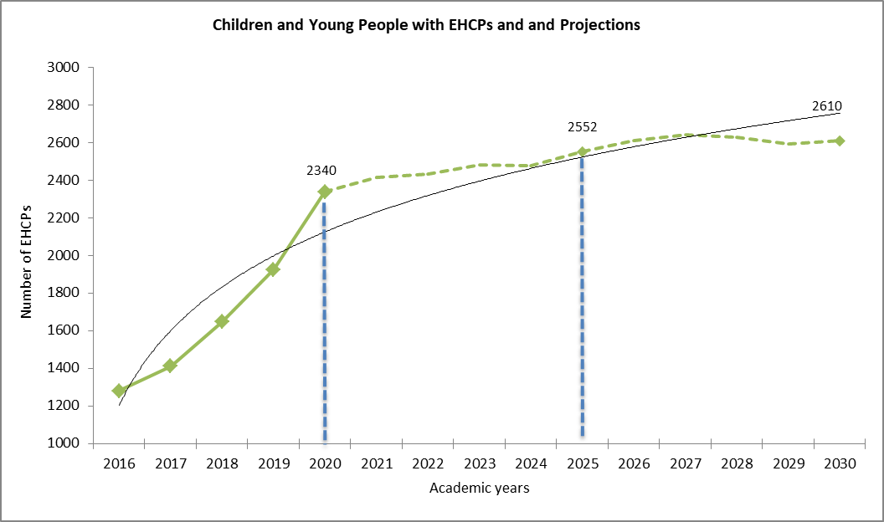

The number and proportion of children aged 11 to 15 is projected to grow the fastest in terms of high volumes by year 2025.

Chart 63: Projection of children and young people with EHCPs by age group

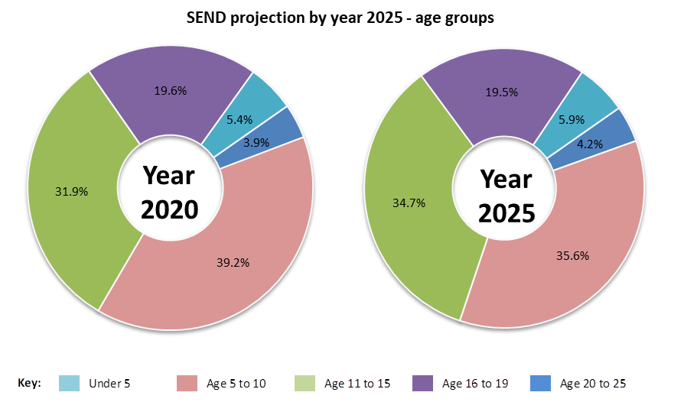

Dudley LA together with other local authorities have a statutory duty to make sure there are suitable school places for all children, including those with SEND. It is important that local authorities are able to plan effectively for this group of pupils, not least because they are a vulnerable group, are growing in number and often require very costly provision.

Demand for high quality provision and specialist places within local settings are slowly outstripping local provision. There has been an unprecedented and significant increase in the number of children and young people with EHCPs that increased by 83% over the last 5 years, with an average annual growth of 17%. Placement out of the borough is known to be expensive including transportation etc. have also increased. The number of children educated within independent settings (educated elsewhere above) has grown by 200% in last 5 years. This is not sustainable on long-term and Dudley will need to plan for more local solutions including use of mainstream settings easing the over reliance on special schools as well as to encourage embedded integration and inclusion.

If the number of children with EHCPs continues to increase yearly at the recent rate of 17%, there will be over 5,000 children with EHCP by year 2025. However, conservative projections taking into consideration recent post inspection action plan, workforce strategy, improved threshold management as well as ONS population growth and birth rates. It is modestly estimated that additional 230 children with EHC plans will require support by the 2025.

### Reasons for EHCP growth locally

The reasons for the increase in the numbers and needs of young people with EHCPs are being subjected to intense national and local scrutiny. Recent OfSTED inspection highlighted the need for strategic approach to assessment and provision mapping. That children with SEND need to be accurately identified, recorded and moderated over time as well as the need for co-ordination of assessment information between agencies.

Another factor is the impact of the Children & Families Act 2014 and the *presumption to assess* has clearly created additional pressure which is resulting in more assessments and increased number of plans being issued with subsequent demand for specialist places and additional costs. In 2019, 99% of all assessments in resulted in EHCPs, this is higher than WM (93%) and national rates (95%). Another contributory factor is the inconsistent approach to threshold management during the EHCP process.

The overall increase in the children with EHCPs, the changing complexity level and types of need has played a part, as has the absolute duty on a local authority to provide appropriate provision irrespective of ‘allocated’ budget.

In addition, the top age group for those eligible for an EHCP assessment has also risen to 25 from 18/19 years old but with no additional funding to support the 19-25 pupil population creating further financial burden. The number of young adults qualifying for a plan is not significant in Dudley and has actually dropped in numbers recently. Conversely, the numbers of children aged 5 to 10 being issued with plans has grown the fastest in 4 years.

One of the major issues facing most local authorities is continued escalation of unfunded SEND cost by the central government and the resulting overspend. This on-going pressure resulting from increasing demand, together with increasing complexity requiring specialist support is not just a local issue but a national one. In 2019, the number of request for assessments increased by 46% in Dudley from the previous year compared to 12% nationally and 8% in the West Midlands. Practically all requests for EHCPs led to assessments being issued in Dudley with only 0.4% of request refused compared with England (23%) and the West Midlands (25%).

Key note:

***Significant increase in the number of issued with EHCP in recent years. More children educated elsewhere including those awaiting provision and not in school has also grown by 200% in last 4 years.***

***The proportion attending independent settings have also increased by over 100% to 95.***

***This is not sustainable and Dudley needs to plan for more local solutions including use of mainstream settings. This will ease the over reliance on special schools as well as encourage integration and inclusion.***

# SEND Provisions in Dudley

Dudley local area strategy for children and young people with SEND to provide sufficient places locally, that pupils with SEND can access education as close as possible to their homes and ensure all schools are inclusive whilst adhering the Disability Act.

A total of 2,340 children have EHCPs maintained by Dudley in January 2020 having increased significantly by 83% over the last 5 years with annual average growth of 16% and resulting in demand for high quality provision and specialist places. Over 200 additional children now have EHCPs per year with more children being placed in independent settings including out of area placement. 2,645 children are currently open within the Case Management System (CMS - Synergy) indicating additional **300 children and young people in six months**. **Caution should be taken as per this high numbers as Dudley is currently overhauling its CMS and they may be some duplicates or legacy cases.**

#### Provision for children with EHCP - settings

January 2020 statutory SEN2 Annual Return shows that:

* 1,013 (43%) children and young people with EHCP attended Special Schools of which 918 are within Dudley.
* 807 (34%) attended mainstream schools including a small number in maintained independent setting.
* 364 young people were in further education of which 9% were in specialist post-16 institution (ISP).
* 70 children were awaiting provisions and include 11 children Electively Home Educated (EHE).

Table 24: Number of children with EHCPs by provision

|  |  |  |  |  |  |  |
| --- | --- | --- | --- | --- | --- | --- |
|  | 2016 | 2017 | 2018 | 2019 | 2020 | 2021  Provisional |
| Alternative provision/Pupil referral unit | 4 |  | 1 | 1 | 7 |  |
| Educated elsewhere | 33 | 31 | 49 | 64 | 103 |  |
| Further education | 32 | 90 | 158 | 246 | 364 |  |
| Mainstream school | 424 | 461 | 534 | 649 | 807 |  |
| NEET |  |  |  | 5 | 25 |  |
| Non-maintained early years | 4 | 5 | 3 | 2 | 21 |  |
| Other | 18 |  |  |  |  |  |
| Special school | 765 | 825 | 902 | 959 | 1,013 |  |
| Total | 1,280 | 1,412 | 1,647 | 1,926 | 2,340 | 2,645 |
| Year on year increase (No) |  | 132 | 235 | 279 | 414 | +305 |

Source: SEN2 annual return

There is currently a need for **200** additional specialist SEND placements across a broad range of needs in Dudley. As at September 2020, 170 children are placed in out of borough independent schools and 78 pupils were recoded to be awaiting placement during the SEN2 census in January 2020. Increasing number of young adults is placed in post-16 specialist provisions. Further data tracking will be required to ascertain that these children have now been successfully placed in appropriate settings.

The increase is not consistent across all primary needs. For example, the number of pupils with Social, Emotional and Mental Health (SEMH) needs increased by 37% indicating 60 more children requiring specialist SEMH support. In one year, additional 58 (17%) children now have Speech, Language and Communication (SLCN) as their primary need and 41 children have Autistic Spectrum Disorder (13%).

Should the number of children with an EHCP continues to increase in line with latest trends; these will further stretch local provisions and it is imperative that Dudley addresses these gaps locally rather than sending children out borough and to more expensive settings. Data business intelligence is expected to inform the demand management and place planning. It is acknowledged that not all children may be provided for locally either due to parental choices or lack of specialist capacity to meet their very complex needs. For example, some children with high level profound multiple learning needs may fall into this category.

Table 25: Change in number primary needs

Source: January school census

There are currently 2,645 children held within the local case management system (Synergy), unfortunately we are not able to demonstrate trends in primary needs as shown above. We have however used the annual school census data knowing that 91% of children in Dudley school live within the borough and one can assume that change in needs amongst school pupils is a reflection of the population.

The number, proportion and predominant needs of children with EHCPs vary with age groups. The numbers increase as age increases through primary years, peaking at age 10 and then declines through secondary years. The age distribution is skewed towards the younger age group and the majority of children with an EHCP are between the ages of 5 and 10 accounting for 41% of the EHCP population.

Increasing number of children with EHCPs are educated in mainstream settings and some with top up funding to ensure adjusted and enhanced learning opportunity. Unfortunately the pace of inclusion is not in par with the rate of demand and more children are attending special school settings or educated elsewhere.

Pressures resulting from increasing demand and lack of capacity meant that many specialist places are currently being commissioned in settings outside of Dudley. 12% of CYPs are educated out of borough and more than half attend independent schools.

Table 26: Location of provision – in or out borough – SEN2 return

| Primary Need | SLCN | MLD | SEMH | ASD | SLD | PD | HI | PMLD | OTH | VI | MSI | SPLD | Not known | Total | % share |
| --- | --- | --- | --- | --- | --- | --- | --- | --- | --- | --- | --- | --- | --- | --- | --- |
| Early Years | 2 |  | 1 | 1 |  |  |  |  |  |  |  |  | 45 | 49 | 2.1% |
| Bases | 3 | 7 | 6 | 1 |  |  | 23 |  |  |  |  |  | 2 | 42 | 1.8% |
| Dudley Mainstream | 277 | 174 | 138 | 85 | 1 | 56 | 12 |  | 9 | 5 |  | 3 | 15 | 775 | 32.8% |
| Dudley Special School | 226 | 208 | 71 | 208 | 102 | 17 | 3 | 28 | 5 | 3 | 5 | 1 | 27 | 904 | 38.2% |
| Post 16 - ISP | 4 | 9 | 13 | 9 | 4 | 5 | 1 | 3 |  |  |  |  |  | 48 | 2.0% |
| PRU | 1 | 2 | 10 |  |  | 2 |  |  | 1 |  |  |  | 76 | 92 | 3.9% |
| OOB Maintained School | 10 | 6 | 12 | 10 |  | 6 |  |  |  |  | 1 |  | 6 | 51 | 2.2% |
| OOB Special School | 6 | 11 | 19 | 9 | 3 | 15 | 9 | 2 | 2 | 1 |  |  | 2 | 79 | 3.3% |
| OOB Independent School | 13 | 12 | 81 | 40 | 4 | 3 | 2 |  | 2 | 1 |  |  | 11 | 169 | 7.1% |
| Post 16 - FE | 19 | 38 | 27 | 33 | 3 | 12 | 7 |  | 3 | 5 |  | 1 | 8 | 156 | 6.6% |
| **Total** | **561** | **467** | **378** | **396** | **117** | **116** | **57** | **33** | **22** | **15** | **6** | **5** | **192** | **2,365** | **-** |
| In borough | 532 | 438 | 266 | 337 | 110 | 92 | 46 | 31 | 18 | 13 | 5 | 5 | 173 | 2,066 | 87.4% |
| Outborough | 29 | 29 | 112 | 59 | 7 | 24 | 11 | 2 | 4 | 2 | 1 | 0 | 19 | 299 | 12.6% |
| % Outborough | 5% | 6% | 30% | 15% | 6% | 21% | 19% | 6% | 18% | 13% | 17% | 0% | 10% | 13% |  |

**Source:** Dudley Finance Team and Commissioning Teams – September 2020

Key note:

***Further work to be done regarding data reconciliation between information held within the Finance team and that on the Case Management System, Synergy to address disparities.***

Although some children’s educational needs are met with out of borough provision, attending alternative settings can often have significant implications for pupils involving longer travelling times and distance or being placed away from family and local support networks which can lead to detachment from local communities and difficulties with independent living post formal education.

While such solutions can provide the required quality of care and education for the young learners, this comes at a premium. Around £10m was spent commissioning specialist places in alternative boroughs in 2020/21 (based on provisional finance data – September 2020) representing 42% of the Dudley’s total enhanced SEND provision expenditure.

Eight in ten of children with EHCPs maintained by Dudley are educated in-borough at an average cost of £7,708. This compares with £33,496 spent on out-borough placements and highlights the direct financial impact of growing needs in Dudley.

Overuse of out of borough educational placements also places further strain on current and future budgets. Such placements incur increased transport costs as well as future needs for independent travel or community living training to reintegrate a young person into their own local community. This cost will also be mitigated or reduced by increasing cost effective local SEND capacity and at similar pace to growth.

Chart 64 Average educational placement cost per EHCP pupil

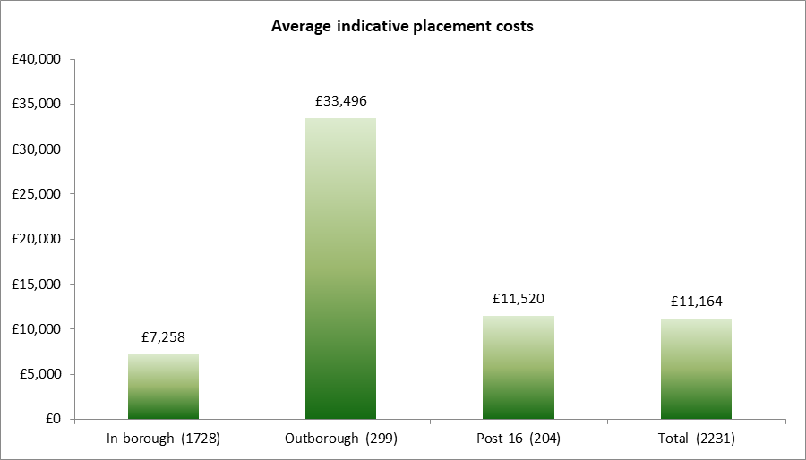

Note: Information on placement top up cost (BASES) was not available at the time of writing this report to give comprehensive comparison.

Re-addressing the aforementioned cost disparity will be no easy task. There will always be some children with very complex needs whose needs cannot be met locally, either due to lack of capacity or not being worthwhile for the council to set up such specialist provisions due to economies of scale. It is also known that children often stay in their starting placements until end of formal education.

As the number of children with SEND needs continue to grow beyond DMBC’s capacity; the use of more out of borough and high cost places will continue to be used to fulfil its statutory obligation to provide access and may lead to the detriment of locally funded places.

Chart 65: Average educational placement cost per primary EHCP needs

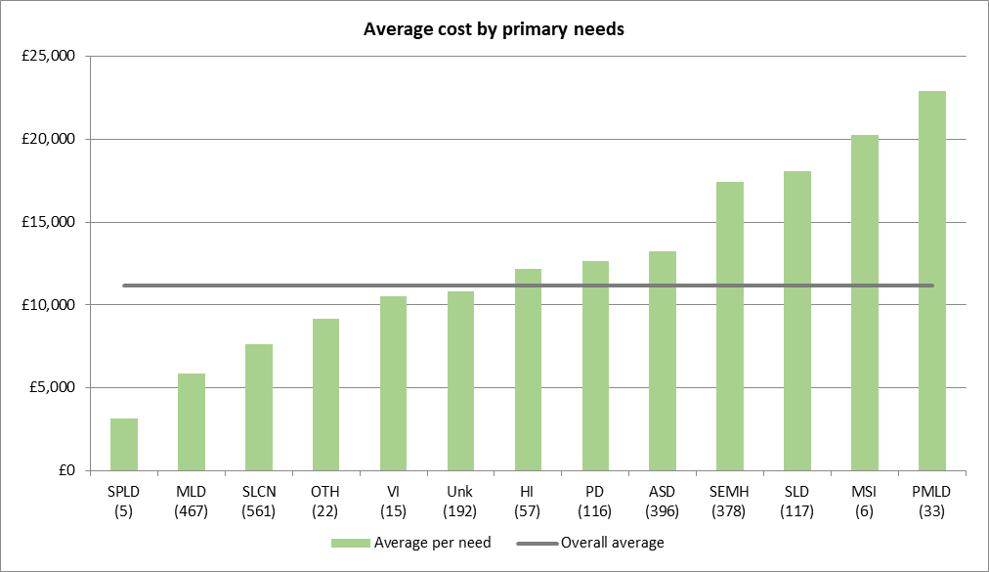

Key note:

***40% of SEND budget is currently spent on 13% of SEND children and young people attending out of area educational placements.***

## Specific Provision – Setting Location

There are 104 Dudley MBC schools: 78 Primary, 40 of which include a Nursery Unit (24 Primary Academy); 19 Secondary (of which 15 are Secondary Academy Schools) and 7 Special Schools

Analysis revealed that 93% of pupils attending any of these schools are resident in Dudley and indicates that they are almost reaching saturation levels. All bar one special school have special classes where children are taught at their pace and according to their needs (January school census return 2020).

Dudley currently meets various SEND needs in mainstream school settings but this varies depending on primary need types. The 2020 school census showed that significantly high proportions of children with sensory needs (hearing and visual impairments) are educated within mainstream schools with additional resource support (Bases).

There is however disparity in terms of primary needs types and available provision. SEMH needs are fast growing across every age group, and the only specialist dedicated provision is for secondary age pupils in one special school with 50 places for boys only.

Most schools are making significant efforts to enhance the specialist teaching required by this group of pupils with SEMH needs to ensure they are taught in an environment and style that best captures their attention and helps them to meet their targets. Six in ten pupils with SEMH in Dudley schools are taught in mainstream settings. However, over 100 are attending schools outside of the borough with 81 placed in high cost independent settings.

Children with SLCN account for a quarter of all EHCPs and over 90% are educated within Dudley. Although, the number of children and young people with SLCN needs going out borough is small (29), it is imperative to continue to expand provision for this group of children as their numbers increase.

The number of children and young people with ASD is on the increase. Almost 400 children and young people with an EHCP have ASD and one in two attend Dudley special schools. However, as special schools are filled to capacity almost 60 now attend schools out of the borough of which 40 are placed in independent special schools. If the number of ASD continues to increase, there is the need to increase provision in borough not just because of the high cost of these provisions, but the other impacts on these children include disconnection from their local communities.

Nine in ten of children and young people with Severe Learning Difficulties are educated in borough and most of them are place in special schools where their needs are best met.

MLD is the 2nd highest SEN needs of children with EHCPs in Dudley. Nine in ten attend in borough schools of which 60% are placed in special schools. There is a general understanding that these children have other specific high level needs being met and that MLD categories where used to align with statutory returns. Action plans are now in place to address these discrepancies as the annual reviews take place.

## Provision by settings – Dudley Schools

**Short Breaks (SEND)** – Provide opportunities for children with SEN to spend time away from their families in safe and supportive environments where they can relax, have fun trying new things and develop friendships that all help to enhance good wellbeing. Short breaks also afford their parents opportunities to have breaks from their caring responsibilities.

**SEN Support** – This is extra and varied support provided in addition to universal education by mainstream schools to children in need of special educational support. The class teacher together with the SEN Coordination (SENCo) may receive advice or support for from other specialist such as Educational Psychologists.

**EHCP** – Education, Health and Care Plan (EHCP) is a statutory document developed for children and young people up to age 25 following formal assessments of need. This is where the child is deemed to require more support than can be provided by SEN Support detailing provision of support in terms of education, health and social care. The plan sets out the child’s needs and the extra help they should receive to support their learning needs.

**Special Schools** – Like mainstream schools, special schools are required to teach the national curriculum. The main differences are related to class sizes, pupil to teacher ratios, teaching approaches, this being geared towards the child’s individual need and are matched closely to their learning styles and strength. An EHCP is always required to gain placement in special schools. For some children, attending a special school is the best option for them where provision can be modified to meet their more complex needs.

A child in a special school often gets taught in segregated classes from other children and will not be able to get experiences and learning they may otherwise have been exposed to in a regular mainstream settings. They also may not experience being in presence of other ‘types’ of people apart from their immediate families and friends.

Table 27: Range of SEND (EHCP) pupils supported by schools - reported at January 2020

|  |  |  |  |  |  |  |  |  |  |  |  |  |  |  |
| --- | --- | --- | --- | --- | --- | --- | --- | --- | --- | --- | --- | --- | --- | --- |
| **Name of setting** | **School capacity** | **No on roll** | **SLCN** | **MLD** | **ASD** | **SEMH** | **SLD** | **PD** | **HI** | **PMLD** | **OTH** | **VI** | **MSI** | **SPLD** |
| The Sutton School | 165 | 179 | 34 | 85 | 31 | 21 | 1 | 3 | 3 |  |  |  |  | 1 |
| The Brier Special School | 150 | 155 | 49 | 43 | 44 | 3 | 1 | 10 | 1 | 1 |  | 2 |  | 1 |
| The Woodsetton School | 103 | 106 | 44 | 34 | 23 | 2 | 2 | 1 |  |  |  |  |  |  |
| The Old Park School | 155 | 155 | 8 |  | 50 |  | 59 | 7 |  | 19 |  |  | 3 | 9 |
| The Halesbury School | 133 | 135 | 51 | 25 | 40 | 8 | 2 | 5 | 1 | 1 | 1 |  |  | 1 |
| The Rosewood School | 49 | 49 | 2 |  | 1 | 46 |  |  |  |  |  |  |  |  |
| Pens Meadow School | 110 | 110 | 17 | 6 | 40 |  | 30 | 3 |  | 13 |  | 1 |  |  |
| **Total on roll (Jan 2020)** | **865** | **889** | **205** | **193** | **229** | **80** | **95** | **29** | **5** | **34** | **1** | **3** | **3** | **12** |

Source: January school census 2020

### Provision overview per settings

**Mainstream School**s – Provide universal education and follow the national curriculum and a lot of CYP with SEND are educated within these settings where their educational experiences are maximised. It introduces them to range of different people which will mostly reflect environments they will encounter throughout their lives.

Not only is SEND inclusion in mainstream schools beneficial for many pupils with SEND, it is also of benefit for their mainstream peers. A mixture of mainstream and SEND pupils in a school teaches all pupils to be mindful of the needs and requirements of those around them, and allows for all pupils to make friends with children with a range of abilities and needs and from a variety of backgrounds.

**SEN Unit** – Special classes based in mainstream schools designed for students with SEND who might otherwise attend a special school. They facilitate the inclusion strategy and enrich the lives of these children by encouraging pupils to access mainstream education experience and environment. Some children with SEND require teachers and support staff to have specialist training in order to help them with their day-to-day learning and activities, some others require specialist accessibility equipment or environment adjustments for sensory needs. More and more mainstream schools are expanding their SEND provision, including specialist units for specific needs and hiring extra SEND-trained staff, so pupils with SEND are more supported than ever.

There are currently 51 places at SEN units (as reported through January school census). 41 places are available across three primary schools and 10 in one secondary school. Additional 31 resourced provisions are available in 2 primaries and 1 secondary.

**Post 16 ISP** - Independent Specialist Provision (ISP) is designed for young people aged 16 to 24 on their last birthday with SEND. They cater for those with an EHCP, a Personal Education Plan (PEP) or with Special Educational Needs (SEND). They support learners towards greater independence, employability or transition to Further/Higher Education.

**Pupil referral units/short stays** – Provide short stay learning opportunities for children who are often at risk of exclusion.

## Level of Support

### Universal

All children in the early years should have access to a broad and balanced EYFS curriculum that meets their individual needs to ensure they learn and develop well and are kept healthy and safe as per the EYFS statutory requirements. All children should be offered differentiated opportunities or alternative approaches to learning by practitioners who have identified children’s individual learning needs and have planned appropriately. The provider will have resources available to meet the ages and stages of each child’s individual development and have intervention plans in place as part of any identified SEND support; the child’s key person will support and monitor the child’s plan to regularly review the effectiveness of the support provided and the child’s progress.

### Emerging or Lower Level SEND

Early years children with emerging or lower level SEND may be assessed as having a delay in one or more prime areas of learning and may require specific resources to enable them to progress as well as their peers. Practitioners may seek advice and support from their Area SENCO and are encouraged to access training to ensure they are competently meeting the needs of all children. It may be necessary to purchase more specialist materials to use with the child. Providers may apply for EYIF funding for emerging or lower level SEND funding as a contribution towards some of these costs.

### Targeted – Children with SEND in need of some specialist involvement

Children will meet the criteria for Targeted support if they have been referred to or have been assessed by professionals from Specialist Early Years’ Service, Hearing Impairment Service, Visual Impairment Service, Physical and Medical Inclusion Service, Educational Psychology, Speech and Language Therapy Service or a relevant medical or health care professional. These children may need access to additional support and/or advice from one or more educational/health professionals. Evidence from the setting demonstrates that the Universal Support in place to date has not resulted in the expected outcomes for the child being achieved. Providers may apply for additional funding as a contribution towards the costs of specific adaptations or training or to enhance adult support if the child has or is in the process of having an EHCP.

### Highest Need/complex SEND

* This is for children who have an Education Health and Care Plan (EHCP).
* Children may also have Disability Living Allowance (DLA) in their own right.
* Agreed top-up funding is provided from the High Needs Block of the DSG.

### Bases - SEN  Units

SEN units are special provisions within a mainstream school where the pupils with SEN are taught mainly within separate classes.

### Bases - Resourced provision

Resourced provisions are places that are reserved at a mainstream school for pupils with a specific type of SEN, taught mainly within mainstream classes, but requiring a base and some specialist facilities around the school.

Resourced provisions:

* are designated by the local authority specifically for making this kind of SEN provision
* receive funding of £6,000 or £10,000 per place, and usually top-up funding for the excess costs of additional support required by individual pupils
* cater for a specific area or areas of SEN (for example specific learning difficulties)
* are usually for pupils with an education, health and care (EHC) plan, but could include pupils with code ‘K’ (SEN support)

Schools and academies should only use this indicator ***where the resourced provision has been formally recognised*** as such by the local authority where the school is located.

Most pupils placed in units will have an EHCP. It is unlikely that a child would be placed in a unit and also receives support from resourced provision, but a school could have resourced provision for one type of need and a unit for another.

# Current Provisions

While analysing what Dudley needs in terms of future provision, it is equally important to assess what is already available in Dudley and how it is meeting needs.

Practically all schools have children with SLCN on roll. The table below shows the number of schools (January 2020) with children with specific primary needs. In spite of this spread, there is evidence of lack of in borough capacity and increasing numbers of children with EHCPs are attending schools out of area.

Table 28:Number of schools with pupils with particular primary need on roll

|  |  |  |  |  |  |  |  |  |  |  |  |  |  |  |
| --- | --- | --- | --- | --- | --- | --- | --- | --- | --- | --- | --- | --- | --- | --- |
|  | **ASD** | **HI** | **MLD** | **MSI** | **NSA** | **OTH** | **PD** | **PMLD** | **SEMH** | **SLCN** | **SLD** | **SPLD** | **VI** | Settings |
| Primary | 67 | 45 | 77 | 5 | 27 | 35 | 62 | 6 | 77 | 79 | 8 | 56 | 35 | 79 |
| Secondary | 19 | 18 | 19 | 3 | 8 | 14 | 19 | 0 | 19 | 18 | 1 | 19 | 16 | 19 |
| Special | 7 | 3 | 5 | 1 | 0 | 1 | 6 | 4 | 5 | 7 | 6 | 4 | 2 | 7 |
| PRU | 1 |  | 2 |  |  | 1 | 1 |  | 2 | 1 |  |  |  | 2 |

Source: January 2020 school census

One in two children with EHCPs are successfully integrated in mainstream schools in Dudley with the support of a range LA services including Sensory Impairment Service (SIS), Educational Psychology Service (EPS), Speech and Language Therapists (SALT or SLT), Learning Support Service (LSS), and Sycamore Outreach. However, half of children with EHCPs are educated in special schools meeting a variety of needs as depicted in the table below.

Table 29: Summary of CYP in special schools by primary need

|  |  |  |  |  |  |  |  |  |  |  |  |  |  |
| --- | --- | --- | --- | --- | --- | --- | --- | --- | --- | --- | --- | --- | --- |
| **Special schools** | **SLCN** | **MLD** | **ASD** | **SEMH** | **SLD** | **PD** | **HI** | **PMLD** | **OTH** | **VI** | **MSI** | **SPLD** | **Total** |
| The Sutton School | 34 | 85 | 31 | 21 | 1 | 3 | 3 |  |  |  |  | 1 | 179 |
| The Brier Special School | 49 | 43 | 44 | 3 | 1 | 10 | 1 | 1 |  | 2 |  | 1 | 155 |
| The Woodsetton School | 44 | 34 | 23 | 2 | 2 | 1 |  |  |  |  |  |  | 106 |
| The Old Park School | 8 |  | 50 |  | 59 | 7 |  | 19 |  |  | 3 | 9 | 155 |
| The Halesbury School | 51 | 25 | 40 | 8 | 2 | 5 | 1 | 1 | 1 |  |  | 1 | 135 |
| The Rosewood School | 2 |  | 1 | 46 |  |  |  |  |  |  |  |  | 49 |
| Pens Meadow School | 17 | 6 | 40 |  | 30 | 3 |  | 13 |  | 1 |  |  | 110 |
| **Total** | **205** | **193** | **229** | **80** | **95** | **29** | **5** | **34** | **1** | **3** | **3** | **12** | **889** |

Source: January 2020 school census

In spite of these provisions; increasing numbers of children are placed in outside educational settings of which the majority is for those with SEMH and indicating unmet needs locally.

The table overleaf shows current designated specialist provision across all ages, settings and arrangement types in Dudley. It is acknowledged that the landscape of needs, placements and associated costs could change requiring a review of new priority areas.

## Education setting with Enhanced and Designated place 2020

| **Setting name** | **SEND Type** | **Setting Type** | **Age group** | **Key Stage** | **Designated Capacity** | **FT / PT provision** | **Commissioned / LA managed** |
| --- | --- | --- | --- | --- | --- | --- | --- |
| Segregated schools (special schools) | | | | | | | |
| Sutton School & Specialist College | MLD | Spe | 11 to 16 | KS3 - 4 | 179 | FT | LA Maintained |
| Brier Special School | MLD | Spe | 5 to 16 | KS1 - 4 | 174 | FT | LA Maintained |
| Woodsetton School | MLD | Spe | 5 to 11 | KS1 - 2 | 107 | FT | LA Maintained |
| Halesbury School | MLD | Spe | 5 to 16 | KS1 - 5 | 140 | FT | LA Maintained |
| The Old Park School | SLD | Spe | 5 to 19 | KS1 - 5 | 151 | FT | LA Maintained |
| Pens Meadow School | SLD | Spe | 5 to 19 | KS1 - 5 | 110 | FT | LA Maintained |
| Rosewood School | SEMH | Spe | 11 to 16 | KS3 - 4 | 50 | FT | LA Maintained |
| Specialist nursery SEND places - Specialist Inclusion Services | | | | | | | |
| Brockmoor Specialist Nursery |  | Nur |  | FSP | 20 | PT | Specialist Nurseries |
| Phoenix Specialist Nursery |  | Nur |  | FSP | 16 |  | Specialist Nurseries |
| Leapfrog, at Netherton Park |  | Nur |  | FSP | 20 | PT | Specialist Nurseries |
| Integrated in mainstream with Top-Up (BASES) | | | | | | | |
| Ashwood Park Primary School | HI | Pri | 4 to 11 | FSP - KS2 | 20 | FT | LA SIS managed |
| The Crestwood School | HI | Sec | 11 to 16 | KS3 - 4 | 8 | FT | LA SIS managed |
| Wrens Nest Primary School | SEMH | Pri | 7 to 11 | KS2 | 8 | FT | Commissioned |
| Wrens Nest Primary School | C&L | Pri | 7 to 11 | KS2 | 10 | FT | Commissioned |
| Beacon Hill Academy | ASD | Sec | 11 to 16 | KS3 - 4 | 10 | FT | Commissioned |
| Gig Mill Primary School | ASD | Pri | 7 to 11 | KS1 - 2 | 8 | FT | Commissioned |
| Hob Green Primary School – KS1 | SLCN | Pri | 4 to 7 | FSP - KS1 | 12 | FT | LA SIS managed |
| Hob Green Primary School – KS2 | SLCN | Pri | 7 to 11 | KS2 | 13 | FT | Commissioned |
| Hawbush Primary School | SEMH | Pri | 5 to 11 | KS1 - 2 | 12 | FT | Commissioned |
| Quarry Bank Primary School | SLCN | Pri | 4 to 7 | FSP - KS1 | 20 | PT | LA SIS managed |
| Intensive Learning Unit | SpLD | - | 7 to 11 |  |  |  | LA LSS managed (traded service) |
| Alternative Provision Commissioned SEND Places | | | | | | | |
| Cherry Tree Learning Centre | Multiple |  |  |  |  |  | Specialist SEMH and medical |
| Sycamore Short Stay School | Multiple |  |  |  |  |  | PRU- LA Maintained |
| Post 16 Further Education (FE) SEND Places | | | | | | | |
| Dudley College of Technology | Multiple | FE | 16 to 25 | KS4 - 5 | 108 |  | Commissioned |
| Halesowen College | Multiple | FE | 16 to 25 | KS4 - 5 | 111 |  | Commissioned |
| King Edward V1 College, Stourbridge | Multiple | FE |  | KS4 - 5 |  |  | Commissioned |

Source: Dudley commissioning and Finance Teams, September 2020

Keys:

|  |  |  |  |  |
| --- | --- | --- | --- | --- |
| Pri | Maintained/Academy Primary |  | Sec | Maintained/Academy Secondary |
| Spe | Maintained/Academy Special |  | FE | Further Education |
| SIS | Specialist Inclusion Services |  |  |  |

# SEND Sufficiency - Identified priority areas by age group

This section of the needs assessment describes the Specialist Provision within Dudley. It describes the growing number and complexity of needs in children and young people with SEND. It reviews utilisation and current provisions in the borough alongside services used outside of Dudley (sufficiency analysis).

Gaps in provision of services in and out of borough, impact of growth together with proposed future provisions are reviewed alongside the required resources, cost and location.

This aims to inform residents, educators and other stakeholders of identified priority needs and show the rationale for the recommendations detailed later on. This will support the development of future plans and the allocation of future funding, as and when it becomes available. We will also use this data to inform future appeals for funding and/or sponsorship of provisions.

There is an on-going review of the inclusion strategy and conversations are being held with all schools to work collaboratively to expand provision to include SEND children and young people locally. Schools will be provided with specialist support and resources to meet the needs the growing population of Social Emotional and Mental Health (SEMH), Autistic Spectrum Disorder (ASD) and Speech, language and communication needs (SLCN).

Dudley’s vision is to improve the life chances of children and young people with SEND. It is reviewing the provision of services locally and where possible to provide opportunity for children and young people with SEND to attend Dudley schools if they so wish. They may be based in mainstreams schools with additional resources or in special schools.

There is also a call to review post-16 provisions that are ambitious and support young people developing life skills in preparation for adulthood, employment and independence. Local intelligence reports that quite a number of young people were not entered for accredited or nationally recognised qualifications.

There is also evidence of increasing cost of provision which is not surprising due to increasing demand. The number of EHCPs on local SEND register increased by over 400 children in just one year.

Chart 66: Distribution of primary needs against average expenditure (EHCP)

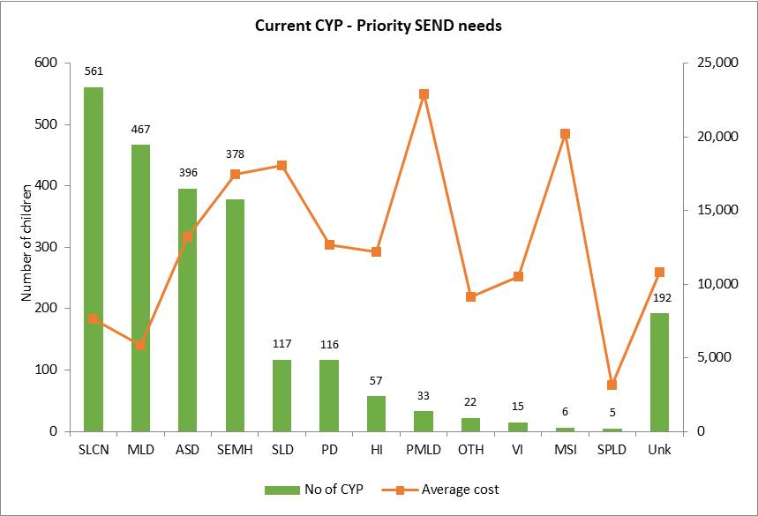

SEND primary needs varies according to age group. This section of the report is based on data extracted for children and young people with EHCPs from the authorities Case Management System in September 2020. Unfortunately due to system issues, not all children with EHCPs are included; 8% don’t have their primary needs identified at the time of writing this report. The data gap is more significant with children under age 5.

There is evidence that more children are being educated out borough, particularly those with SEMH. As at September 2020; 180 children and young people were attending out of borough independent schools. Analysis showed that that over 90% of these children could have their needs met within the expertise of the current special schools. Less than 10% are educated out of area (OoA) due to their needs requiring highly specialist settings, or are children looked after placed out of borough by Children’s Social Care.

The conclusion is that most of the children and young people are accessing schools out of borough because of lack of capacity in borough, as a result of parental preferences or as a result of tribunal outcomes.

Chart 67: Number on children placed out of area by primary need

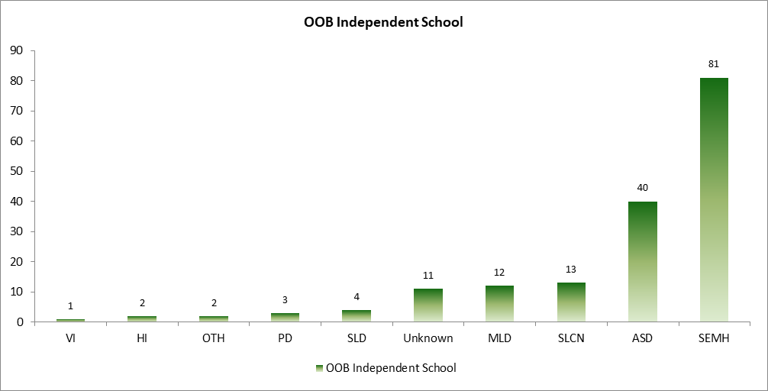

Key note:

***Provision for SEMH is one of the highest accounting for 25 % of the whole spend and of which 58% are for pupils placed out of borough. This primary need is also set to increase as the SEMH increases and considering the potential impact of Covid-19 on children and young people’s wellbeing that could manifest as SEMH.***

## Under 5 – Priority Needs

The Under 5 SEND cohort is the second smallest group after those aged 20 to 25. This is due to operational make-up of the way to under-5 service mode is delivered. The number and need of this age group gives an indication of future provision for SEND needs. It also means that provision of early intervention for some children with less complex needs may facilitate inclusion and education in mainstream settings whilst reducing the need for placements in specialist settings.

Chart 68: Under 5s primary needs and educational placements

|  |  |
| --- | --- |
|  |  |

**Source:** Finance Team, September 2020

### Speech, Language and Communication Needs (SLCN)

67 under 5 children have SLCN and account for 42% of the group. This is a significant proportion of the group and the distribution is in line with overall picture of needs in Dudley. Please note that needs for a few children was declared unknown at the time of data extraction affecting 54 children. The proportion of children under 5 with SLCN in Dudley (50%) is double that of national average (22%) for same age group.

98% of children under the age of 5 are educated in-borough at an average cost of £6,101. Cost of out of borough provision is in line for the 3 children involved. Spend on under-5s with SLCN account for 46% for the groups spend with the majority (65%) spent on in-borough special schools placements. It is important to note that SLCN is one of the fastest growing needs and provision within Dudley will need to increase capacity in tangent with this.

### Severe Learning Difficulties (SLD)

The number of children with SLD is very small for this age group but the average cost £14,510 is well above that of the under 5s. All attend local special schools and there is no evidence of increasing numbers locally indicating adequate capacity.

### Autistic Spectrum Disorder (ASD)

Only five children are identified as having ASD with average placement cost of £10,033 and they are educated in borough. Considering that this group is one of the fastest increasing locally, it is imperative to ensure there is enough capacity locally to meet needs. The proportion of children under 5 with ASD in Dudley (19%) is below national average (37%) for same age group.

Key note:

***SLCN accounts for 42% of the Under 5 SEND cohort needs and is a priority for this cohort considering that this primary need is one of the fastest growing needs across Dudley.***

***Dudley is an outlier for SLCN compared with national for similar age group cohort.***

## Ages 5 to 10 – Priority Needs

Children aged 5 to 10 with an EHCP is the largest group across all ages accounting for 41%. This distribution is slightly above national rates. As reflected in the under 5s, the majority have SLCN which was identified at a young age. This further emphases the need for early intervention and support to maximise their educational experiences. There is evidence of increasing local provision with 90% of this group of children educated locally at an average cost of £7,354. Average place cost for the 104 children that attend out of borough schools is £33,800 but significantly more is spent for the 55 placed in independent settings (£48,514).

Four in ten children are however educated in special school settings and only 25 are eligible for additional resource provision (BASES). This means that emphasis should be made in promoting inclusion into mainstream setting for some of the children with lower levels of need and who will also benefit from the positives of mainstream education. Note that average cost for in borough placements is under estimated as cost of bases (additional resources) was not available at the time of writing this report.

Chart 69: 15 to 10 year old primary needs and educational placements

|  |  |
| --- | --- |
|  |  |

**Source:** Finance Team, September 2020

### Speech, Language and Communication Needs (SLCN)

##### Independent places for 5 to 10 year olds cost average of £65k each

347 children have SLCN representing 35% of the needs for this group of children. This is the largest need and is also in line with overall picture of needs in Dudley. 96% of children aged 5 to 10 with SLCN are educated locally with 95% placed in special schools. Noteworthy is the high cost of provision in external independent schools (7 children); £65,195 compared with in borough average of £6,438 for children age 5 to 10 with SLCN.

### Moderate Learning Difficulties (MLD)

##### Independent places for 5 to 10 year olds with MLD cost average of £21k each

176 (18%) children aged 5 to 10 have MLD and all bar nine children are placed in Dudley schools at an average cost of £5,282 per head compared with £20,762 for the few attending out borough settings.

### Social, Emotional & Mental Health (SEMH)

##### Independent settings for 5 to 10 year olds with SEMH cost average of £48k each

130 (13%) children age 5 to 10 have SEMH as their primary need. Considering that this need is the fastest growing need in Dudley; it is imperative that provision increases in line with demand. A third of the cohort is educated in borough but over 41 children are educated out of borough with an average cost of £29,551 which is 3 times the in-borough average of £9,842. Twenty-eight children (22%) are in independent settings. Independent school placements take up 77% of SEMH spend for this cohort with an average of cost (28 children).

Provision for children with very complex needs such are severe and profound learning difficulties is expensive but most of them are educated within Dudley special schools

### Autistic Spectrum Disorder (ASD)

##### Independent settings for 5 to 10 year olds with ASD cost average of £52k each

ASD is the 3rd most predominant need (15%) for the age 5 to 10 cohort with 149 children. 88% are educated in borough and seven in ten are attend Dudley special schools. The average cost for in borough placement is £6,895 compared with £34,323 for all out of borough placements. Independent school placement take up 32% of ASD spend for this cohort with an average of cost £52,013 each (11 children).

***SEMH is a priority area for the 5 to 10 cohort considering the projected increase, numbers placed out of borough and the cost placements.***

It should be noted that the costs detailed above are an average of mainstream and in-borough special schools.

## Ages 11 to 15 – Priority Needs

Four in ten of children (866) with EHCPs are between this age group of which the majority are boys. This proportionate share (37%) is broadly in line with national distribution (35%).

Moderate leaning difficulties is the most common need for this cohort accounting for 24%. It appears that most children have overcome earlier issues with SLCN and fewer children have it as their primary needs. ASD is the 2nd priority need for this group with 175 children and followed by those with SEMH. Please note the primary need for 74 children in this cohort were not matched at the time of writing this report.

Eight in ten children are educated locally of which 60% are placed in special school settings and only 14 are eligible for additional resource provision (BASES). This means that emphasis should be made in promoting inclusion into mainstream setting for some children with lower levels of need and who will benefit from the positives of mainstream education. Note that average cost for in borough placements is under estimated as cost of bases (additional resources) were not available at the time of writing this report

137 children attend schools out borough and the majority (64%) are placed in independent settings. The average cost for children placed out of borough is £24,000 with significantly more for the 87 placed in independent settings (£46,936).

Chart 70: 11 to 15 year old primary needs and educational placements

|  |  |
| --- | --- |
|  |  |

**Source:** Finance Team, September 2020

### Moderate Learning Difficulties (MLD)

##### Independent places for 11 to 15 year olds with MLD cost average of £27k each

Over 200 children (248%) aged 11 to 15 have MLD and all bar fourteen children are placed in Dudley schools at an average cost of £3,896 per head compared with £18,330 for the few attending out of borough settings. Out of borough Independent School provision costs £27,246 (5 children) on average accounting for 6% of cohort with MLD.

### Autistic Spectrum Disorder (ASD)

##### Independent settings for 11 to 15 year olds with ASD cost average of £50k each

Two in ten children age 11 to 15 are diagnosed as having ASD; this is the 2nd most predominant need for cohort with 175 children. 81% are educated in borough and of which seven in ten are in special schools. The average cost for in borough placement is £6,042 compared with £21,893 for all out of borough placements. Independent school placement take up 56% of ASD spend for this cohort with an average of cost £49,880 (27 children).

### Social, Emotional & Mental Health (SEMH)

##### Independent settings for 11 to 15 year olds with SEMH cost average of £45k each

Almost 200 children aged 11 to 15 (20%) have SEMH as their primary need. Considering that this need is the fastest growing need in Dudley; it is imperative that provisions increase in line with demand. 70% of the cohort is educated in borough but over 51 children are educated out of borough with an average cost of £24,046 compared with in borough average of £9,306. Thirty-nine children (23%) are placed in independent settings taking up 74% of SEMH spend for this cohort with an average of cost £45,486 (39 children).

There is the group of children (74) for whom their primary needs was not available at the time of this analysis (9%) of the cohort. Eight are ten are placed Dudley setting with an average cost of £8,236. However, the cost of out of borough placements is £28,424 with an out of borough independent school placement cost of £44,445 (7 children).

***Considering that one in five of those with ASD and SEMH are educated outside the borough, the projected increase in numbers and the associated costs; ASD and SEMH are priority areas for the 11 – 15 age group.***

## Ages 16 to 19 – Priority Needs

Two in ten of young people (300) with EHCPs are between the ages of 16 and 19. The proportionate share (13%) of this cohort amongst the EHCP population is below national distribution (21%).

Social, Emotional and Mental Health (SEMH) needs are the most predominant need for this cohort accounting for 21%. ASD is the 2nd priority need for this group with 55 young people and followed by those with MLD. Please note 33 children in this cohort did not have their primary need matched at the time of writing this report.

Eight in ten children are educated locally of which 25% are placed in special school settings. Half of this cohort are in post-16 education and of which 22% are in independent specialist provisions (ISP). 32 young people are also placed in PRU and this may call for assimilation into the ISP where their needs may be better met.

Fifty-two young adults are placed out of borough with almost half in independent settings. The average cost for children placed out of borough is £26,400 and the cost is significantly more for the 23 placed in independent settings (£46,929). Have of the young people attending independent settings have SEMH.

Chart 71: 16 to 19 year old primary needs and educational placements

|  |  |
| --- | --- |
|  |  |

### Social, Emotional & Mental Health (SEMH)

##### Independent settings for 16 to 19 year olds with SEMH cost average of £38k each

Almost 70 young people aged 16 to 19 (20%) have SEMH as their primary SEND need. The growing trend of this need is evidently becoming a concern in Dudley. This analysis has shown that there is not enough provision locally resulting in the need to use high cost independent schools out of borough. Considering that this primary need is the fastest growing need in Dudley; it is imperative that provision capacity increases in line with demand. 70% of the SEMH cohort is educated in borough but over 20 young people are placed out of borough with an average cost of £31,281 compared with in borough average of £8,317. Independent schools out of borough take up 52% of the SEMH spend on 16 to 19 cohort with an average of cost £38,137 (14 children). SEMH need accounts for half of the cohort being educated out of borough.

### Autistic Spectrum Disorder (ASD)

##### Independent settings for 16 to 19 year olds with ASD cost average of £85k each

Almost one in five young people age 16 to 19 are diagnosed as having ASD; this is the 2nd prevalent need for this cohort with 55 children. 84% are educated in borough and of which three in ten are in special schools. The average cost for in borough placement is £16,367 compared with £36,084 for all out of borough placements. Independent school placement take up 20% of ASD spend for this cohort with an average of cost £85,645 (2 children).

***SEMH is a priority area for the 16 to 19 cohort***

## Ages 20 to 25 – Priority Needs

Only 56 young people age 20 to 25 have an (EHCP. Their proportionate representation of 2.4% is significantly below national distribution (6%). The majority (67%) of this cohort are in Post-16 further education and 30% with Independent Specialist Provider (ISP).

Chart 72: 20 to 25 year old primary needs and educational placements

|  |  |
| --- | --- |
|  |  |

Three of the young people aged 20 to 25 have moderate learning needs (MLD), followed by those with ASD (21%). Young people with profound multiple difficulties though are small in number account for 15% of the total spend with an average of £42.

***45% of the total spend on this cohort is spent on Post-16 Independent Specialist provisions.***

# Priority Need Summary

In summary, the high priority areas of need for each age group and those requiring future developments to manage the impact of demand include the provision for SLCN, SEMH and ASD needs. The priority areas of need have been identified based on growth, cost of provision externally and the numbers being sent out of borough.

Chart 73: 20 to 25 year old primary needs and educational placements

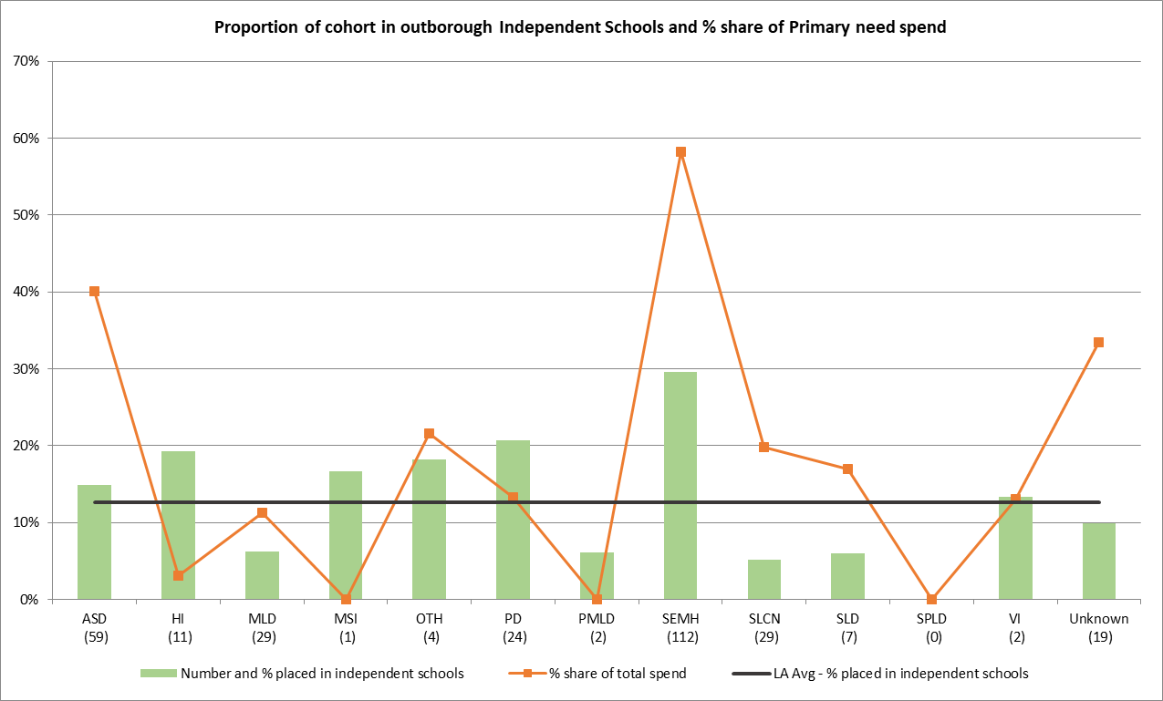

Source: Finance and Commissioning Team, September 2020

### Social, Emotional and Mental Health (SEMH)

There is not enough specialist provision in Dudley and three in ten of children and young people with this primary need are attending out of borough independent schools, taking up 58% of the budget. **Out of borough placements cost 4 times more than local provision.**

### Autistic Spectrum Disorder (ASD)

Provision for children with ASD is ranked 2nd for area of priority need. 40% of group spend is on the 15% attending Independent Schools out of borough. **Independent schools cost 10 times that of local provision for this primary need.**

### Speech, language and communication needs (SLCN)

Although the proportion of pupils educated in Independent School settings is small; they take up 20% of the total spend of this primary need. **Independent schools cost 14 times that of local provision for this primary need.**

**Key note:**

***Data quality issues and consistencies are the common thread picked up across many aspects of this report, particularly that relating to the Case Management System – Synergy. These issues are currently been addressed and ensuring that commissioning finance information correlates with the activity records and to provide a single view with narratives.***

1. <https://www.npi.org.uk/files/3414/7087/2429/Disability_and_poverty_MAIN_REPORT_FINAL.pdf>
2. <https://www.hqip.org.uk/wp-content/uploads/2019/05/LeDeR-Annual-Report-Final-21-May-2019.pdf>
3. <https://www.kingsfund.org.uk/publications/whats-happening-life-expectancy-uk>
4. https://learning.nspcc.org.uk/safeguarding-child-protection/deaf-and-disabled-children#risk-and-vulnerability-factors
5. <https://assets.publishing.service.gov.uk/government/uploads/system/uploads/attachment_data/file/398815/SEND_Code_of_Practice_January_2015.pdf>
6. https://www.who.int/disabilities/world_report/2011/report/en/
7. <https://www.gov.uk/government/statistics/family-resources-survey-financial-year-201819>
8. https://assets.publishing.service.gov.uk/government/uploads/system/uploads/attachment_data/file/874507/family-resources-survey-2018-19.pdf
9. https://www.gov.uk/government/statistics/special-educational-needs-in-england-january-2020
10. <https://www.who.int/dietphysicalactivity/childhood/en/>
11. <https://files.digital.nhs.uk/A0/273EE3/MHCYP%202017%20Trends%20Characteristics.pdf>
12. <https://www.ons.gov.uk/peoplepopulationandcommunity/healthandsocialcare/childhealth/articles/childrenwhosefamiliesstruggletogetonaremorelikelytohavementaldisorders/2019-03-26>
13. <https://digital.nhs.uk/data-and-information/publications/statistical/mental-health-of-children-and-young-people-in-england/2017/2017>
14. <https://www.ons.gov.uk/peoplepopulationandcommunity/healthandsocialcare/childhealth/articles/childrenwhosefamiliesstruggletogetonaremorelikelytohavementaldisorders/2019-03-26>
15. https://fingertips.phe.org.uk/profile/child-health-profiles/data#page/1/gid/1938133228/pat/6/par/E12000005/ati/202/are/E08000027/cid/4
16. <https://www.ons.gov.uk/peoplepopulationandcommunity/birthsdeathsandmarriages/livebirths/adhocs/11580numberoflivebirthsat37oroverweeksgestationwithlowbirthweightbyclinicalcommissioninggroup2018>
17. <https://www.geneticdisordersuk.org/>
18. <https://www.who.int/genomics/public/geneticdiseases/en/index2.html>
19. <https://www.ons.gov.uk/datasets/mid-year-pop-est/editions/mid-2019-april-2020-geography/versions/1>
20. https://www.ons.gov.uk/peoplepopulationandcommunity/birthsdeathsandmarriages/livebirths/bulletins/birthsummarytablesenglandandwales/2019#number-of-births-and-fertility-rates
21. https://www.ons.gov.uk/peoplepopulationandcommunity/birthsdeathsandmarriages/deaths/datasets/deathsregisteredbyareaofusualresidenceenglandandwales
22. <https://www.ons.gov.uk/datasets/mid-year-pop-est/editions/mid-2019-april-2020-geography/versions/1>
23. <https://www.ons.gov.uk/peoplepopulationandcommunity/birthsdeathsandmarriages/livebirths/bulletins/birthsummarytablesenglandandwales/2019>
24. https://www.ons.gov.uk/peoplepopulationandcommunity/birthsdeathsandmarriages/deaths/articles/quarterlymortalityreports/januarytomarch2018
25. <https://www.gov.uk/government/collections/english-indices-of-deprivation> 
26. https://www.ons.gov.uk/peoplepopulationandcommunity/healthandsocialcare/childhealth/
27. https://explore-education-statistics.service.gov.uk/find-statistics/characteristics-of-children-in-need
28. <https://www.autism.org.uk/advice-and-guidance/what-is-autism>
29. <https://www.cdc.gov/ncbddd/autism/facts.html#:~:text=Autism%20spectrum%20disorder%20(ASD)%20is,social%2C%20communication%20and%20behavioral%20challenges>.
30. <https://www.gov.uk/government/statistics/education-provision-children-under-5-years-of-age-january-2020>
31. <https://explore-education-statistics.service.gov.uk/find-statistics/16-18-destination-measures/2018-19>
32. <https://www.gov.uk/government/statistics/family-resources-survey-financial-year-201819>
33. [**https://www.ons.gov.uk/peoplepopulationandcommunity/populationandmigration/populationprojections**](https://www.ons.gov.uk/peoplepopulationandcommunity/populationandmigration/populationprojections)