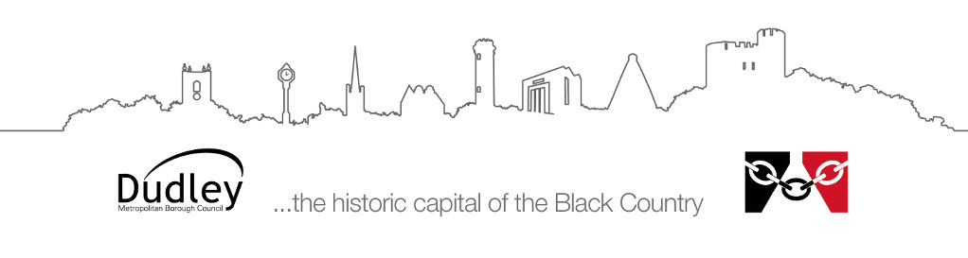
Information sheet for parents/carers
Visual Impairment Service
Baby and Toddler Group

The Visual Impairment Service Baby and Toddler Group is an informal and fun group that runs monthly for babies and toddlers with a Visual Impairment and their parents. It is run by Qualified Teachers of the Visually Impaired. The sessions are shared with the Dudley Hearing Impairment Team who offer support to families of children with a Hearing Impairment.
These sessions take place at the Stourbridge Family Centre (https://goo.gl/maps/bEtVhybwu53zQDmXA), where we have the use of the Early Years Suite and a Sensory Room. The centre has access to both parking and changing facilities and the group is free to attend.
These sessions give you the opportunity to have a time where you and your child can engage in various play and sensory activities with the support from qualified Teachers of the Visually Impaired, as well as having the opportunity to access specialist toys, equipment and advice. Occasionally we have ‘guest speakers’ attending the group to give you information about other services available.
Session activities include; singing, craft, messy play, sensory play, signing, music, role play, toys, social times for snacks and access to the large and well-equipped sensory room. There are opportunities throughout the session to speak with other parents of children who have a sensory impairment.
In addition to the fortnightly sessions, we take part in day-trips. For more information about the group please contact us on; 01384 818003.

