Information for parents/carers and schools
Hearing Impairment Support
Guidance relating to Background noise - why deaf children cannot filter the sounds they want to hear from other noise

This information sheet explains why it is difficult for hearing impaired children to filter the sounds that they need to hear from the background noise. It’s basically all to do with the cochlea. The cochlea is in the inner ear and looks like a tiny snail shell. It is about the size of a pea
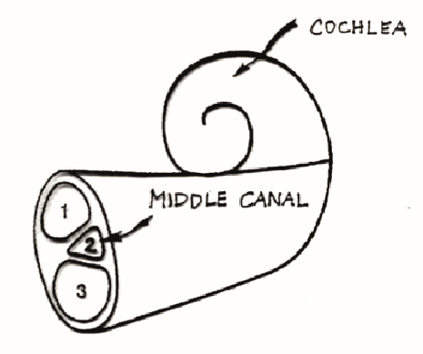
How does the cochlea work?

The cochlea has three canals inside. The top canal and the bottom canal protect the middle canal. The middle canal contains many little hair cells that stand in rows. Each one is connected to the hearing nerve which sends messages to the brain.
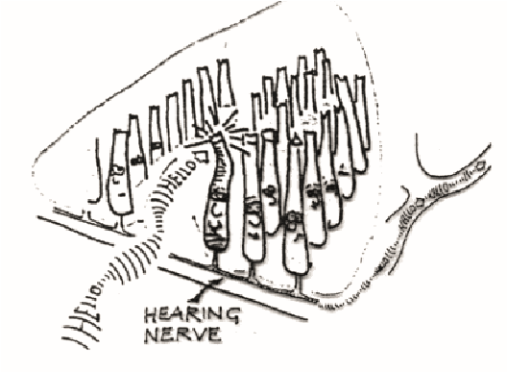
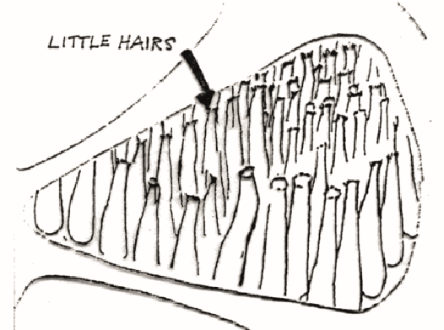
As sound waves touch the hair cells they bend and send the sound wave message to the hearing nerve because they are connected to it. The sound message is delivered by the hearing nerve to the brain. Each hair cell is tuned to pick up a certain pitch of sound. Outer hair cells pick up high frequency sounds, inner hair sounds low frequency sound.
In sensory-neural hearing loss some of the hair cells do not work or some may be missing. It is much more difficult for the ear to discriminate one sound from another. Different sounds may appear similar. The filtering mechanism of the ear is faulty here, so sounds cannot readily be distinguished from one another. The Cochlea’s ability to resolve frequencies (FREQUENCY RESOLUTION) is damaged. So, sounds may sound similar.

The cochlea’s ability to separate sounds and the timing of sounds may also be impaired. This is known as TEMPORAL RESOLUTION. The effect of this is that the sequence of sounds is scrambled so that the brain may receive the middle sound of a word before the beginning
Frequency and temporal resolution problems make it difficult for hearing impaired listeners to perceive speech in good listening conditions and these are the difficulties that hearing aid technology has yet to overcome. In background noise, these problems are exacerbated even further due to competing sound sources

