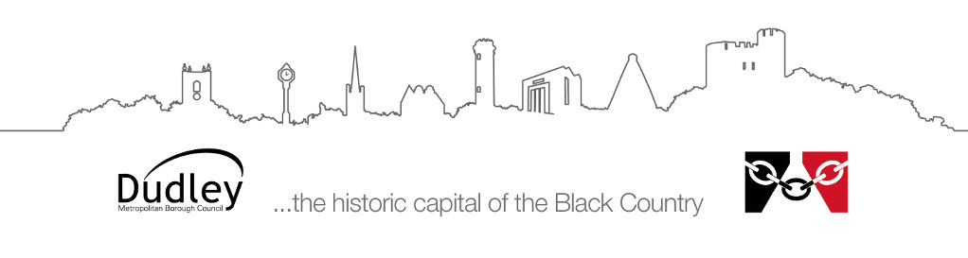

Information for parents/carers and educational settings

Visual and Hearing Impairment Services
Supporting children with multi-sensory impairments

The Visual and Hearing Impairment Services work together to provide advice, information and training for parents/carers and teachers of babies, children and young people with a dual sensory impairment.

The Service consists of Qualified Teachers of Visually Impaired (QTVI), Qualified Teachers of the Deaf (QTOD), Multi-Sensory Impaired (MSI) Intervenor (Early Years), Habilitation Specialist (mobility and independence), ICT Specialist, Specialist Resources Co-Ordinator, Educational Audiologist (Ed Aud).

What is Multi-Sensory Impairment (MSI)?
People who have multi-sensory impairment (MSI) will have a combination of hearing and vision impairments. Most people with MSI will have some useful hearing and vision but some may be completely deaf and/or blind.

Definition of deafblind: ‘The term dual sensory loss can be used interchangeably with deaf blindness denoting the fact that combined losses of sight and hearing are significant for the individual even where they are not profoundly deaf and totally blind. It is the way in which one sensory impairment interacts or compounds the second impairment, which causes the difficulties, even if, taken separately, each single sensory impairment seems relatively mild.’ Department of Health: Deafblind Children and Adults Policy Guidance

Communicating with a Child with MSI
Communicating with a child with MSI requires planning and preparation as they will be missing out on auditory and visual information about the world around them. This will require the use of alternative communication strategies, such as on-body signing, objects of reference and sensory cues. Developing the most effective communication pathways for a child with MSI will be supported by the professionals working with the child, such as QTVI, QTOD, Speech and Language Therapist, and these professionals will monitor and support the development of the communication strategies employed.

Support from an Intervenor
Children with MSI often require the support of an Intervenor. A trained intervenor will understand the impact of MSI on the child’s development and will have the skills to support their communication, mobility, orientation and learning. They will work to maximise the child’s potential to learn, live and contribute to their world. We have an Intervenor that supports pre-school children with MSI in their home. The Intervenor will make regular support visits to work with the child to develop sensory skills, social skills, communication and other areas of development appropriate to each individual. Once the child starts school the support from a trained Intervenor can be provided within school.

Further Information
More information regarding support for people with MSI can be found from SENSE, a national organisation that supports people who are deafblind:
https://www.sense.org.uk/

