Information for parents/carers and schools

she
Visual Impairment Service
Sighted guide - how to safely guide a
child with a visual impairment

This information provides guidance on how to safely ‘guide’ a visually impaired child using the ‘sighted guide technique’. Here we outline the core principles of sighted guide. Sighted guide is also known as dependent travel.

The sighted guide grip
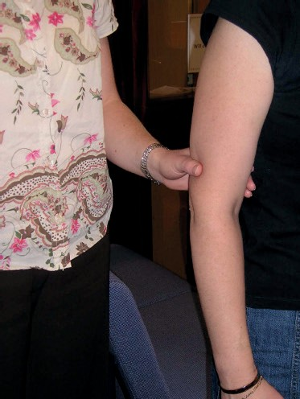
A good grip is essential.

It is the responsibility of the child who is being guided to maintain the grip throughout sighted guide travel.

The child should grip their guide’s arm above their elbow with their fingers on the inside of the guides arm and thumb on the outside.

The guide’s arm should be straight, and the child’s arm should be slightly bent to ensure that they are half a step behind their guide

As an alternative, when guiding a small child, the grip may need to be transferred to the guide’s wrist or fingers due to the significant height difference between the child and their guide.

Changing sides
- Firstly, you must inform the child that you need to change sides and explain why.
- To change sides simply move your guiding arm back allowing the child to move across and locate your other arm.

Doorways
- It may be necessary to change sides for the child to be on the hinge side of the door.
- The guide needs to inform the child of an approaching door and let them know if the door is a pull or push.
- The guide should make contact with the door with their free arm, then as they pass through, transfer the door to the guiding arm in order for the child to take control of the door.
- Encourage the child to use their free hand to trail your guiding arm, locate the door handle and be responsible for opening the door.

Steps and stairs
- All steps, stairs and kerbs must be approached square on.
- Before ascending or descending any steps or stairs you may need to change sides to allow the child to trail down your arm with their free hand and hold the handrail.
- The child needs to position their hand slightly in front of their body on the handrail so that they are able to follow it.
- As the guide you should always be one step in front of the child.
- Maintaining the sighted guide grip when ascending or descending steps/stairs allows the child to feel the motion of their guide’s body.
- When descending stairs, the child may need to slide their foot to the edge of the first step. Then use their heel to determine the depth of the step.
- It may be necessary for the sighted guide grip to be transferred from the arm to the shoulder to prevent the child from leaning forward when descending stairs.
- Verbal guidance is imperative when negotiating steps/stairs. You need to inform them of whether you are ascending or descending steps/stairs and always notify them of the last step.

Seating

Never back a child into a seat
- Inform the child that you are approaching a chair and that you want them to sit down.
- Always try to guide so that you centrally approach the back of a chair.
- Place your guiding arm on the back of the chair and instruct the child to trail your guiding arm in order to make contact with the chair.
- Then encourage the child to feel the depth of the chair and ensure that the seat is clear.
- You must inform the child of arm rests.
- The child should then be able to sit down without further assistance.

