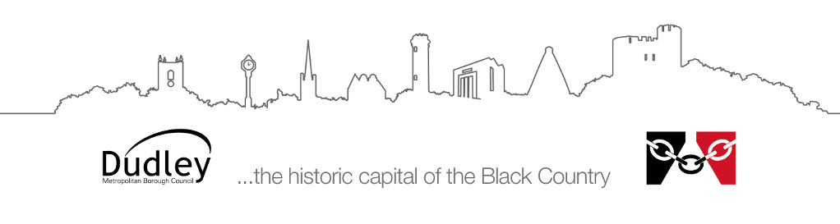
sheet for

Information for parents/carers and preschool and nursery
Visual Impairment Service
Identifying children with a sight problem and supporting them in Pre-school or nursery

Identifying sight problems in young children
The following are all signs that a child may have a visual impairment:
- Complaining of dusty or gritty eyes
- Tilting the head to look at things
- Holding things very close to their faces
- Screwing up or rubbing eyes, continual blinking, incessant frowning for no reason
- Finding bright light uncomfortable, i.e. hurting their eyes or making their eyes water
- Unusual eye movement such as rapid involuntary movement of both eyes in a horizontal or vertical direction
- Bumping into objects or knocking things over
- Sign of anxiety or insecurity in the playground
- The eye appears to be misshapen or irregular.

If you have any of these concerns about your child, please contact us for advice.

Children with squints
A squint is when one or both eyes turn in or out. A child with a squint may be using vision in one eye only, which may affect the child’s ability to judge depth, the speed of something approaching and judging distance. They may also not have 3D vision. Squints may also cause difficulties which require good co-ordination and judgement of speed and distance, for example during P.E./games.
Sometimes the good eye is patched to encourage the lazy eye to work. In most cases the squint can be surgically corrected (cosmetic only). It is essential to co-operate with patching if this has been prescribed, and to get information from the orthoptist as to the degree of patching required. If the child is having difficulties coping during patching, please contact us.

Children with sight in only one eye
Sight in one eye only may be referred to as monocular vision. Many children have monocular vision, but this does not often present a problem, although sight in the ’good’ eye should be monitored regularly.
Progress should not be affected as most children with monocular vision adjust to the situation. However, there may be certain areas where the pupil will need additional help.
These are:
- Hand/eye co-ordination
- Height, depth and distance perception ~ this may have implications in P.E. & Games and road safety.
Pupils with monocular vision should be seated centrally, preferably directly facing, and with the sighted eye towards the activity. Teachers and peers should be seated on the sighted side and should also approach from that side. The visual impairment service need not be regularly involved, although we do need to be aware of any child with monocular vision.

Wearing glasses
If a child in nursery wears glasses, try to make sure that:
- The glasses are worn (including for P.E./games lessons).
- They are clean.
- When they are taken off, they are put in one special safe place.
It is helpful to know why the child wears glasses so please check with parents.
Short sighted - when the child will have blurred vision for things in middle and long distance.
Long sighted - when the child will have blurred near vision.

Tips for organising the nursery environment
- Avoid unnecessary clutter, especially on the floor.
- Consider the child’s position in the nursery for different activities. The child may need to be at the front for group activities.
- Displays should be clear and at an appropriate height for the child.
- Children with visual difficulties rely on their hearing more. It is difficult to listen in noisy conditions. Controlling the background noise will improve the listening environment considerably.
- Make sure light is on your face and not behind you. Don’t stand in front of sunny windows as the visually impaired child will be unable to see your face. Be aware that bright sunshine can cause glare. Blinds can help to adjust light levels.
- Make sure children are working in a well-lit area.

Things to avoid - safety considerations
- Objects at head height, e.g. coat pegs, hanging plants, lockers, etc.
- Windows left open.
- Schoolbags left on the floor.
- Electric cables across the floor.
- Tilted chairs and chairs being pushed back suddenly.
- Sharp objects held by other children, e.g. scissors.
- Insecure doors which may ‘catch’ in the wind.

Hand - eye coordination and fine motor skills
The development of hand-eye co-ordination and good motor skills depends on the ability to use the eyes properly. Children with some visual difficulty may need more practice with:
- Construction toys
- Threading beads and buttons
- Puzzles
- Pegboards
- Jigsaws and shape sorting

Early writing
- It can be difficult to see lines through tracing paper unless the line underneath is very bold. Children may have difficulties copying lines on paper unless there is a good contrast.
- They may prefer to use a black felt pen rather than a pencil.
- Paper with dark lines can be obtained from the Visual Impairment Service.

Early reading
- Scanning left to right is a visual skill. Children with visual difficulties may need to be taught left to right scanning.
- Try to choose books with clear pictures and where the print is clearly laid out and easy to find.
- Encourage children to look at pictures.

P.E. and outdoor play
Activities which require physical skills and co-ordination may present difficulties for visually impaired children. The ability to judge depth, speed and distance are related to the use of vision.
Children may lack confidence in developing these skills. There may be issues concerning safety in P.E. and outdoor activities. We can provide further advice on this.

