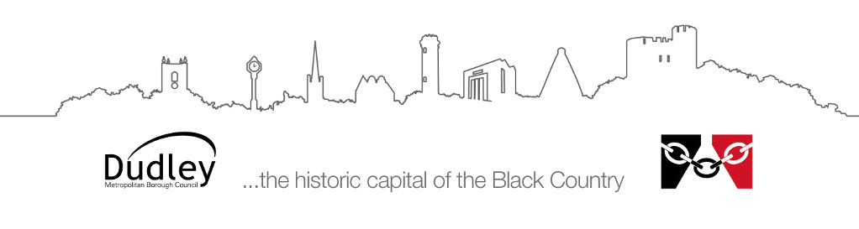

Information for parents/carers and schools

Visual Impairment Service
Habilitation (mobility and independence)
training for children with a visual impairment

Mobility and independence training, which is known as ‘habilitation’ training promotes and develops the independence of a child with a visual impairment.

What is habilitation training?
A qualified Habilitation Specialist will develop the necessary skills and experience in order to promote early movement, sensory, spatial and body concepts and ultimately independence. This may include long cane training, route learning and independent living skills. This training can take place in the home, at nursery or school, or out in public settings, as appropriate. The specialist will take into consideration the child’s individual habilitation requirements and any additional needs.
Advice will always be provided to parents and teaching staff.

What is the referral process?
A Qualified Teacher of the Visually Impaired (QTVI) will refer a child for training following assessment and discussion with the parents/carers and school.

What happens once a child has been referred for habilitation training?
A Habilitation Specialist will contact the child’s parents/carers and ask them to sign a consent form giving their permission for a habilitation assessment. The relevant school’s permission will also be required.

What are the benefits of habilitation training?
The training:
- Promotes and encourages a child’s movement and exploration within safe environments.
- Helps to develop a child’s body, spatial and social awareness.
- Promotes concept development.
- Encourages self-help and independence skills.
- Promotes sensory awareness.
- Teaches a child specific habilitation and orientation skills to assist independent movement.
- Provides a child with familiarisation training prior to a school transfer. This will encourage and promote safe, independent movement within school.
- Mobility training can provide a child with experience and familiarisation in their local community including travel training using public transport.
- Can teach road safety and specific crossing skills.
- Can help a child to learn to travel safely in poor lighting conditions using a long cane.
- Can also provide appropriate independent living skills education.

Additional tasks which may be carried out by a Qualified Habilitation Specialist include:
- Risk Assessments and advice re: PEEPs for Educational settings.
- Environmental audits.
- Production of map models to assist a habilitation programme.

