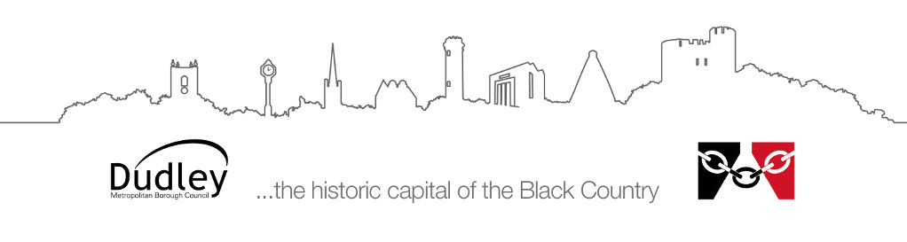

Information for parents/carers and educational settings

Visual Impairment Service
Accessibility for visually impaired pupils

This information provides some general guidance and suggestions to help with possible adaptations to a setting/building or physical environment to make it more accessible for pupils with a visual impairment.

How can the visual impairment service help?
If a pupil with a visual impairment is attending or due to attend school, the visual impairment service can carry out an environmental audit based on the individual needs of the pupil. In addition, advice can be sought from us to complete a risk assessment, if required.
Any works that are completed must be carried out in accordance with manufacturer’s guidance and statutory guidance.
Safety must always be a major consideration when making recommendations to adapt the environment to be more accessible for children and young people with a visual impairment. It is also important to ensure that the physical conditions of a nursery, school or college building do not create barriers to learning.

Tips - indoors

Lighting and shade
Working in a well-lit environment is important to all of us. We need good lighting, using sources of natural and artificial light, particularly in corridors and stairways. Light should be controllable by a switch, blinds or curtains.

Colour and contrast
Colour and contrast help us to use our vision successfully to find our way around the environment, separate the foreground from the background and identify people, places and objects. Given the role of vision in direct and incidental learning, thoughtful and sensitive use of colour and contrast will benefit everyone.

Colour and contrast are most important in the following areas:
- Signage
- Handrails
- Fittings in toilets and changing rooms, e.g. tiles around washbasins
- Light switches
- To define a circulation route
- To increase the visibility of doors/doorframes/handles
- Work surfaces/cupboard/lockers
- Any items which might protrude such as coat pegs/hooks
- To contrast furniture with flooring
- Glass doors/large windows could be covered with suitable transfers.
Try to avoid having:
- Patterned wall or floor coverings which can be confusing
- Complicated coloured patterns on items e.g. tableware
- High gloss finishes as reflection can distort images

Floors and Flooring
- Contrasting colour/tone should be used for distinguishing stairs from the approaching floor
- Flooring should be of good quality to prevent ‘tripping’ hazards
- Floors should be free from obstacles and clutter e.g. bags, boxes left lying around
- Flooring should not produce glare
- Door mats should be recessed

Changes in Level (stairs, steps, ramps)
- All stairs/steps should have continuous handrails on both sides, placed at suitable heights for all children
- Tops and bottoms of ramps should be easily distinguished by contrasting texture/colour
- Stairs should have nosing (step edging) of contrasting colour

Signage
The purpose of signage is to communicate information clearly. The following, therefore, need to be considered:
- Text should be of a suitable size and font (serif fonts should be avoided)
- There should be good contrast between the background and text of the sign
- There should be good contrast between the sign and the background that it is positioned against
- Tactile signage.

Tips - outdoors
- Any steps should be highlighted in contrasting colours - slip resistant paint should be used
- Handrails should be fitted for all steps/ramps
- Pathways should have clearly defined edges
- Floor surfaces should be even and well finished
- All bushes/hedges/trees should be cut back from steps and pathways
- Parking should not be allowed in non-designated areas.
- Playground equipment should have good contrast.
- Moveable equipment should be set up in the same place each time.
- All plants should be non-toxic and safe to touch.

Safety
Potential hazards can be overlooked, and this can be particularly dangerous for children who have a visual impairment. Both children and carers need to be aware of the potential dangers which can easily be rectified:
- Objects at head height; e.g. coat pegs, hanging plants, lockers, etc.
- Windows left open, especially those at head height
- Bags left lying on the floor
- Electric cables across the floor
- Tilted chairs and chairs being pushed back suddenly
- Sharp objects held by other children; e.g. scissors, pencils, etc.
- Insecure doors which may ‘catch’ in the wind
- Glass doors such as patios or large plain glass windows
- Inconsistent lighting
- Doors left ajar
- Locker or cupboard doors left to swing open
- Slippery or chipped and broken edges of steps
- Holes in carpet or lino
- Deliveries left in corridors.

